Studying abroad

1. Look at the pictures below and answer the questions:

* What are the main differences between the classes in the pictures?
* Which country do you think each class is from?
* In which of the countries would you most like to study? Why?

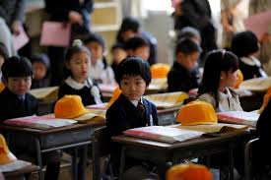 [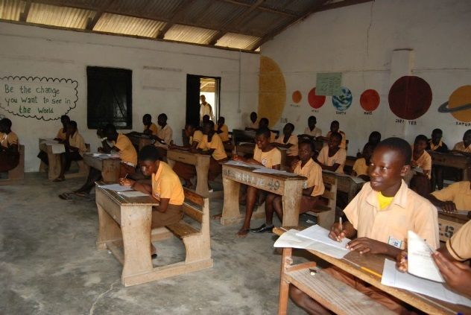](http://www.google.cz/url?sa=i&rct=j&q=&esrc=s&source=images&cd=&cad=rja&uact=8&ved=0ahUKEwj04YSC97HYAhULJ1AKHfvTCe8QjRwIBw&url=http://www.kimbolton.cambs.sch.uk/ghana&psig=AOvVaw3tivkKeugbMtCBIMEwKWJb&ust=1514729956605507)

a) b)

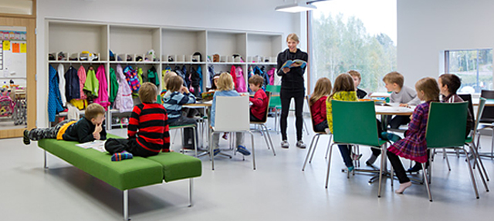 [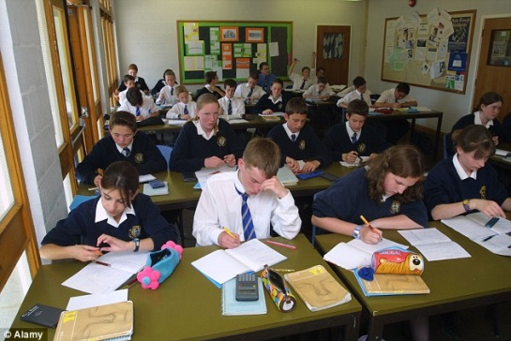](http://www.google.cz/url?sa=i&rct=j&q=&esrc=s&source=images&cd=&cad=rja&uact=8&ved=0ahUKEwiwh-WA-LHYAhUFbVAKHfqFB-wQjRwIBw&url=http://www.dailymail.co.uk/news/article-2768769/Pupils-losing-hour-day-s-teaching-rowdy-behaviour-Headteachers-fire-allowing-disruption-unchecked-damaging-pupils-exam-chances.html&psig=AOvVaw1Xvm2bwmGFrhpIDYjkFARs&ust=1514730234531483)

c) d)

2. In your opinion, which countries have the best education systems in the world?   
Do you know which countries belong to the “World’s TOP 20 Education Systems” list?

In groups, try to guess the TOP 10 education systems in the world.

1. 6.

2. 7.

3. 8.

4. 9.

5. 10.

Reading

1. Match the words with their definitions.

prestigious a) memorize

require b) a serious attempt, hard work

maturity c) the subjects studied at school and what they include

learn by heart d) fail to do something fast enough

fall behind e) having a high reputation

soar ahead f) responsible for

curriculum g) something that must be done

accountable for h) the quality of behaving mentally and emotionally like an adult

effort i) request / demand / have need of

compulsory j) learn something faster than others

2. Read the text about the Finnish education system and identify the main reasons why it is one of the best in the world. What values are appreciated by Finns?

**THE FINNISH EDUCATION SYSTEM**

The education system in Finland is one of the best in the world. Here are some reasons why:

Teachers

* Being a schoolteacher is one of the most **prestigious** professions in Finland.
* A three-year undergraduate degree plus a two-year master’s degree are **required** to become a teacher.

The Teaching Method

* Children start receiving education at the age of seven, when they reach intellectual **maturity**.
* In the first two years, students attend school for 4-5 hours a day and get little homework.
* Until the sixth grade, children usually have the same teacher for most subjects.
* A number grading system is not used until the 5th grade, so there is little competition between students.
* Schools don't give homework until students are teenagers. Learning is done in the classroom.
* The relationship with the teacher is very close; each class is limited to 20 students.
* Students spend time exploring, creating and experimenting, rather than **learning by heart**.
* Teachers take care of students who **fall behind**. Extra attention is also given to students who **soar ahead**.

Schools

* Each school has **curriculum** autonomy; individual teachers have classroom autonomy.
* Teachers and students are involved in educational planning.
* Finland has very few private schools.

Education Culture

* In Finland, 80% of families visit a library at the weekend.
* Parents generally believe they, rather than the school, are **accountable for** the education of their children.
* Finns value discipline and **effort** as part of the Lutheran culture.

Education Policy

* In 2009, Finland spent 6.8% of its GDP on education.
* **Compulsory** education is free. This includes classroom material and school transport.

(Adapted from <http://www.englishcurrent.com/finnish-education-system-upperintermediate-esl-lesson-plan/>

3. Name some of the main similarities and differences between the Finnish education system and the Czech education system.

4. Can you describe what it is like to study at university in the Czech Republic?

Try to remember the vocabulary related to studying at university (student activities, responsibilities, etc.).

Group discussion:

* Talk about what you like and dislike about university life in the Czech Republic.
* Tell each other about your timetable and classes.
* Tell each other about your arrangements for this week.
* Tell each other about your plans for this semester.
* Talk about how you think your life will be different when you graduate.