**Are you a successful language learner?**

**1. Discuss the questions in small groups.**

* What makes a successful language learner? Natural talent? Or hard work?
* How successful are you at learning languages?

**2. Work in pairs. Discuss what you would do in the situations below – be honest!**

**Make notes on your partner's answers in the box on the right.**

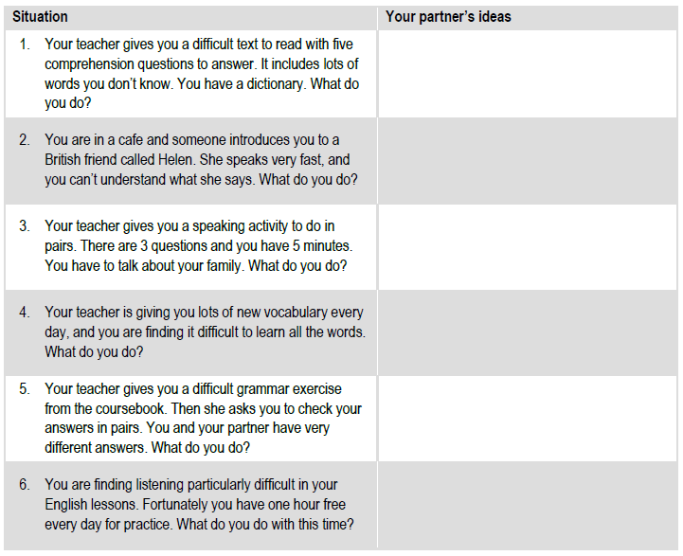

**Your teacher will give you the answer key when you have finished. Use the key to give your partner a score. Check the meaning of the score – do you agree?**

**Answer key**

**Using your notes, score your partner’s answers using the key below. You can score your partner for more than one answer. For example, if they gave two good ideas for question 1, they can score points for both: +3 and +2 = +5 (total points) But if they gave one good idea and one bad idea, you need to add (+) and subtract (-) points: +3 and -2 = +1 (total points).**

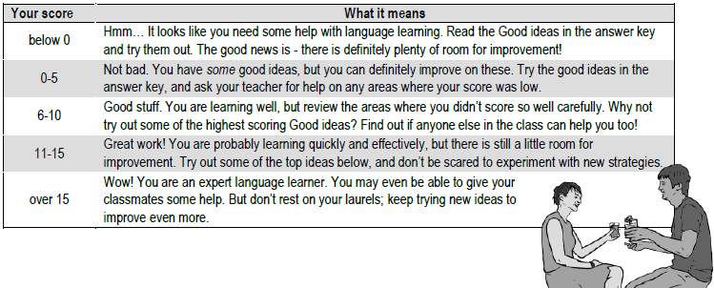

**3. Look again at the good ideas in the answer key. Discuss the questions in pairs.**

* Which ideas would you like to try in the future?
* What else could you do to become a more successful language learner?

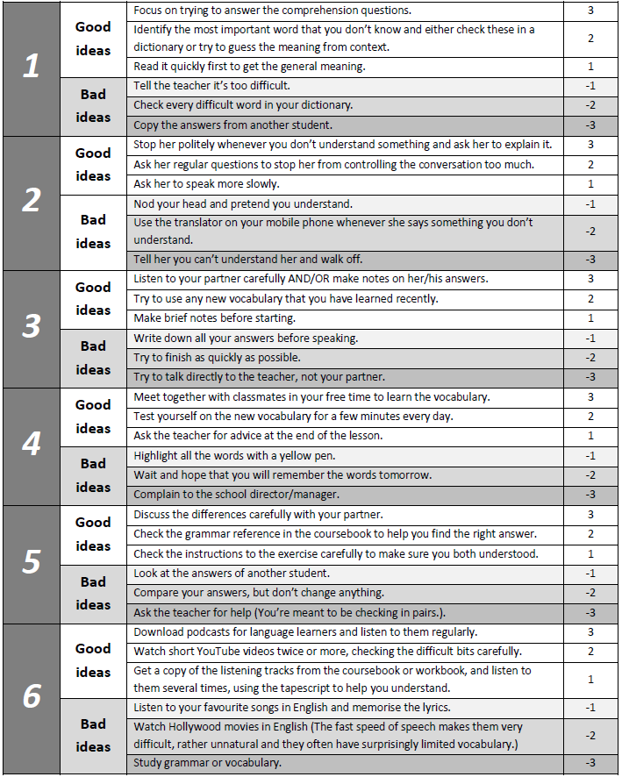

Adapted from *Delta Downloads: Photocopiables,* J Anderson, Delta Publishing, 2016