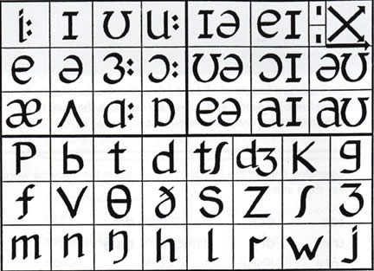

[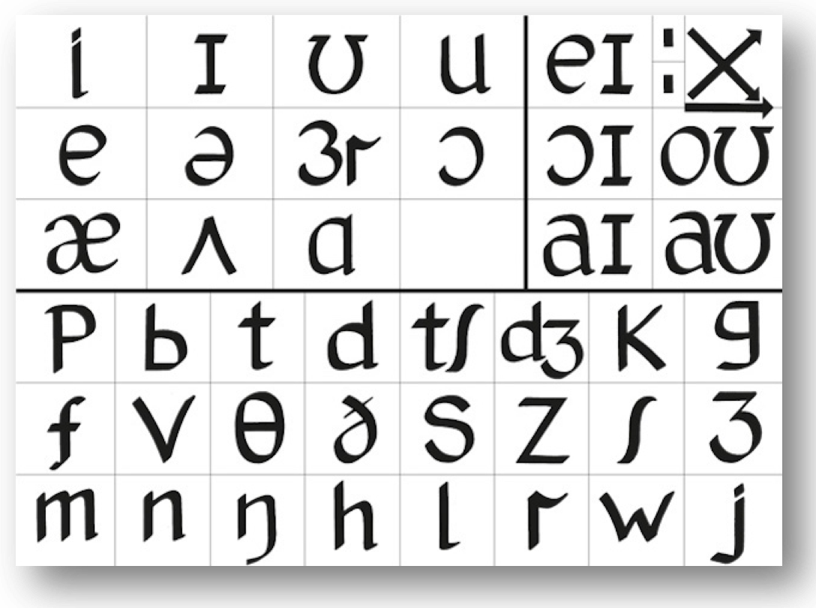](https://www.google.com/url?sa=i&url=http%3A%2F%2Fwww.adrianunderhill.com%2Fthe-pronunciation-charts%2Ffinal-us-chart%2F&psig=AOvVaw0OUJyGDwfLNPNdyDu4bxcR&ust=1582015876886000&source=images&cd=vfe&ved=0CAIQjRxqFwoTCPDb3MSa2OcCFQAAAAAdAAAAABAE)

**GenAm: 1 rhoticity, 2 nasality, 3 open vowels, 4 flapping, 5 yod dropping, 6 American raising.**

Camden Town (Roger Kingdon)

unique (Jan Werich)

event (a student) heathen

dessert (myself)