1. Put yourself in a sociable mood
2. Sophistication
3. Give turns, take turns
4. Pictures: a) IN the picture

b) localize pics on the sheet, label them

c) listen

d) 2 minutes

Cambridge oral test Part 2

1. Choose two, localiye and label them
2. similarities
3. differences
4. details

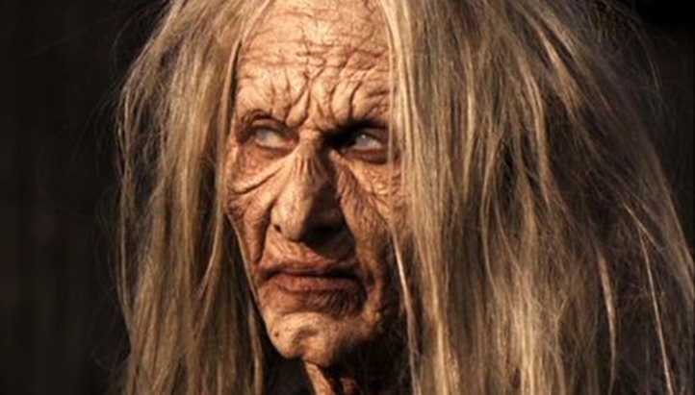 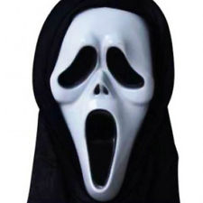

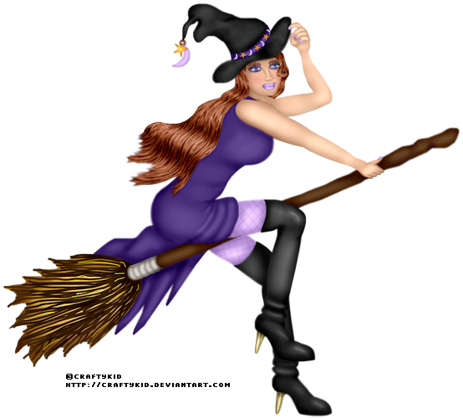 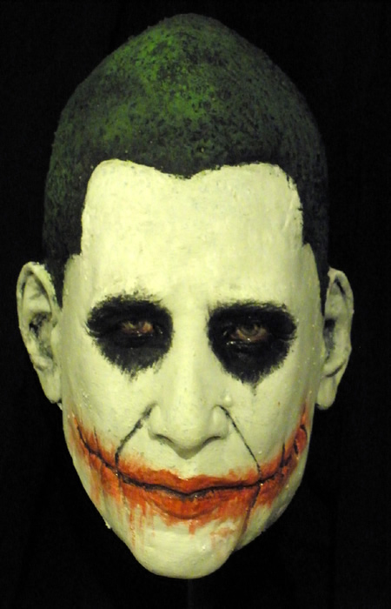

Cambridge oral test Part 3

You have about 3 minutes to reach an agreement. A picture for inspiration:

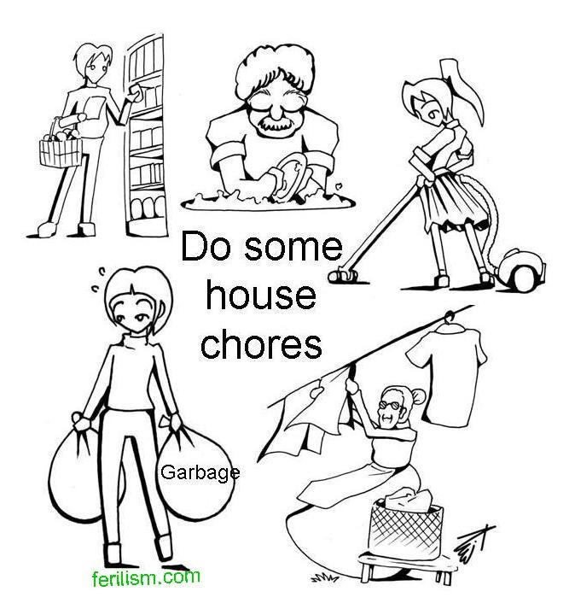

A hypothetical bachelor’s project

**Title**  The impact of Halloween masks

on attractiveness perception

**Hypothesis** People wearing scary masks will be found less attractive than those wearing neutral/pretty ones

**Method** Half a dozen masks tipped out at a Halloween party, two dozen respondents (12 males - 9 hetero, 3 homosexual, 12 females - 11 hetero, 1 self-pronounced lesbian) filling out a questionnaire assessing the degree of the mask wearer’s attractiveness

**Results** Hypothesis disproved, respondents not influenced much by the masks, assessed the wearers‘ natural attractiveness

You investigated the attractiveness of people depending on masks they put on for a Halloween party. The hypothesis was that