**Vowels and diphthongs tongue twisters**

1. The rain in Spain falls mainly on the plain.
2. My brother’s mother’s my uncle; my uncle’s son’s my cousin.
3. Sue knew too few tunes on the flute.
4. Rose knows Joe phones Sophie, but Sophie and Joe don’t know Rose knows.
5. Fear tears in your ears.
6. Laura’s daughter bought a horse and called it Laura.
7. It’s hard to park a car in a dark car park.
8. Roy enjoys noisy toys.
9. Nile crocodiles have the widest smiles.
10. The fat cat sat on the man’s black hat.
11. Sarah and Mary share their pears fairly.
12. John wants to watch Walter wash the dog.
13. Steve keeps the cheese in the freezer.
14. Tim bit a bit of Kitty’s biscuit.
15. “It’s best to rest,” said the vet to the pet.
16. The girl heard the nurse work.
17. Be sure your cure is pure.
18. I ate an apple and a banana in a cinema in Canada.
19. That cook couldn’t cook if he didn’t look at a cook book.
20. Mrs Brown counted cows coming down the mountain.

**Which of the sounds below do these tongue twisters practise primarily?**

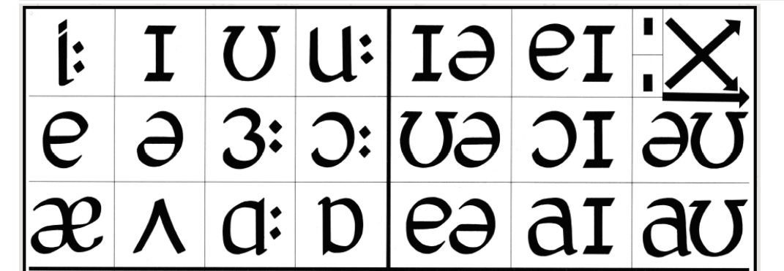

**Try to say the tongue twisters several times in a row. How fast can you be while still pronouncing the sounds correctly?**

