Physical Impairment
- Read the article about cerebral palsy and fill in the missing words.

Abnormality | affect | affected | Awkward | brain | Decreased
diplegia | Hemiplegia | increased | legs | quadriplegia | slow
spasticity | tone | tongue | types | writing | 10-20 %
Cerebral Palsy (CP)
Cerebral palsy is a group of disorders that (1) ___________ a person's ability to move and maintain balance. It is due to a non-progressive brain (2)______________. People with cerebral palsy have damage to the part of the (3)______________ that controls muscle tone. It is what lets you keep your body in a certain posture or position. For example, it lets you sit straight and keep your head up. Changes in muscle tone let you move. The (4)______________ in different muscle groups must be balanced for you to move smoothly.
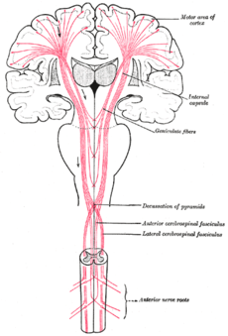
There are four main (5)______________ of cerebral palsy - spastic, dyskinetic, ataxic, and mixed.
- Spastic: People with spastic cerebral palsy have (6)______________ muscle tone. Their muscles are stiff. Their movements can be (7) __________. About 70-80 percent of people with cerebral palsy have spasticity. Spastic cerebral palsy is usually described further by what parts of the body are (8)______________. In spastic (9)______________, the main effect is found in both legs. In spastic (10)______________, one side of the person's body is affected. Spastic (11)______________ affects a person's whole body (face, trunk, legs, and arms).
- Dyskinetic (also called athetoid): People with dyskinetic cerebral palsy have (12)______________ movements that they cannot control. The movements usually affect a person’s hands, arms, feet, and (13)______________. Sometimes the face and (14)______________ are affected, and the person has a hard time talking. Muscle tone can change from day to day and can vary even during a single day. About (15)______________ of people with cerebral palsy have the dyskinetic form.
- Ataxic: People with ataxic cerebral palsy have problems mainly with balance. They might be unsteady when they walk. They might have a hard time with quick movements or movements that need a lot of control, like (16)______________. They might have difficulty controlling their hands or arms when they reach for something. People with ataxic cerebral palsy can have increased or (17)______________ muscle tone. Only about 5 -10 percent of people with cerebral palsy have ataxia.
- Mixed: Some people have more than one type of cerebral palsy. The most common pattern is (18)_________________ plus dyskinetic movements.

