**Natural disasters EduScrum**

**class 7**

Natural disasters are violent events that are outside the control of people. They are caused by the forces of nature and may result in loss of life, injury, and damage to buildings and property. There are many types of natural disasters. Let's discover the most well-known ones.

part A

1. Work in your team. Create the “big paper chart” documenting your work process. Follow the example on the board. Use post it notes. Follow the order of the tasks. You will use all new information in the second part of the project (part B)! Focus, learn new words and grammar, and cooperate with each other. Are you ready?!
2. Important note! Your work will be evaluated. You can get up to 10 points for cooperation and communication (work in groups, division of work, speaking English, following rules, respecting each other), 10 points for tasks and 10 points for presentation of your work. It means 30 points in total.
3. What is a natural disaster? What natural disasters do you remember from the video or do you know about? **Discuss** it in your group and **create a word cloud** using words you know or remember from the video connected with this topic. Your word cloud must be created in your exercise book. Use your classbook page 36 to help you.

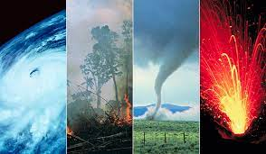

1. **Read the text** in your student's book page **37**. Are there any new words? Write them down into your exercise book, look them up in a dictionary. Do exercise **36/7**, write the answers in your exercise book.
2. Create a **word search** to practice irregular verbs in past simple tense. A **word search** is a [word game](https://en.wikipedia.org/wiki/Word_game) that consists of the letters of words placed in a grid, which usually has a rectangular or square shape. The objective is to find and mark all the words hidden inside the box. The words may be placed horizontally, vertically, or diagonally. Choose 20 irregular verbs (consult the table in your workbook). Use a white sheet of paper. Write the list of your verbs in infinite below the grid.

Your teacher will make copies of your word search and your classmates will complete it.

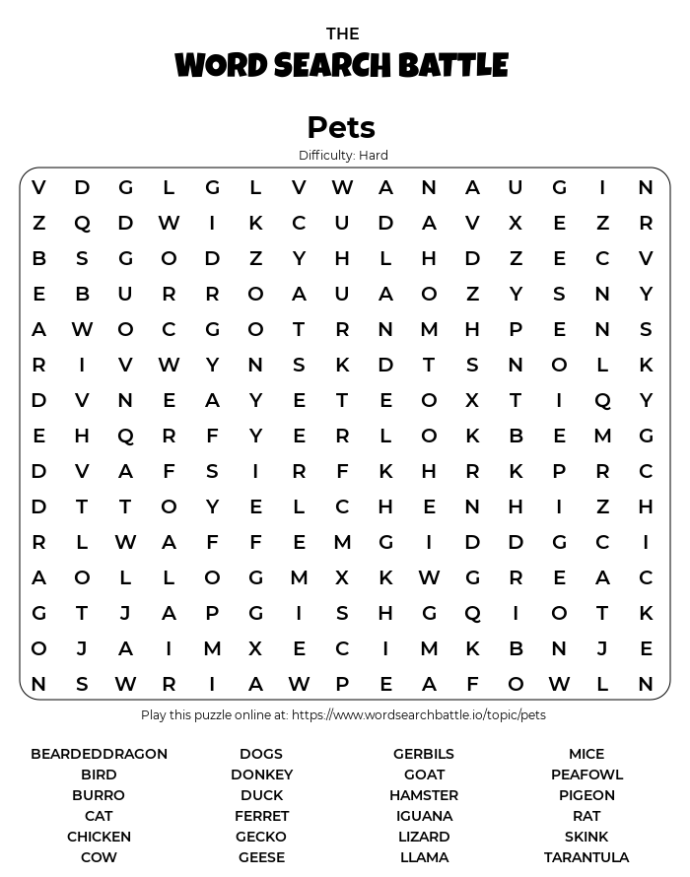

Well done! Now you are ready to become a natural disasters expert!

part B

You will work as an expert in one of the areas as you will be part of a team of your classmates. Let's call it the **BASE CAMP** team. Your base camp team is the same as in part A of this project.

1. In your base camp team, agree on the roles: **English expert, Design & Art expert**, **Geography expert and / or History expert.** Your task is to inform other people about natural disasters. Step by step, you will create a **learning poster about one of the biggest natural disasters in history**. Choose one natural disaster based on the pictures you can see on the walls of your classroom. Prepare 5 arguments / reasons why you choose this natural disaster.
2. Once you choose a natural disaster, you are going to **meet your expert colleagues from other groups** in the **EXPERT CAMP** teams. Don't forget that other teams are not your enemies, cooperation is needed and helpful! Discuss your role and brainstorm as many ideas as you can as English, Design & Art expert, Geography and / or History experts. Answer these questions: What do you know about these natural disasters? What will you write on the poster? What will the poster look like? How to make the poster look attractive and easy to understand? What is the most important information when talking about natural disasters? Use books and tablets. You have 30 min to do the brainstorming.
3. Go **back to your BASE CAMP** group. Share new information and ideas for your natural disaster poster.
4. Go on the internet and find information about great European/world natural disasters. Choose one specific disaster (for example [2023 Turkey – Syria earthquake](https://en.wikipedia.org/wiki/2023_Turkey%E2%80%93Syria_earthquake)) and **create a learning poster** about it. Use **ideas from EXPERT CAMP groups meeting**. Use **past simple tense**, minimum 150 words.

a) Your poster should be about:

* *natural disaster description - when, where, what*
* *killed or injured people*
* *the way people cope with the situation (cope with - zvládnout)*
* *how to know the natural disaster is coming*

b) Draw some **pictures** of the disaster, or look them up on the internet, download them and send them to your teacher by e-mail to be printed. Glue them to your poster.

c) Invent **5 questions** about your disaster, you will ask your classmates after your presentation. Write them down on the back of your poster.

d) **Present the poster** to your classmates and your teacher. Don´t read the text, memorize it or tell it in your own words. Each team member should present one part of the text.