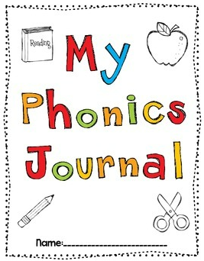

Lesson 1: Phonemic chart
What I remember from the 1st semester:

What is easy (surprisingly ):

What I must go through again:

Overall feelings after the 1st lesson:

2:

