Specific Learning Disabilities

short line

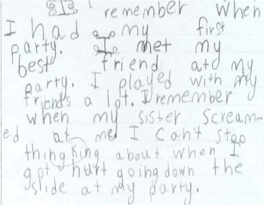1.

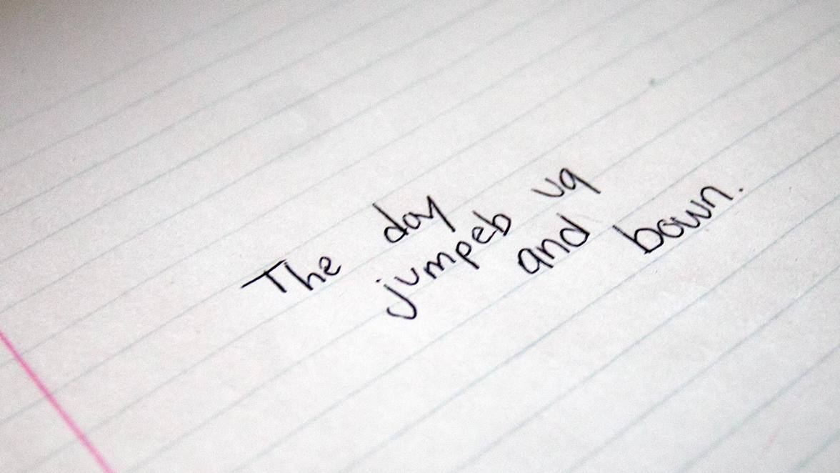

### 2. “The day jumped up and down.”

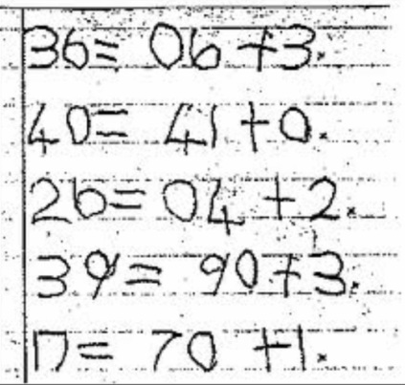

# 3.

# Specific Learning Disabilities Definition

Fill in the missing words for the following definition.

|  |  |  |
| --- | --- | --- |
| **language** | **dyslexia** | **impairment** |
| **behavioral** | **learning** | **reading** |
| **abilities** | **cognitive** | **intelligence** |

For some students, the barrier to effective learning is a part of their developmental makeup. These students, although almost always of average or above average **__________**(IQ), have a specific condition that has a large impact on their **_________**. These students have a specific learning disability.

The learning difficulties associated with a Specific Learning Disability are not the result of intellectual disability, physical or sensory [deficits](https://en.oxforddictionaries.com/definition/deficit) (e.g., hearing impairment), emotional or **___________** difficulties, or poor educational opportunities. A specific learning disability results from an **____________** in one or more of the **_________** processes related to learning, such as **____________** processing from **_________** or spoken language or math processing **___________**. Students with a specific learning disability have difficulty in one academic area while coping well or even excelling in other areas.

All specific learning disabilities are severe, persistent, occur despite a good level of educational opportunities, and the students do well in other academic areas. The most common specific learning disability is **___________**, which is a persistent difficulty in the area of reading and spelling.

*Adapted from: https://dsf.net.au/what-are-learning-disabilities/*

# Typical Learning Difficulties

What are the learning difficulties for each specific learning disability?

|  |
| --- |
| **Dyslexia**: |

|  |
| --- |
| **Dysgraphia**: |

|  |
| --- |
| **Dyscalculia**: |

|  |
| --- |
| **Dyspraxia**: |

|  |
| --- |
| **Dysorthographia:** |

2.

**Making a suggestion**

You will be given a role-play card with a description of a difficult situation. Brainstorm solutions, evaluate possibilities, agree on a solution and formulate a suggestion.

Useful language

**How to respond to ideas:**

That´s a good idea.

I´m not happy about that at all.

That might work.

I think that´s a great idea.

I am not sure about that.

**Showing you are listening:**

I see.

Right.

**Making suggestions:**

Why don´t we (do)…?

Maybe we should (do)…

We could (do)…

How / What about (doing)…?

Shall we (do) …

We must …

I suggest we (should do) …

**Accepting suggestions:**

Yes, I think we should…

Fine.

OK. Let´s (do)…

That´s a great idea.

That might be possible

**Rejecting suggestions:**

I´m not sure about that.

I don´t think that will work.

**Expressing sympathy:**

I completely understand.

That can’t be easy for you.

That must be really difficult.

(Adapted from Business Result Pre-Intermediate and Intermediate, Oxford Press,