Phonetics and phonology, phonemes, allophones, sound combinations, metrical phonology

Linguistics studies primarily the spoken word. To make the research easier linguists use a specially devised system of notation. In the system one symbol represents one sound. Perhaps the best known of these systems is IPA (the International Phonetic Alphabet). Many of IPA symbols are borrowed from the conventional Latin alphabet. In some cases the symbols are variations of alphabet letters, in some cases they are old letters not used in writing nowadays, some are brand new. Knowledge of phonetics seems to be basic for linguistic knowledge itself. It is a prerequisite for linguistics.

Linguists want to be accurate in transcription of sounds. Therefore they divide the utterance into smaller and smaller units. The smallest segment of sound, which can distinguish two words, is a phoneme. E.g. sat and sad. Pairs of words such as lock and log, which differ by only one phoneme, are called minimal pairs. Minimal pairs offer one way to identify the phonemes of any language. The number of phonemes in the language is relatively small. It varies from language to language. The average number is around thirty-five. English has forty-four.

British English is a widely spoken variety of English. The standard pronunciation in British English is known as RP (Received Pronunciation). There are forty-four phonemes used in RP, consonants and vowels. The number of vowels can be divided into pure or unchanging vowels, as in let, cat, and diphthongs (gliding vowels) as in lay, boat.

The phonemes have also their variant forms called allophones. The number of variations differs from phoneme to phoneme. As for variations we distinguish so called free variations (The case when the variation is random. No two sounds can be exactly the same even if the speaker tries hard.) The second group of phonemes appear in complementary distribution. It means that the way a sound is pronounced is conditioned by the sounds surrounding it. It also can be conditioned by its position in the word. E.g. pit is pronounced with clear explosive [p]. But in spit it is aspirated. So the clear variant and the aspirated variant of [p] are both allophones of the phoneme [p].

All languages have certain permitted traditional sequence of sounds and other sequences that are not allowed. Spanish for example does not permit a word to begin with [s] cluster. That is why Spanish is translated as Espaňol with [es] at the beginning. In English consonant clusters with three consonants at the beginning of words obey three strict rules:
- The first phoneme must be [s].
- The second phoneme must be [p], [t] or [k].
- The third phoneme must be [l], [r], [w] or [j].

Many phonemes share common features. They are mostly easily distinguishable. That is why we can identify a group of voiced and voiceless consonants. Labials, nasals … . Any feature that distinguishes one phoneme from another is called a distinctive feature. A group of sounds which share important features in common (labials, nasals …) is known as natural class of sounds.

English phonemes are segmental phonemes as they are segments of sounds. Other languages can perform non-segmental phonemes. E.g. North Mandarin Chinese distinguishes numerous words by differences in the rise and fall of tone.

English possesses non-segmental features, too. Each word and group of words has its own rhythm. A relatively new branch of phonology studies the rhythm as interplay of stressed and unstressed syllables. It is metrical phonology. Metrical phonology uses tree diagrams to demonstrate an internal structure of rhythm. It shows how strong and weak syllables alternate.

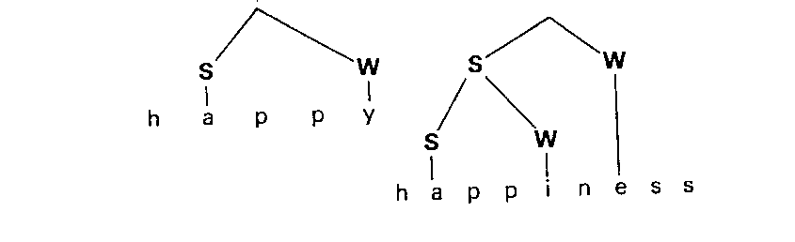

S = strong
W = weak

Recent phonology pays attention also to the interaction between sound segments and rhythm.

