The scope of linguistics

The system of all languages is surprisingly similar in their basic structure. Abstract thought and language are closely connected, which distinguishes human beings from animals. An inability to use language adequately can affect our status in society. This proves how important language is and that it deserves our attention and studying. Therefore linguistics seems to be one of the fastest-expanding branches of knowledge. It tries to answer the basic questions: “What is language” and “How does language work?” It wants to discover all aspects of language, its structure and the smallest elements, its spoken and written form, how language is used in different situations etc.

A linguist is a scientist studying the language generally while polyglot is a person who can speak several languages. A linguist does not need to be fluent in languages because language in his eyes is a material for studying not for actual using

Linguistics itself is descriptive, not prescriptive. It does not prescribe the rules, which have to be used. It only describes the situation in the language, it describes language in all aspects.. The prescribing attempts were hardly ever successful in history. Languages are vivid systems. All users of language contribute to its existence, changes, riches and it is a permanent process. Languages are constantly changing. That is why linguists can only be observers and recorders, not judges. First of all they pay attention to spoken language as primary. Old scholars used written pieces as a material to study forgetting that human beings started to speak first and all writing systems came into existence later. The importance of written word was over-stressed by old grammarians in the past, because of its permanence. This attitude began as far back as the 2nd century B.C. in Egypt where grammarians used 5th century Greece as their models. The belief in the superiority of the written word can be traced for over two millennia.
The spoken word proceeded the written everywhere in the world in all languages. Moreover, most writing systems reflect the vocal sounds. Spoken utterances show many common features with written sentences, though we may also see considerable differences. In spite of the fact that the written language and spoken language are overlapping systems, they must be studied separately: the spoken first, then the written.

Many traditional textbooks in the past assumed that Latin offers a universal framework into which all languages fit. This opinion was causing much harm in language teaching for centuries. Latin was used as an ideal example of the system, having a very logical grammar. Foreign language teaching then meant using the Latin system without any regard to the existence of other individual systems. To linguists, it is unthinkable to judge one language by the standards of another. Though we are trying to set up a universal framework, there is no reason why this should be the grammar of Latin.

Linguistics covers a wide range of topics and its boundaries are difficult to be traced. In the centre as a linguistic core there is phonetics. It is the study of human speech sounds. Phoneticians study how sounds are produced. They are interested in the position of the tongue, teeth and vocal cords during the production of sounds. They record and analyse sound waves. Linguists, on the other hand are more interested in the way the language is patterned. They analyse the form of these patterns more than the physical substance.

Phonetics is surrounded by phonology (sound patterning). It studies the function of the sounds.

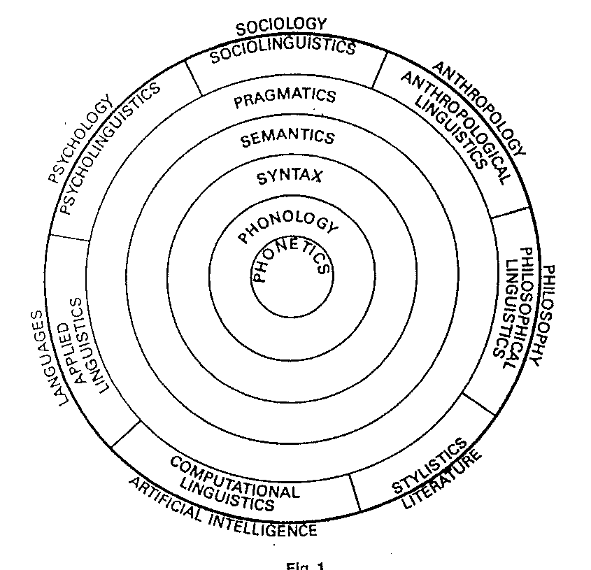

Phonology is surrounded by syntax. Syntax is interested in arrangement and the form of words. Semantics studying the meaning is placed outside syntax. Phonology, syntax and semantics constitute the grammar of a language.
Around the central grammatical core comes pragmatics. It deals with how speakers use language in ways, which cannot be predicted from linguistic knowledge alone. It is interested in how language is used in different situations.
Then there are brand new branches of linguistics connecting language with the external world:
Psycholinguistics studies the language and mind. Sociolinguistics studies the language and society. Applied linguistics talks about the application of linguistics to language teaching. Computational linguistics studies the ways in which computers can simulate languages and their working. Stylistics is a study of language and literature. Anthropolinguistics (ethnolinguistics) studies language in cross-cultural settings. Philosophical linguistics provides the link between language and logical thought.

It is difficult to find the boundaries between the branches mentioned above as these various branches overlap to some extent.

Still there is an important branch that has been omitted. It is historical linguistics. It is the study of language change. It studies languages in the course of time covering their history. This approach is called diachronic. We may talk about diachronic linguistics.
When linguists study languages at a single point of time, we talk about synchronic linguistics.

Also linguistic typology as a science has been omitted. It deals with different language types.

Example of a task:

Stylistics is a study of

- language and society
- language and literature
- language and behaviour.

