Development of Experimental
Skills in Physics Education



J.Trna & E.Trnova
Masaryk University Brno
Czech Republic

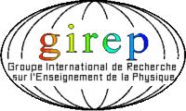
GIREP 2008
INTERNATIONAL CONFERENCE
Physics Curriculum Design,
Development and Validation

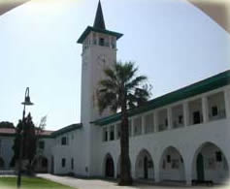
University
of Cyprus
18 - 22
August, 2008

1. Physics Skills

- Sensual part (reacting to optic, acoustic and tactile stimuli and information)
- Intellectual part (planning psychomotor skill realisation; making decision of task solution approach inciting to psychomotor activity; choosing the optimal problem solution which includes kinetic activity; etc.)
- Kinetic part (direction and extent of movement, speed and duration of movement, intensity of movement)

2. Classification of Skills

- Experiment designing and planning.
- Experimental apparatus designing.
- Experimental apparatus formation and examination.
- Development of an experimental procedure.
- Data collection and presentation in appropriate format (observation, reading instruments and presentation of results with appropriate accuracy, replication of observations and significant figures).
- Analysis of experimental results.

3. Development of Skills

- Motivation stage:
Acquisition of interest and attitudes towards experimenting.

- Orientation stage:
Acquiring knowledge necessary for the skill; creation of experimental habits.

- Crystallization stage:
Solving of simple applied tasks of simple experimenting.

- Completing stage:
Solving of complicated applied tasks of experimenting.

- Integration stage:
Solving of a problem situation, problem tasks and projects containing experiments.

4. Methodology - Worksheets for students

(A) Simple reproductive task (crystallization stage):
Student progressed exactly according to the instructions and there was no need to use his creative thinking.

(B) More creative task (completing stage):
Student should use his creative thinking not only according to the detailed description; should modify the procedure of measuring; adapt the metres, apparatus etc.

(C) Complex problem task or project (integration stage):
The skill had to be creatively integrated into a structure of other skills and used as a complex skill: suggest the appropriate method of measuring, make or design a suitable measuring apparatus, interpret the obtained data and devise its processing.

5. Students at the age of 8 – 11

(A) Tasks (crystallization stage):
Students solve tasks on the basis of written and verbal instructions. They measure the human body temperature and air temperature in the classroom.

(B) Tasks (completing stage):
Students compare temperatures by measuring temperatures inside the school, outside the school building (at different points of the compass) and at different levels above and below ground in the school garden.

(C) Tasks (integration stage):
A project on temperature measuring was oriented to finding the relationship between air temperature and the behaviour of animals (reproduction) or plants (generation of fruits).

6. Students at the age of 12 – 15

(A) Tasks (crystallization stage):
Students solve tasks on the basis of written or verbal instructions (laboratory directions). The crystallization stage should include repeated temperature measurement based on time (air temperature measuring during the day); formation and evaluation of graphic dependence.

(B) Tasks (completing stage):
Many experimental tasks involving temperature from a range of natural substances and phenomena. We included tasks in the form of the following laboratory experiments: water melting and boiling temperature curve.

(C) Tasks (integration stage):
A creative project task (e.g. project Globe).

7. Students at the age of 16 – 19

(A) Tasks (crystallization stage):
Students solve tasks on the basis of written laboratory directions. They measure temperature on the screen of the school weather station.

(B) Tasks (completing stage):
Students, after achieving the crystallization stage, can manage complicated problem solving by means of their acquired skills, as well as their conceptual knowledge: more complicated temperature measuring tasks, e.g. thermometers calibration.

(C) Tasks (integration stage):
A project with an interdisciplinary character with the solving of interdisciplinary problems. The temperature measuring skill can be integrated, for example, into environmental problem solving (global warming, etc.).

8. Results

Age of students | (A) Crystallization stage  (%) | (B) Completing stage  (%) | (C) Integration stage  (%)
8 – 11 | 84 | 10 | 0
12 – 15 | 91 | 43 | 12
16 – 19 | 97 | 66 | 19

Table 1: Percentage of students, in the 3 age groups, successfully
completing tasks related to the 3 levels of acquiring of
experimental skills.

9. Conclusions

Students in the age of 8 – 11:
Students at this age were capable of visual operation with concrete things. Therefore it is possible, at best, to reach to the third development (crystallisation) stage of a new skill). The first stage (motivation) was found to be the critical role. The second stage (instructional) could not be too time-consuming, or the content too difficult. It was important for the teacher to specify student activities using simple instructions and, on the top of that, ensure students understood the instructions. Undertaking applications of simple teaching aids, well-known from daily life, was shown to be appropriate.

Students in the age of 12 – 15:
At this student can be involved in abstract thinking. We can reach, in part, even to the fourth development stage (completing) stage. The first stage (motivation) plays still an important role as both an initial and continuing motivator. The second stage (instructional) can be more time-consuming as well as encompassing more difficult content and abstract concepts can be acquired and structured. Acquisition of skills usually proceeds more quickly. Students’ manual handling skills are at a high level. The core of skills acquired is at the third stage (crystallization). Undertaking laboratory work helps to strengthen the skills and here it is appropriate to use laboratory measuring apparatus and other equipment.

Students in the age of 16 – 19:
Student at the upper secondary school achieves a high level of personal development. Thus the fourth completing stage involving problem tasks solving tasks can be mostly realised. The tasks can be in the form of project with strong interdisciplinary character. It is important not to forget repetition and completion of all previous stages within the undertaking of the project. If the earlier stages are underrated, or not given enough attention in the lower school, the skills are not acquired. Especially, the motivation stage must not be forgotten.

The contribution was developed in the frame of the project SOCRATES, European Teachers Professional Development for Science Teaching in a Web-based Environment (EuSTD-web), 129455-CP-1-2006-1-PT.

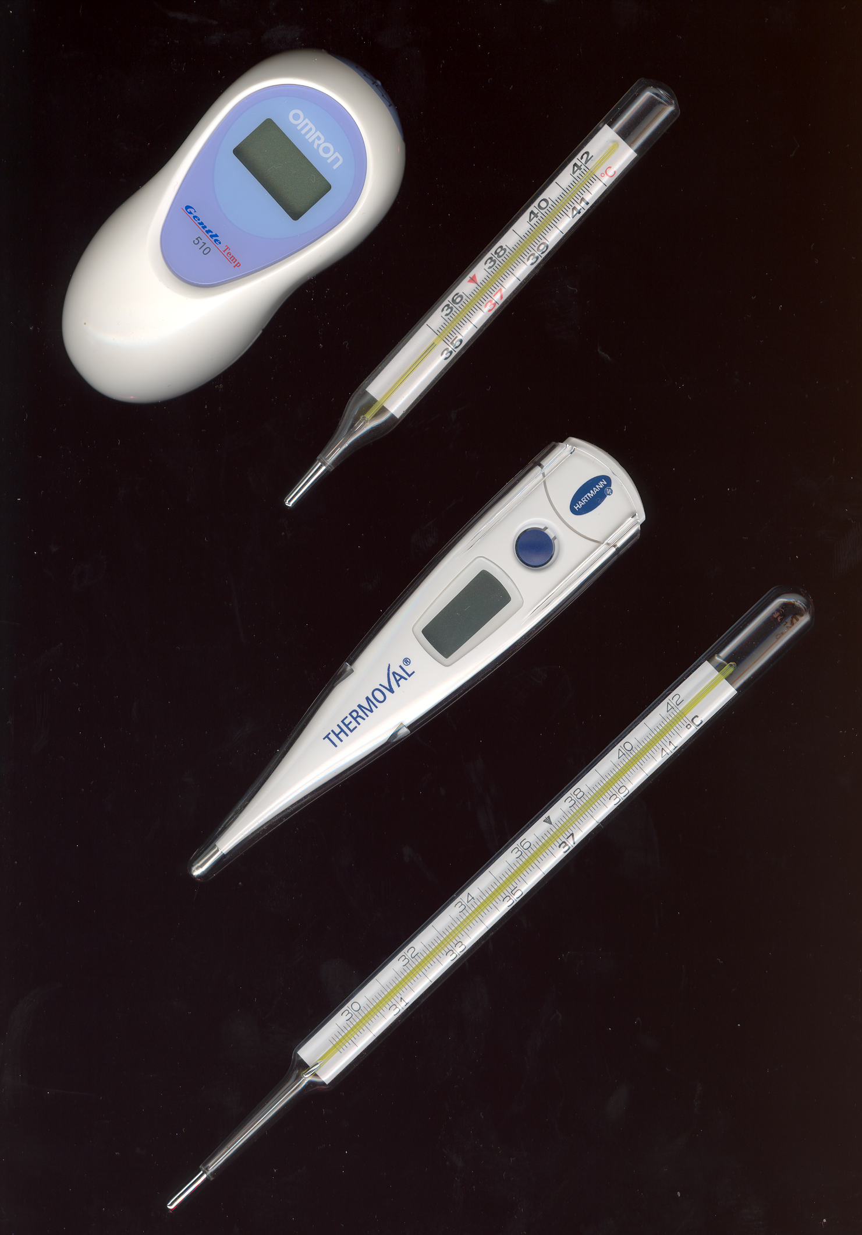

Authors:

Josef Trna & Eva Trnova
Department of Physics
Faculty of Education
Masaryk University
Porici 7
603 00 Brno
Czech Republic
Email: trna@ped.muni.cz

