1 Paperchromatografie of chlorophyl

Material:
- Some leaves
- Mortar met pestle
- (Clean silversand)
- aceton?
- petroleumether 40-60°C?
- liquid (petroleumether 40-60°C - aceton 9:1)
- chromatograficpaper
- capillair
- pencil
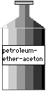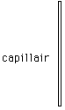
- Do everything in a fire free room .
- Put the leave partikels in the mortar.
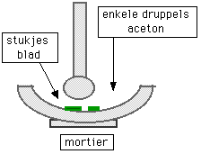

- Add a little silversand and polish them.
- Add a little aceton.
- Polish again until a green liquid arises. (extract).
- Take a slip of chromatografiepaper.
- Just touch the edges. (not the whole paper with your fingers)
- Draw a line down below at 2 cm of the edge with a pencil (= startline)
- Put the filtreerpapier on a clean background and draw with the capillair a line of chlorophyll on the start line

2
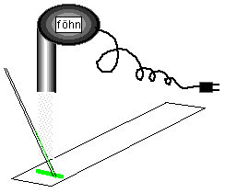
- Dry the spot with a föhn. Repeat this 10 to 20 times.
- Try to keep the spot as small as possible.
- Pour the liquid (acetone/ petroleum) into a cilinder glas. Not more than 1.5 cm high.
- Hang the paper on the cork with the bottom in the liquid
- De chlorophyll spot must be above the liquid and the edges of the paper must not touch the side of the glass.
- When the liquid is almost above (after 25 minutes), remove the chrmomatogramme
- Mark with the pencil the front and the place of the coloured spots.
The distance (rF-value) is calculated for every spot by dividing the distance (A) by the distance between start and front(B).De rF- value is by a certain T and a certain liquid characteristic for a matter. The rF- values of the chlorophyll can be looked up.
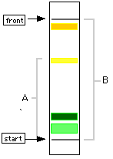
What is Rf value?: It is the distance travelled by the sample or analyte divided by distance travelled by the solvent front in chromatography. For example, if a compound travels 2.1 cm and the solvent front travels 2.8 cm, the R_{f} is 0.75 The R_{f} for a compound is a constant from one experiment to the next only if the chromatography conditions below are also constant:
- solvent system
- adsorbent
- thickness of the adsorbent
- amount of material spotted
- temperature

