Solar-cel

Nanocristaline
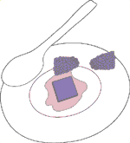
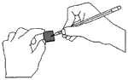
Step 1 - Stain the Titanium Dioxide with the Natural Dye: Stain the white side of a glass plate which has been coated with titanium dioxide (TiO). This glass has been previously coated with a transparent conductive layer (SnO), as well as a porous TiO film. Crush fresh (or frozen) blackberries, raspberries, pomegranate seeds, or red Hibiscus tea in a tablespoon of water. Soak the film for 5 minutes in this liquid to stain the film to a deep red-purple color. If both sides of the film are not uniformly stained, then put it back in the juice for 5 more minutes. Wash the film in ethanol and gently blot it dry with a tissue.
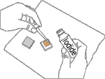
Step 2 - Coat the Counter Electrode: The solar cell needs both a positive and a negative plate to function. The positive electrode is called the counter electrode and is created from a "conductive" SnO coated glass plate. A Volt - Ohm meter can be used to check which side of the glass is conductive. When scratched with a finger nail, it is the rough side. The "non-conductive" side is marked with a "+." Use a pencil lead to apply a thin graphite (catalytic carbon) layer to the conductive side of plate's surface.
Steps 3 & 4 - Add the Electrolyte and Assemble the Finished Solar Cell: The Iodide solution serves as the electrolyte in the solar cell to complete the circuit and regenerate the dye. Place the stained plate on the table so that the film side is up and place one or two drops of the iodide/iodine electrolyte solution on the stained portion of the film. Then place the counter electrode on top of the stained film so that the conductive side of the counter electrode is on top of the film. Offset the glass plates so that the edges of each plate are exposed. These will serve as the contact points for the negative and positive electrodes so that you can extract electricity and test your cell.
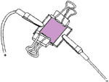 | Use the two clips to hold the two electrodes together at the corner of the plates.  The output is approximately 0.43 V and 1 mA/cm² when the cell is illuminated in full sun through the TiO side.

