Ways of communication

1. Talk to your partner about the following:
1. Think about your greeting habits. What do you usually do: 1) when you meet somebody for the first time, 2) when you meet your good friends, 3) when you meet somebody with a higher social status for the first time/ for an informal dinner, 4) when you meet somebody you admire, 5) when you meet your brother or sister’s friends
shake hands kiss him/her on the cheek hug him/her to say hello or good-bye
ask questions about his/her family ask what his/her job/field of study/field of interest is
give him/her your email address buy him/her a drink touch him/her on the arm
ask how much he/she earns stand close to him/her look at him/her directly
bow to him/her smile and laugh a lot put your hands in your pockets
use his/her first name
2. For the items that you never do, can you think of a country where someone would act this way?
3. Are the first impressions important to you?
4. What do you notice if you meet somebody for the first time? Is there something that can discourage you from further contact with that person?

Non-verbal communication

VIDEO 1:Why is the non-verbal communication important?

http://www.youtube.com/watch?v=VfDWQG47pAQ
Watch the introductory video and fill in the missing words:
……… per cent of all ………… communication is non-verbal – body language.
……… per cent is your ……….
So that means that ……… per cent of what’re saying ain’t ever come of your ……….
It’s just a ……… and ……… and ………!
It’s a ……… to tell ……… and others who you are and what you are ……… of a way to get what you ……….

Exercise

Fill in the words in blank spaces. There is one extra word in the list.
which powerful of also someone gesture our how much
communicate is well body to that

Humans use language to communicate, but we 1………….. communicate nonverbally with our bodies. The way in 2. ………… we stand or sit, how we use 3.………….. eyes, what we do with our hands, as 4. ………. as what we wear – all of these convey 5.………. messages to other people. In fact, anthropologists claim 6. …………. only a small percentage of what we 7………….. is verbal, however most of it is nonverbal.
Some 8…………. our body language is conscious, such as the “thumbs up” a 9…………. used in many cultures to signal “OK”. But 10 ………….. of what we communicate with our bodies 11 …………. unconsious. Even in one’s own culture, unconscious 12…………… language can be difficult to read. Imagine, then, 13 ……….. much more incomprehensible the body language of 14 …………. from a different culture would be!

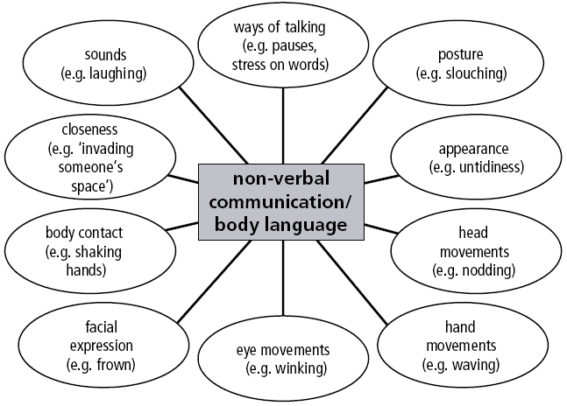

VIDEO 2: That’s what a busy professional needs
http://www.youtube.com/watch?v=356cdVuNZQI&feature=related
Watch the video and answer the following questions:
1. Who is body language important to?

2. What were Carol’s previous jobs? How were they connected to the field of non-verbal communication?

3. What gesture do all the people round the world use? When can you benefit from it?

4. Is body language something new to us that we have to learn?

5. How can a conscious body language help you in your work place?

6. What are the main merits (přednosti, klady) of the book?

Honesty in communication

Read the first part of the article informing about “Lies, Lying, Liars.” For statements 1-5 decide if they are true or false.

“Lies, Lying, Liars”

Can you imagine a whole day without telling lies? “Yes, of course”, most people would answer, but then they’ve probably forgotten all those little lies that are said so easily –
“This is delicious.” “You look lovely in that shirt.” “I’d love to come with you.” etc.
Lying is a way of making life run more smoothly.
We are told not to lie from the moment we learn how to do it. According to psychologist Richard Wiseman, this is at the age of about four when children realise they can deceive people. We are not born liars!
In childhood, the line between imagination and lying is often not clear. Children are praised for creative imagination but generally criticised for hiding the truth.
As adults we have definite ideas about which kinds of lies are OK and which are not. Very often the reason for the lie is the important thing in accepting or rejecting the lie.
Generally speaking there are three types of lies, and liars. The first sort of liar wants to please people, the second wants to protect him or herself, the third sort doesn’t care about other people and lies to get what he or she wants.

1 Adults have their own rules about what is acceptable. _____
2 Lying can be put into different categories. _____
3 Children can easily distinguish between imagination and lying. _____
4 Lying is a skill that we acquire during life. _____
5 Most people lie regularly because it gives them pleasure. _____
6 As soon as it’s learnt, lying is forbidden. _____

Read the second part of the article and match headings to the paragraphs 1-5.

1._______________
If someone is fishing for compliments and you tell them what they want to hear, you probably think it’s a “kind” lie. However, you get something as a result of this lie – affection, friendship, peace and quiet.

2. _______________
When you lie for self-protection, the reason is clearer. To explain your lateness, you tell your boss the train was delayed, not that you overslept. You cannot be blamed for being late, because you are not responsible for the “behaviour” of the train and the consequences.

3. _______________
The third sort of lie could be more dangerous. It is, for example, the kind that people tell in order to climb up the ladder at work, without caring who gets hurt in the process.

4._______________
But what about being lied to? Can you spot when someone is telling you a lie? Apparently there are some verbal clues – lots of ‘ums…’ and ‘ahs…’ – and it takes much longer to liars to answer a simple question. They also speak faster but don’t always give the right amount of detail.

5._______________
And then there’s body language. Experts say there are certain things that can help identify someone who’s not telling the truth. Speaking through their fingers and putting the hands over the face is one. Playing with their hair or clothes and being unable to stay still for any length of time is another.

But the truth of the matter is that we all lie at some time, and if anyone tells you they don’t -they’re lying.

A The worst kind?
B Both sides benefit
C How to hear lies
D Visual signs
E Not your responsibility
F Who can you believe?

White lies

Discussion:
1. How can you tell if someone is lying?
2. Is lying always a bad thing to do?
3. Who do we lie most often to?
4. What do we most often lie about?

Reading: Do you agree with the individual paragraphs?

Although we are all very good at telling lies we are not so good at spotting them. Unless someone is a “professional” liar there are a number of things that people tend to do when they lie: they tend to avoid eye- contact; their voice has a higher pitch and it sounds unnatural; they tend to touch their nose, ears or neck; scratch parts of their body, and shift in their seats.
Interestingly, we tend to lie more to attractive people rather than unattractive people.
Most lies are not intended to be deceptive. Generally we lie unconsciously, either to be tactful or to protect ourselves or the others by editing out details.
Lying is not always a bad thing; married couples who religiously tell each other everything are more likely to get divorced than those who have a few secrets.
In any case, imagine what life would be like if we always told the truth!

