

Physical Impairment

In-class material

- Read the article about cerebral palsy and fill in the missing words:
abnormality affect affected brain decreased diplegia
hemiplegia increased intellectual disabilities legs quadriplegia tone
mild cerebral palsy severe cerebral palsy slow symptoms tongue types writing 5 -10 percent 10-20 percent 70 - 80 percent
Cerebral Palsy
Cerebral palsy is a group of disorders that ______________ a person's ability to move and to maintain balance. It is due to a non-progressive brain ______________. People with cerebral palsy have damage to the part of the ______________ that controls muscle tone. It is what lets you keep your body in a certain posture or position. For example, it lets you sit up straight and keep your head up. Changes in muscle tone let you move. For example, to bring your hand to your face, the tone in your biceps muscle at the front of your arm must increase while the tone in the triceps muscle at the back of your arm must decrease. The ______________ in different muscle groups must be balanced for you to move smoothly.
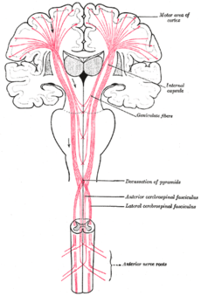
There are four main ______________ of cerebral palsy - spastic, athetoid, ataxic, and mixed.
- Spastic: People with spastic cerebral palsy have ______________ muscle tone. Their muscles are stiff. Their movements can be awkward. About ______________ of people with cerebral palsy have spasticity. Spastic cerebral palsy is usually described further by what parts of the body are ______________. In spastic ______________, the main effect is found in both legs. In spastic ______________, one side of the person's body is affected. Spastic ______________ affects a person's whole body (face, trunk, legs, and arms).
- Athetoid or dyskinetic: People with athetoid cerebral palsy have ______________ movements that they cannot control. The movements usually affect person’s hands, arms, feet, and ______________. Sometimes the face and ______________ are affected and the person has a hard time talking. Muscle tone can change from day to day and can vary even during a single day. About ______________ of people with cerebral palsy have the athetoid form.
- Ataxic: People with ataxic cerebral palsy have problems mainly with balance. They might be unsteady when they walk. They might have a hard time with quick movements or movements that need a lot of control, like ______________. They might have a hard time controlling their hands or arms when they reach for something. People with ataxic cerebral palsy can have increased or ______________ muscle tone. Only about ______________ of people with cerebral palsy have ataxia.
- Mixed: Some people have more than one type of cerebral palsy. The most common pattern is spasticity plus athetoid movements.
The ______________ of cerebral palsy vary from person to person. They can also change over time. A person with ______________ might not be able to walk and might need lifelong care. A person with ______________, on the other hand, might walk a little awkwardly, but might not need any special help.
People with cerebral palsy can have other disabilities as well. Examples of these conditions include seizure disorders, vision impairment, hearing loss, and ______________.
(adapted from http://www.cdc.gov/ncbddd/dd/cp2.htm)

2. Now read a short article about poliomyelitis and get ready to answer the questions below the article.
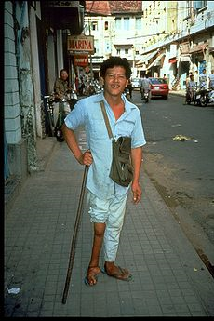
Poliomyelitis

Poliomyelitis (polio) is a highly infectious disease caused by a virus that invades the nervous system.

Up to 95% of persons infected with polio will have no symptoms. About 4 - 8 percent of infected persons have minor symptoms such as fever, fatigue, nausea, headache, flu-like symptoms, stiffness in the neck and back, and pain in the limbs which often resolves completely. Fewer than one percent of polio cases result in permanent paralysis of the limbs (usually the legs). Of those paralyzed, 5-10% die when the paralysis strikes the respiratory muscles. The virus is transmitted by the contact with an infected person.

There are two types of vaccine that can prevent polio: inactivated polio vaccine (IPV) and oral polio vaccine (OPV). IPV has been used in the United States since 2000; however OPV is still used throughout much of the world.

(adapted from http://www.cdc.gov/vaccines/vpd-vac/polio/in-short-both.htm)

Questions:

- What is the difference between cerebral palsy and polio? Why are they often confused?

- What are the main types of cerebral palsy? What are the major differences between them?

- What are the typical symptoms of polio?

- How can a severe cerebral palsy or polio affect your life?

