

Hearing Impairment 1

Home preparation

Video
(http://www.youtube.com/watch?v=Ve24kXu1LTg&NR=1&feature=fvwp)

Watch the video and fill in the table.

Four Extraordinary Lives of Deaf People

Name | Job | Future plans | Problems they experience | What factors influence Tanya’s understanding the spoken language?

What do the three of these four people have in common?

In-class tasks

1. Put the following terms describing the structure of the ear into the correct places in the picture:

a labyrinth an eustachian tube a tympanic membrane / ear drum
an outer ear/an ear lobe a cochlea
auditory ossicles (bones of the middle ear) an auditory nerve

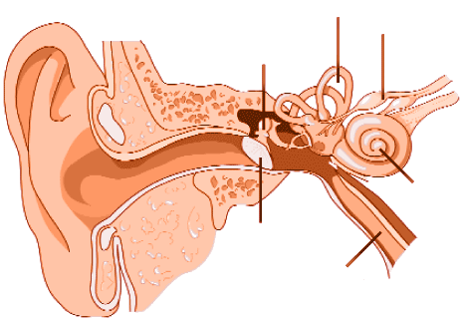

2. Video
(http://www.youtube.com/watch?v=lioNIbtFxSY&feature=related)
Now watch a short video showing how the sound is transformed into the electricrical signal in our ear and what the two basic types of the hearing loss are.
Write down all the new vocabulary connected to the structure of the ear mentioned in the video:

English word | Pronunciation | Czech equivalent

3. Try to find Czech equivalents to the following terms:

hearing impairment -
a hearing impaired person -
to be deaf -
the deaf -
hard of hearing -
hearing loss -
hearing aid -
cochlear implant -
sign language -
CODA’s –
deaf-blind -

4. Video
Watch the video and answer the following questions:
(http://www.youtube.com/watch?v=q45BFozJPWs&feature=related)

a) What percentage of the U.S. population is deaf or hard of hearing?

b) What things cannot be done by the people with hearing impairment ?

c) What are the three most common types of hearing loss?

d) What are the basic causes of a conductive hearing loss?

e) What can people with a conductive hearing loss use to improve their ability to hear?

f) What are the basic characteristics of a sensorineural hearing loss?

g) What is the mixed hearing loss?

h) What other criteria are used to distinguish between the individual hearing impairments?

i) What are the most important things that we should bare in mind when communicating with the hearing impaired?

