What did Adam say on the day before Christmas ?

It’s Christmas, Eve !

What do you call people who are afraid of Santa Claus?

Claustrophobic.

What did Tarzan sing at Christmas time?

Jungle Bells.

What is the cow’s holiday greeting?

Mooooory Christmas!

Why does Father Christmas go down the chimney ?

Because it soots him !

Soot = zašpinit sazemi, suit = vyhovovat

What do you call a letter sent up the chimney on Christmas Eve ?

Black mail !

What do elves learn in school?  
 The Elf-abet!

Elf = skřítek

Where do polar bears vote?  
The North Poll.

Why do birds fly south for the winter ?  
Because it's to far to walk.

What kind of bird can write?  
A PENguin.

What's a good holiday tip?  
A: Never catch snowflakes with your tongue until all the birds have gone south for the winter.

What nationality is Santa Claus?  
North Polish.

What do snowmen eat for breakfast?   
Snowflakes.

If Santa Claus and Mrs. Claus had a child, what would he be called?   
A subordinate claus.

**Why was Santa's little helper feeling depressed?**   
He had low elf-esteem.

**What's white and goes up?**

A confused snowflake.

**How do snowmen get around?**

They ride an icicle.

Who is never hungry at Christmas?  
The turkey - he's always stuffed!

How do you know when there is a snowman in your bed?

How do you know when there is a snowman in your bed?

You wake up wet!

How do snowmen greet each other?  
Ice to meet you!

What do we call five minutes after the gifts are opened!

Christmess.

What kind of tree do fingers grow on?   
A palm tree.

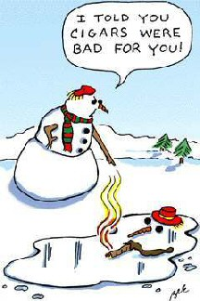

We had grandma for Christmas dinner.   
Really?

We had turkey.

What does Santa call reindeer that don't work?  
Dinner.