Communication, means of communication

Communication is the act of sharing or exchanging information, ideas or feelings. It is a vital part of personal life and is important in any other situation where people encounter each other.


How can these people communicate?



face to face – with words or non-verbally

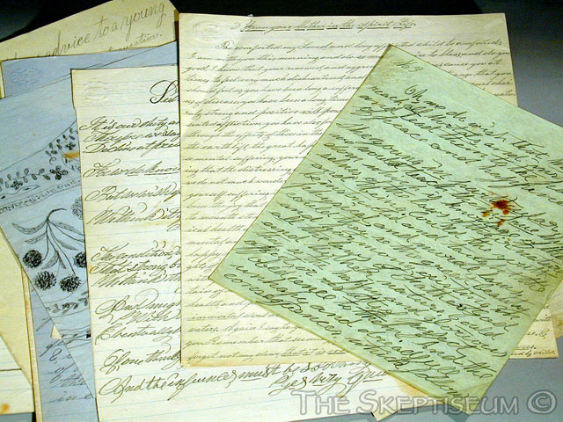
writing (books, letters, photographs, etc. – an early version of movable type of communication)

 by different types of electronic communication

- telephone, radio and television – all of them are modern types of communication. There is no doubt that they have been most important communication technologies in history.
- computers and information technologies: letters, memos, reports and other documents can be transmitted almost anywhere at the speed of light

Which of these types of communication do you use very often?

Use of the Internet



The Internet is the foundation of computer networks. It is interconnected by both wires and by waves forwarded directly and through satellites. Computer networks can carry all kinds of digital information, including video images, sounds, graphics, animations and text. Computers are used in business, education and free time.

Vocabulary

On the internet
Web address = internet address
Broadband – with a broadband connection you can get information from the internet very fast
Fast (also quick) opposite slow
Online = on the internet
Chatroom – a place on the internet where people read and reply to messages, usually about a subject (e.g. cars, music)
Download – if you download information from the internet, you copy it to your computer (the information is called data)
MP3 player – a small machine you can listen to music on, e.g.an iPod

Practice

A Is the meaning the same or different? Write S or D. Read the example first.

➢ | Online | On the internet | S
1 | web adress | email adress
2 | visit a website | go to a website
3 | a search engine | a website
4 | fast | quick
5 | MP3 player | CD player
6 | download songs | copy songs from the internet
7 | go online | use the internet
8 | visit a chatroom | chat online
9 | broadband | download
10 | data | computer information

B Complete this extract from a guide to using the internet with the following:

chat room, download, newsgroup, online, sites, web page

The World Wide Web is made up of millions of 1 …………… created by anybody from multimedia corporations to ordinary people like you and me. On the web you can read 2 …………… newspapers and magazines; you can watch videos,
3 …………… music or buy anything from a CD to a holiday. You can go into a 4 …………… and talk to other people all over the world or join a 5 …………… for more serious debate. If you are really ambitious you might even like to try creating your own 6 …………… . Then you can show your holiday pictures to the whole world!

Making contact by phones

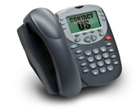
Phone numbers | What’s your phone number? It’s 245731.  What’s your mobile number? It’s 077000 900 796.  What’s the (area) code for Liverpool? It’s 0151.
Phone verbs | You call or ring someone. = phone someone  You text someone. = send someone a text (message), e.g. CUL8R = see you later  You take a message. = take information during a phone call and give it  to someone else  You leave a message. = give information to someone on the phone who then  gives it to someone else
Phone problems | The line is engaged/busy. = the person you phoned is speaking on the phone  The person is out/isn’t in. = not there  It’s the wrong number. = you make a mistake with the number  The battery is flat on the mobile. = no electricity

Phone conversations
First listen to the two phone calls.
Then work in pairs and practise the conversations. When you finish, change roles.

Laura (L) is phoning Brenda (B). Paul Jackson (PJ) is speaking to a receptionist (R).

B Hallo? R Hello?
L Is that Brenda? PJ Oh, hello, can I speak to Mr. Grant, please?
B Yes, speaking. R I’m sorry, but he’s out at the moment.
L Oh, hello. This is Laura, Laura Freebairn. Who’s calling?
B Hi, Laura, how are you? PJ It’s Paul Jackson.
L I’m fine, thanks. Is Jessica in, please? R Right, and do you want to leave a message?
B Yes, just a moment – I’ll get her for you …. PJ Yes, please. Can you tell him I’ll ring him back this evening? R Of course, no problem.
PJ Thanks very much. Goodbye.

Making a call
What words are missing in the conversations below?
Think the words over and then compare them with those in the recording.

1. Hello. 2. Hello.
☞ Hi. Is …………… Liz?  Hello. Is David …………… , please?
Yes, who’s that? I can hardly hear you. I’m afraid he’s out. Can I …………… ?
☞ …………… Diana. I’m on my mobile…….  No, don’t worry. I’ll …………… later.

3. Could I speak to Judith, please?
☞ I think you must have the …………… number. There’s …………… of that name here.

Phone messages



Listen and complete the phone messages (answering machine messages).
A
This is 641 480. I’m afraid there’s no one to take your call right 1 …………… . Please leave your
2 …………… and 3 …………… after the tone and I’ll call you back.
Ah, yes, hello. Mr Trotter, my 4 …………… is Rachel and I’m 5 …………… in your advertisement. Could you call me back, please? Any time before 6 o’clock. The number is 087044 6091. Ask for Rachel. Bye.

B
Stuart here. I’m not home at the 6 …………… , so please leave a 7 …………… after the beep. Thanks.
Hello, good morning. 8 …………… is Bella Moor, that’s Moor – M – double O – R. I’m 9 ……………
about the Kung Fu classes. You can call me back on my 10 ……………, that’s 0447 395822.
But I’ll try to 11 …………… you again later.

Listen to the messages again and answer the questions.

1 What is Rachel’s phone number? 2 What is a good time to call her? 3 What is Bella’s phone number?
4 What is her family name?

How to write an email in English

Emails are often seen as less formal than printed business letters. In the business world you cannot afford to let your language appear to be informal.

Use this link to find out more
http://www.englishtown.com/community/channels/article.aspx?articlename=184-email

