Part 1

Current problems in schools

“Discipline is psychologically necessary for schools in order to function smoothly.
Learners need discipline for their own sense of well-being. They need to know the limits
and become aware of boundaries.
Parents, educators, the environment and society as a whole have a role to play in ensuring
good discipline among children. They can also contribute to the collapse of discipline.”

Taken and adapted from
http://libserv5.tut.ac.za:7780/pls/eres/wpg_docload.download_file?p_filename=F1018410629/Kumbula%20J%20Chapters.pdf

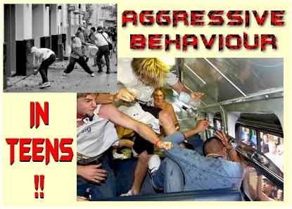

Disruptive and aggressive behaviour has a negative impact on students' well-being and learning outcomes.

One of the most serious problems seems to be bullying.
The word 'bullying' is used to describe many different types of behaviour ranging from teasing or deliberately leaving an individual out of a social gathering or ignoring them, to serious assaults and abuse. Sometimes it is an individual who is doing the bullying and sometimes it is a group. In any case, bullies are cowards. They tend to pick on children who won't stand up for themselves. That's because children don't know how. They need to be taught.
Taken from
http://www.tooter4kids.com/bullying.htm

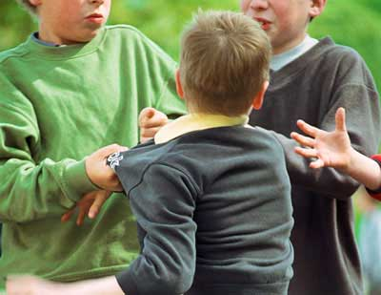

WHAT IS BULLYING?

Read the six questions below and then find the paragraph in A – F which is the suitable answer to each question.
Before you start reading the paragraphs check if you understand the highlighted words.

1. What can you do if you are being bullied?
2. Why are some young people bullied?
3. What is bullying?
4. Why do some people bully?
5. What can you do if you see someone else being bullied?
6. Why is bullying harmful?

A
Bullying is when someone keeps doing or saying things to have power over another person.
Some of the ways they bully other people are by: calling them names, saying or writing nasty things about them, leaving them out of activities, not talking to them, threatening them, making them feel uncomfortable or scared, taking or damaging their things, hitting or kicking them, or making them do things they don't want to do.
Have any of these things happened to you? Have you done any of these things to someone else? Really, bullying is wrong behaviour which makes the person being bullied feel afraid or uncomfortable.
B
There are a lot of reasons why some people bully.
They may see it as a way of being popular, or making themselves look tough and in charge.
Some bullies do it to get attention or things, or to make other people afraid of them. Others might be jealous of the person they are bullying. They may be being bullied themselves.
Some bullies may not even understand how wrong their behaviour is and how it makes the person being bullied feel.

C
Some young people are bullied for no particular reason, but sometimes it's because they are different in some way - perhaps it's the colour of their skin, the way they talk, their size or their name.
Sometimes young people are bullied because they look like they won't stand up for themselves.
D
Some people think bullying is just part of growing up and a way for young people to learn to stick up for themselves. But bullying can make young people feel lonely, unhappy and frightened. It makes them feel unsafe and think there must be something wrong with them. They lose confidence and may not want to go to school any more. It may make them sick.
E
Coping with bullying can be difficult, but remember, you are not the problem, the bully is. You have a right to feel safe and secure.
And if you're different in some way, be proud of it! Stand strong. Spend time with your friends - bullies hardly ever pick on people if they're with others in a group.
You've probably already tried ignoring the bully, telling them to stop and walking away whenever the bullying starts.
If someone is bullying you, you should always tell an adult you can trust. This isn't telling tales. You have a right to be safe and adults can do things to get the bullying stopped.
Even if you think you've solved the problem on your own, tell an adult anyway, in case it happens again.
An adult you can trust might be a teacher, school principal, parent, someone from your family or a friend's parent. If you find it difficult to talk about being bullied, you might find it easier to write down what's been happening to you and give it to an adult you trust.
F
If you see someone else being bullied you should always try to stop it. If you do nothing, you're saying that bullying is okay with you.
It's always best to treat others the way you would like to be treated.
You should show the bully that you think what they're doing is stupid and mean. Help the person being bullied to tell an adult they can trust.

You can have a look at the original article – taken and adapted from
http://www.nobully.org.nz/advicek.htm

'Sticks and stones may break my bones, but names will never hurt me.' Remember that old rhyme? It wasn't true when you were in school, and it isn't true now. Teasing, taunting and other forms of bullying can cause serious emotional harm to children that lasts much longer than the bloody nose or scraped knees. Ignoring or excusing the behaviour, saying things like 'kids will be kids,' only perpetuates the situation.

Taken from
http://parentingteens.about.com/cs/bullying/a/bullyproof.htm

Look at the pictures and discuss them with your partner.
➢ What is happening in each picture?
➢ How would you characterise the children’s behaviour?
➢ Are such situations common in schools?

A B
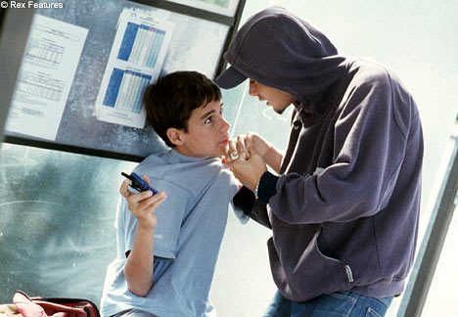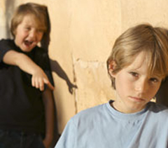

C D E
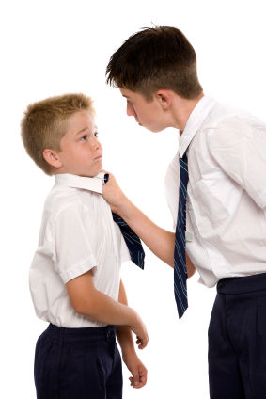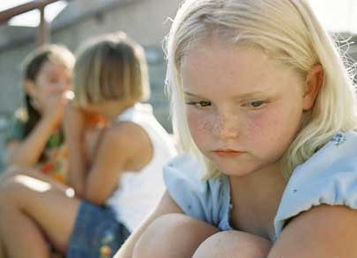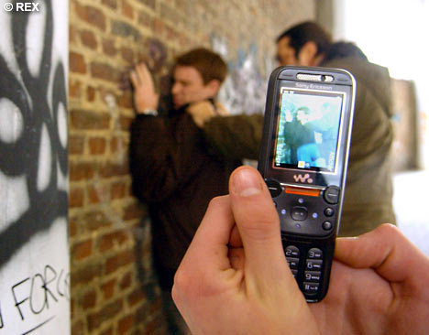

Check if you understand the words below. You can use them in your discussion.
to assault/assault, to call names, to exclude/exclusion, to hit, to ignore, to intimidate/intimidation, to leave sb. out, to take sth away, to threaten, etc.

People who are different in any way can become targets for bullying.
Listen to the song Don’t Laugh at me and remember or write down the differences mentioned in the song. After listening discuss the differences with your partner or partners.

http://www.teachertube.com/viewVideo.php?video_id=260&title=Don_t_Laugh_At_Me

or http://learningtogive.org/lessons/unit187/lesson1.html (if the previous one doesn’t work)

or another version with Mark Wills http://www.youtube.com/watch?v=FVjbo8dW9c8

You can also watch the following video where you find some fact about bullying
http://www.youtube.com/watch?v=ha6QP-qvVZw

