Part 2

Teenage drinking is a definite problem. Too many teens drink too much and too young - getting drunk has become part of a normal weekend for so many teenagers, whether in clubs or pubs, in parks or on the streets, at parties or at home.

Read the mixed text about teenage drinking. Think of the correct order of the paragraphs and put together the original article.
While reading check if you understand the highlighted expressions.

A
"This must involve changes to legislation, responsible marketing, effective monitoring of the drinks industry and health education."
In Scotland, it is an offence for anyone under 18 to buy alcohol for a person under 18 years old - the BMA would like to see that legislation introduced in England and Wales.

B
The increase in the availability of "designer drinks", the so-called "alcopops" has been accused of making alcohol far more attractive to younger people. 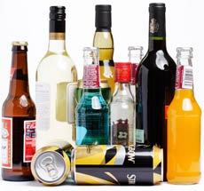
Research has shown that it is particularly the 13-16 age group that is attracted to the idea of alcopops.
A spokesman for the BMA said: "There is a need for government action to address the problems of underage and teenage drinking.

C
"Alcohol and Young People" suggested that not only was there a general rise in the proportion of 11 to 15-year-olds who drink alcohol regularly, but also that there is an increase in the amount they are drinking on each occasion.
Alcohol Concern suggested that a third more 11-15 year olds are drinking regularly.
It is far easier to work out the health effects of drinking on adults - it is known that heavy drinking over the years is a risk factor for certain cancers, particularly oral and liver, and raised blood pressure which can contribute to heart disease.

D
Doctors are worried about an apparent increase in the number of young teenagers who are drinking heavily.
While many of the more serious health effects of drinking affect those who have been drinking for many years, it is feared that alcohol abuse during the formative years sets a pattern for later life.
The British Medical Association (BMA) published a report highlighting these fears last year.

E
The Portman Group, which sets standards for advertising within the alcohol industry, has taken steps to prevent it appealing to young teenagers.
This week, it announced a ban on the use of words such as "revitalising" in connection with drinks which contain a stimulant such as caffeine as well as alcohol.

F
"Binge" drinking every now and then tends to be far more harmful to health than drinking a moderate amount occasionally.
It has also been suggested that teenagers are more likely to have casual sex if they are regular drinkers.
Doctors think that this effect could be far more pronounced in the young, as alcohol will tend to have more effect on their developing bodies.

G
In its 2009 report, it also called for the UK government to:
- Ban all alcohol marketing communications, enforce a minimum price for alcoholic products
- Increase excise duty, and adjust so that it more accurately reflected the strength of the alcoholic product
- Regulate availability of products through reduction in licensing hours for on- and off-licensed premises
- Undertake a full audit of the market and consider ways to prohibit products that either appeal to young people more than adults, or are associated with problematic drinking.
The use of words such as "revitalising" in connection with drinks which contain a stimulant such as caffeine as well as alcohol are now banned.

Taken and adapted from:
http://news.bbc.co.uk/2/hi/health/821883.stm

Truancy

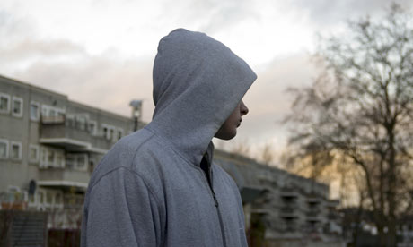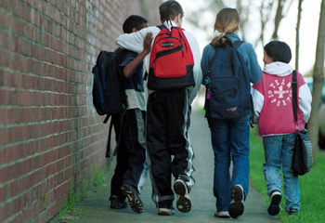

Every year hundreds of thousands of UK students play truant.

Read the following paragraph and fill in the missing verbs in the correct form. Use the verbs from the list below.

deal, mean, put, realise, solve, suffer

Many parents don’t __________ it, but truancy affects every single student and teacher in UK schools today. When even one student is truant the entire class __________ as a result. Precious time is wasted disciplining students; whole classes __________ behind schedule in order to help others catch up and the disruption of pupil’s constantly disappearing __________ that everyone loses out.
Though it may seem that truancy can __________ with by simply getting students back into the classroom this may prove only minimally effective. In actual fact students play truant from school due to a variety of underlying issues and only when these __________ will all students once again feel comfortable in the classroom.

Some of the reasons that students engage in truancy include:
- Bullying at school.
- An inability to do course work, or to ask for help.
- An uneasy relationship with teachers or administrators.
- Peer pressure.
- Exclusions that leave them with little interest in attending school.
- Abuse at home that they fear will become obvious at school.

Discussion
Do you think that truancy is a serious problem in our schools? Discuss it with your partner/s.

Practice

1 Read the text first and ….
Bullying among children is aggressive behaviour that is intentional and that involves an imbalance of power or strength. Typically, it is repeated over time. Bullying can take many forms such as hitting or punching (physical bullying); teasing or name-calling (verbal-bullying); intimidation through gestures or social exclusion (nonverbal bullying or emotional bullying); and sending insulting messages by e-mail (cyberbullying).
There is no one single cause of bullying among children. Rather, individual, family, peer, school, and community factors can place a child or youth at risk for bullying his or her peers.
Children and youth who bully are more likely to have friends who bully and who have positive attitudes toward violence. In fact, most research indicates that children and youth who bully have average of above-average self-esteem.

….. then match the following definitions with the appropriate nouns in the text.
1 opinion or way of thinking and the behaviour reflecting this …………………………..
2 a person who is equal in ability, rank, age, value, etc. …………………………………..
3 making fun of somebody unkindly …………………………………………………….
4 keeping somebody out from a place, group, etc. ………………………………………..
5 good opinion of oneself ………………………………………………………………….
6 lack of balance; disproportion …………………………………………………………….

2 Complete the text with appropriate expressions from below.
any, because, children's, different, effect, feel, frightening, leaving, often, on, taught, that, them, who

The word 'bullying' is used to describe many ________ types of behavior ranging from teasing or deliberately ________ an individual out of a social gathering or ignoring ________ , to serious assaults and abuse. Sometimes it is an individual ________ is doing the bullying and sometimes it is a group. In ________ case, bullies are cowards. They tend to pick ________ children who won't stand up for themselves. That's ________ children don't know how. They need to be ________ .
The important thing is not the action but the ________ on the victim. No one should ever underestimate the fear ________ a bullied child feels. It is painful, upsetting and ________ . It can lead to a fear of school and reduces ________ confidence. Children often feel weak and friendless and ________ think it is their fault. If it is not stopped children ________ helpless because no one can protect them.

