Teachers and their job
Discussion

Do you think teaching is an easy job or a difficult one?
What special problems does a teacher have?
What are the advantages and disadvantages of this job?

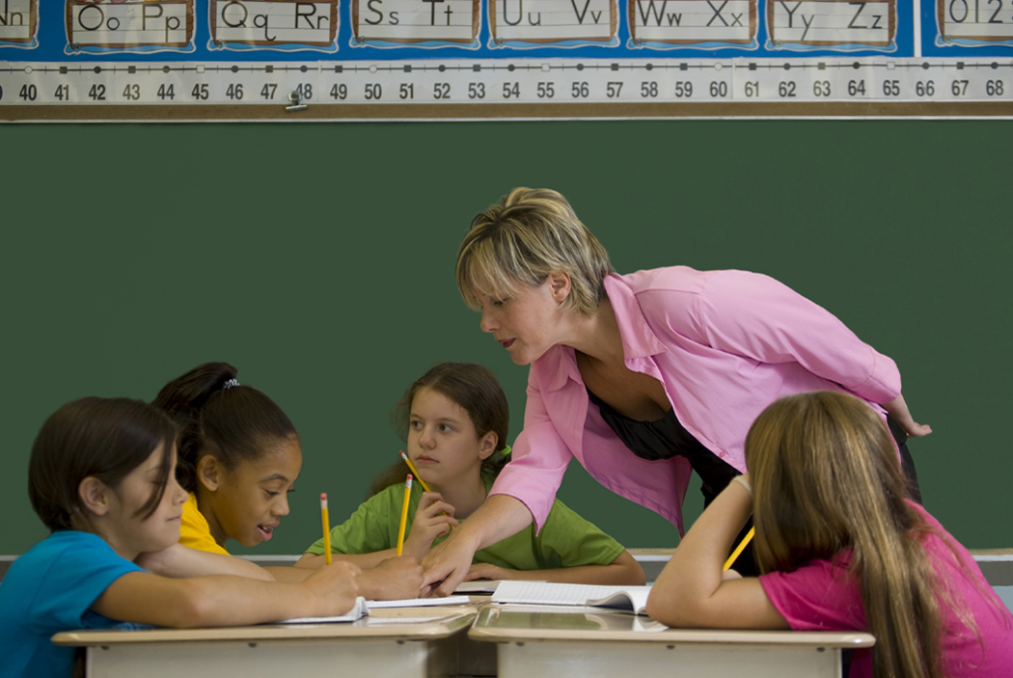
http://www.google.cz/imgres

What makes a good teacher?

Look at the following qualities. Which of them are the qualities of a good teacher?
Compare your list with the partner and justify your choice.

A good teacher should:

1 make the lesson interesting
2 be friendly
3 play a movie or documentary every second week
4 be humorous
5 positively discriminate some pupils
6 not take an interest in the problems of the pupils
7 know the subject well
8 be prepared to admit he/she doesn’t know all the answers
9 prepare the pupils well for the examination
10 improvise a lot during the lesson
11 be able to accept criticism
12 be strict but fair

Read the text below. While reading check if you understand the highlighted words.
(An optional activity – cut the text to pieces, put them anywhere in the classroom and students must find their own part, read it and tell the other students.)

What do teachers do?
What is this job like?
Teachers teach children to read, write, do math, and much more. They use games, videos, computers, and other tools to teach children different subjects.
Teachers show students skills. They also explain information. Teachers plan their lessons before they teach which can take a lot of time.
Teachers try to make their lessons easy to understand. They teach things in different ways so that different students can learn in the way that is easiest for them. Teachers might use a chalkboard, a projector, or a computer. They make posters or worksheets before class starts. Teachers plan the schedule for the day.
Teachers also assign homework and class projects. They often have students work together to do projects. When students are not doing as well as they should, teachers help them.
After class, teachers grade papers and projects. They also create tests. They write students' report cards. And they meet with parents to try to help their children do better in school. Teachers sometimes go to workshops to learn how to teach better. Some teachers also help with sports or other after-school activities.
Most middle school and high school teachers focus on one subject. They might teach English, science, or history, for example. Some teach students how to do a job. High school teachers spend more time explaining a subject and less time with activities like games.
Teachers like to see children learn. But sometimes teaching lots of students can be stressful. Teachers also have to deal with children who misbehave.
Many teachers work more than 40 hours a week. While most go on vacation during the summer, some choose to teach in summer school. Some take another job. Some go to college to learn more about teaching.
Taken and adapted from
http://www.bls.gov/k12/help01.htm

Read the text and ….
A Few Things That Make a Great Teacher

What makes a TEACHER a great one?
People have been discussing this topic for hundreds of years.

A great teacher won't be great if you just work on your weaknesses. You have to identify your strengths.
These are just my observations from my experience.

A great teacher builds on relationships. Great teachers have empathy with and understanding of student needs.

A teacher who is great is organized. Show the students your program. Students usually work when teachers do as well.

A great teacher is a great sharer. Sharing and receiving good ideas is what keeps schools and education dynamic. Be a sharer and accept sharing from others.

A teacher who is great is firm but flexible. Surprisingly, they seldom need to raise their voice because students know that their prime purpose is to value add to their day. A great teacher uses authority to bring order rather than aggression.

A great teacher gives clear instructions. Remember the KISS principle. Keep things SIMPLE.
http://en.wikipedia.org/wiki/KISS_principle

Great teachers engage students in learning. The reality is that engaged students learn. These teachers have the skill of engaging students IN learning rather than teaching TO them.

They are focused. They keep what is most important well... MOST important.

Taken and adapted from
http://ezinearticles.com/?10-Things-That-Make-a-Great-Teacher&id=7235047
….. decide if these sentences are TRUE (T) or FALSE (F).

1 A good teacher shouldn’t think of his/her own weaknesses.
2 Good relationships are very important for teachers and students.
3 Planning is not useful in teaching.
4 Students respect those teachers who shout at them.
5 Good teachers know that teaching also means engaging students in learning.

Other interesting websites where you can find a lot about teaching
http://www.soyouwanttoteach.com/
http://www.school-teacher-student-motivation-resources-courses.com/goodteacher.html
A fun quiz that tells you what kind of teacher you are.
http://www.teachingenglish.org.uk/what-kind-teacher-are-you
The quiz was inspired by Howard Gardner's theory of multiple intelligences which suggests that different people learn and do things in very different ways.

