Nomenclature of Organic Compounds

General rules

Nomenclature of Alkanes
Straight-Chain Alkanes |  |  | Alkyl Groups
English name | Czech name |  | English name | Czech name
methane | methan | CH₄ | methyl | methyl | CH₃-
ethane | ethan | CH₃CH₃ | ethyl | ethyl | CH₃- CH₂-
propane | propan | CH₃CH₂CH₃ | propyl | propyl | CH₃-CH₂-CH₂-
butane | butan | CH₃(CH₂)₂CH₃ | isopropyl | isopropyl | (CH₃)₂CH-
pentane | pentan | CH₃(CH₂)₃CH₃ | butyl | butyl | CH₃-CH₂-CH₂- CH₂-
hexane | hexan | CH₃(CH₂)₄CH₃
heptane | heptan | CH₃(CH₂)₅CH₃
octane | oktan | CH₃(CH₂)₆CH₃

With alkanes containing a branched chain, such as
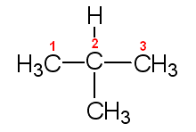
2-methylpropane

the name is more complex. A branched-chain alkane such as 2-methylpropane can be considered to be derived from a straight-chain alkane by replacing one or more hydrogen atoms by alkyl groups. The name consists of two parts:

- a suffix that identifies the parent straight-chain alkane. To find the suffix count the number of carbon atoms in the longest continuous chain. For a three-carbon chain, the suffix is propane; for a four-carbon chain it is butane, and so on.
- a prefix that identifies the branching alkyl group and indicates by a number the carbon atom where branching occurs. In 2-methylpropane, referred to above, the methyl group is located at the second carbon from the end of the chain:
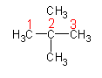
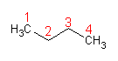
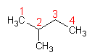
pentane 2-methylbutane 2,2-dimethylpropane

Notice that
- if the same alkyl group is at two branches, the prefix di- is used (2,2-dimethylpropane). If there were three methyl branches, we would write trimethyl, and so on.
- the number in the name is made as small as possible. Thus, we refer to 2-methylbutane, numbering the chain from the left, rather than from the right.

branched chain – rozvětvený řetězec
straight chain – přímý (rovný) řetězec

Nomenclature of Alkenes
The systematic names of alkenes are derived from those of the corresponding alkanes with the same number of carbon atoms per molecule. There are two modifications.

- the ending –ane is replaced by –ene

ethane ethene

- where necessary, a number is used to designate the double-bonded carbon; the number is made as small as possible.

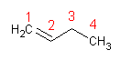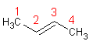
but-1-ene but-2-ene

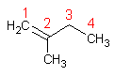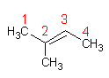
2-methylbut-1-ene 2-methylbut-2-ene

You may be surprised to learn that there are actually two different 2-butenes, differing from each other in molecular geometry.

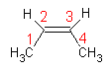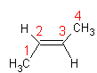
cis-but-2-ene trans-but-2-ene

double-bonded carbon – uhlík se dvěma vazbami

Nomenclature of Alkynes

The IUPAC names of alkynes are derived from those of the corresponding alkenes by replacing the suffix –ene with –yne.

ethyne propyne

but-1-yne but-2-yne

Derivatives of Benzene

Monosubstituted benzenes are ordinarily named as derivatives of benzene.

chlorbenzene nitrobenzene aminobenzene hydroxybenzene methylbenzene
(aniline) (phenol) (toluene)

The last three compounds listed are always referred to by their common names, shown in red.

common – běžný (triviální)
referred – uváděný

Functional Groups

Many organic molecules can be considered to be derived from hydrocarbons by substituting a functional group for a hydrogen atom. The functional group can be a nonmetal atom or small group of atoms that is bonded to carbon.

Carboxylic Acids
The systematic names of these compounds are obtained by adding the suffix –oic to the stem of the name of the corresponding alkanes. In practice, these names are seldom used for the first two members of the series, which are commonly referred to as formic acid and acetic acid.

methanoic acid ethanoic acid
(formic acid) (acetic acid)

A wide variety of carboxylic acids occur in nature, giving a sour or tart taste to foods.

Self-tests

Write the name
Write the correct names of these compounds:

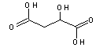 malic acid

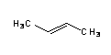 but-2-ene

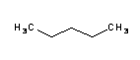 pentane

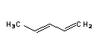 pent-1, 3-diene

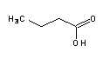 butanoic acid

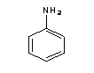 aminobenzene
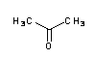 propanone

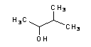 3-methylbutan-2-ol

Draw the formula
Draw the right formulas of these compounds

ethanoic acid

ethanal

nitrobenzene

propyne

trans-but-2-ene
pent-2,3-diene
hexane

2-methylbut-2-ene

hept-1,3-diyne

phenol

aminomethane

but-2-ene-1-ol

