**Prepositions of Time (in, on, at)**

**IN**

We use **in** with years, seasons and months.

I got married **in 2007**.

I got married **in winter**.

I got married **in December**.

**On**

We use **on** with days and dates.

I got married **on 31st December**.

I got married **on New Year's Eve**

**AT**

We use **at** with times and well-known holiday periods.

I got married **at 3.30**.

I got married **at New Year**.

Here are some other *examples you should learn*:

* **In** + the morning, the afternoon, the evening, but **at** night.
* **At** + mealtimes (at breakfast, at dinner ...).
* **At** + the weekend.
* **At** the moment, **at** present, **at** that moment.
* **In** the past, **in** the future.

Remember: we don't use in/on/at when we say "this / last / next".

I'll see you **next week**.

Taken from: <http://www.tinyteflteacher.co.uk/learning-english/prepositions/prepositions-time.html>

**Exercise 1: Complete the sentences with the correct preposition.**

1) We all meet ___________ Christmas.

2) We have a turkey for dinner ___________ Christmas Day.

3) She feels sleepy ___________ the morning.

4) I’m sorry, I can’t talk to you __________ the moment.

5) Last night he went to bed __________ midnight.

6) I’ll give you a ring ________ Sunday morning _________ 10 o’clock.

7) In England, the school term ends ___________ July.

8) People used to commute to work by tram ___________ the past.

9) There’s a big party at Freedom Square __________ New Year’s Eve.

10) We have a meeting _________ the first Tuesday of the month.

11) Charles is arriving _________ November, 17th, _________ three o’clock _________ the afternoon.

12) She started studying at university __________ 2013.

13) Ok. See you _________ next week __________ Tuesday.

**Exercise 2: Write down at least 8 sentences with the IN/ON/AT prepositions.**

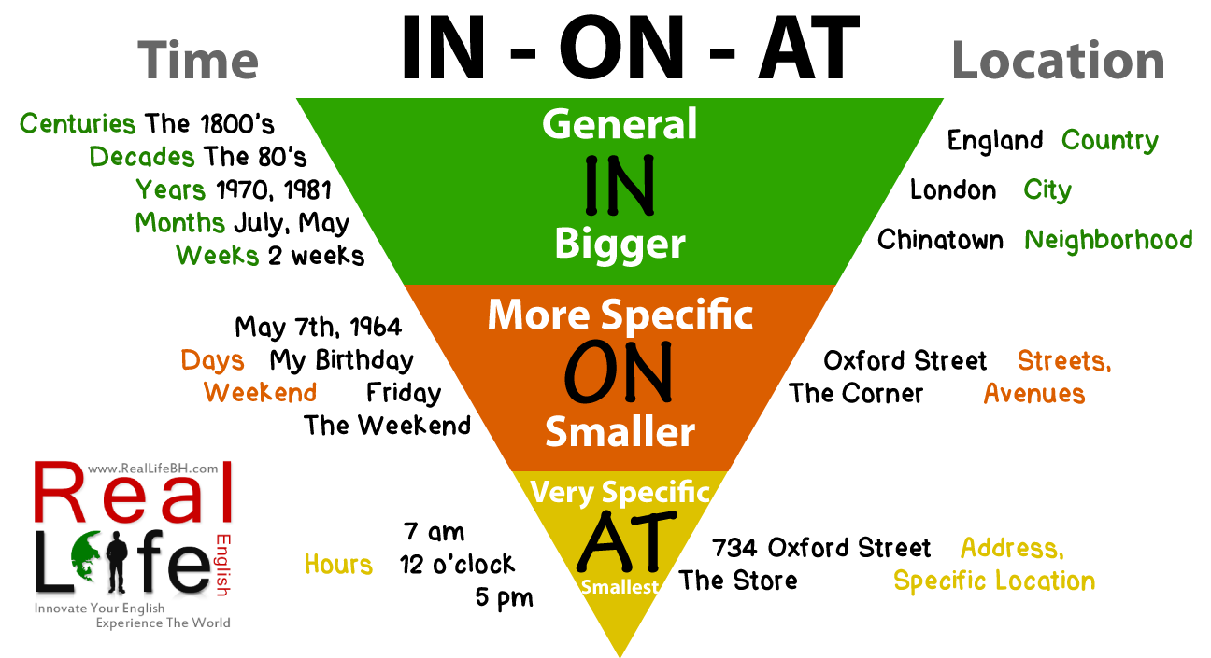

Picture taken from <http://reallifebh.com/wp-content/uploads/2014/02/in-on-at.png>

**Prepositions of Place and Movement**

**(in, on, above, under, next to, behind, in front of, between, near**

**up, down, over, to, past, into, around, through, across)**

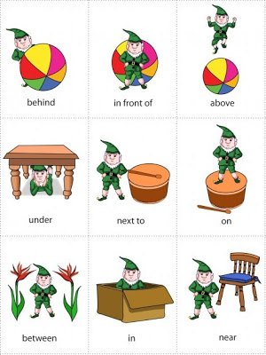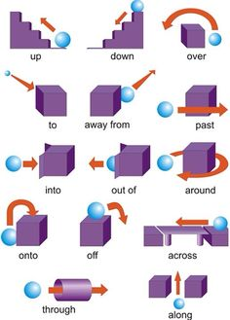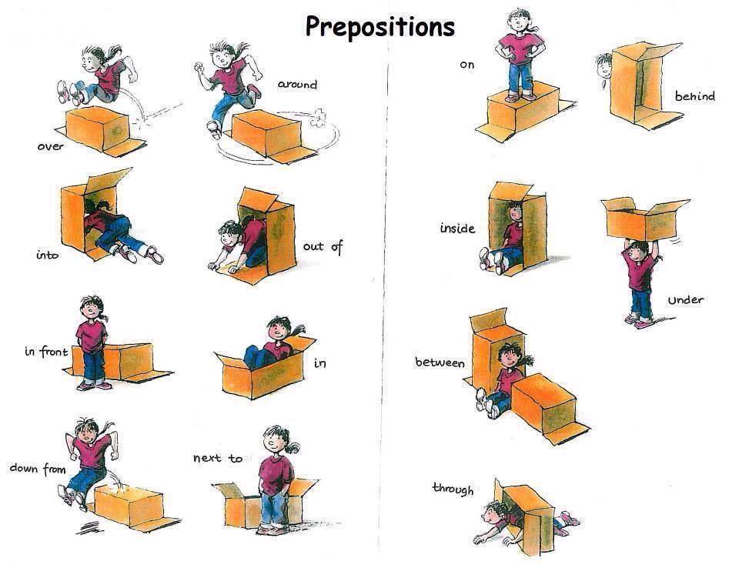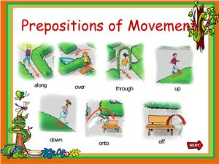

Pictures taken from:

<http://www.falibo.com/course/level_1/img/place_01.jpg>

<http://media-cache-ak0.pinimg.com/236x/b1/4f/46/b14f46da7b9faf9bf9a5e50d389e1c64.jpg>

<http://intermedio2cristina.files.wordpress.com/2014/03/prepositions-of-place-and-movement.jpg>

<http://cv01.twirpx.net/0915/0915941.jpg>

**Exercise 3: Complete the sentences using the correct preposition from the brackets.**

1. The mouse ran **__________** the table to hide. *(through / in / under)*
2. The dog ran **__________** the garden to play. *(into / onto / over)*
3. The ship sailed **__________** the world. *(round / through / over)*
4. The train went **__________** the tunnel. *(over / through / onto)*
5. The paint fell **__________** the floor. *(into / onto / round)*
6. She broke her leg when she fell **___________** the stairs. *(off / in / down)*
7. The burglar made a mistake when he ran **__________** the policeman. *(towards / under / onto)*
8. I was tired after walking **___________** the hill. *(through / into / up)*
9. When the train arrived at my destination I got **__________**. *(into / onto / off)*
10. The horse jumped **__________** the fence. *(over / under / down)*

<http://www.learnenglish.de/tests/prepositions/prepofmovement.html>