TOPIC 7
My secondary and tertiary education

Talk about your secondary school and discuss it with your neighbour, share your experience. What questions will you use?

Secondary education: secondary grammar school
secondary technical school
secondary vocational school
Higher/Further education: university – Masaryk University, Charles University
college - Teacher’s Training College
faculty - the Faculty of Education
department – the Department of History
degree – Bachelor’s degree, Master’s degree

My studies at Masaryk University
Masaryk University, located in Brno, is the second-largest public university in the Czech Republic and the leading higher education institution in Moravia. At present it comprises nine faculties with over 200 departments, institutes and clinics. The university also plays a major role in the social and cultural life of the South Moravian Region.
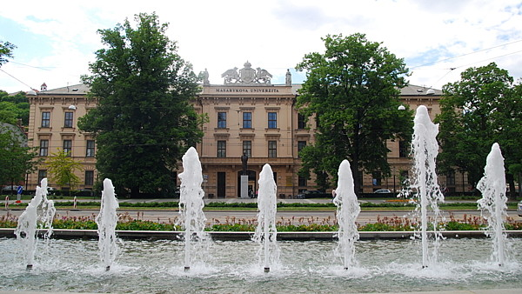
Several interesting facts and figures
- MU is one of the fastest growing higher education institutions in the Czech Republic.
- A total of 73,772 applicants for studies were registered in 2012.
- MU graduates are extremely successful on the job market.
- MU is the only university in the world with an Antarctic research station.
- Since 1922, a total of 168,043 students have graduated from Masaryk University.
Taken from
http://www.muni.cz/general/about?lang=en

VOCABULARY PRACTICE
Read two paragraphs about study at university.

Use the words below to complete the text. In each paragraph there is one extra word in the list.
college, did, exams, grade, made, passed, result, took
Exams
When I was at secondary school, I went to all the lessons and ………… my homework, but I didn’t work very hard. So, when I ………… exams at 16, my results weren’t fantastic. I ………… six, which was good, but
I failed maths. My worst ………… was physics – I got a ………… E, which was terrible. After that, I went to a sixth form ………… where I worked hard and did well. I passed all my ………… at 18 and went
to university. That’s where I am now.

attend, degree, doing, failed, lasts, weeks, work, write
A university degree
I started university two years ago, when I was 19, and I’m ………… a degree in Spanish and French. The course ………… three years, and there are three terms a year. I ………… in the library a lot because – like many undergraduates – I have to ………… lots of essays. I also have to take exams, and last term I ………… one and had to take it again. I got the result two ………… ago; fortunately I passed this time. When I’ve got my ………… – a BA – I want to do research for a PhD.

Read the following text and choose the correct word for each space. For each question, circle the letter next to the correct option – A, B, C or D:

STUDYING ABROAD

Student exchange programmes are a fantastic way to give students the 1 __________ to live somewhere else for a school year, which helps them learn 2 __________ the customs and the way of life of other people.
For this reason increasingly large numbers of young people are recognising the advantage of living in
3 __________ country and are deciding to study abroad. They will eat new food, 4 __________ new traditions and learn the way people their own age live from day to day. 5 __________ they live abroad, they stay
with carefully chosen host families, attend a 6 __________ school, and every student on the exchange programme has 7 __________ who directly supports them the whole time they are abroad. Students
8 __________ be aged between 15 to 18 years and be good at a foreign language to qualify as an exchange student.

1 A: opportunity B: cause C: occasion D: reason
2 A: for B: about C: of D: by
3 A: separate B: different C: another D: new
4 A: watch B: experience C: indicate D: consider
5 A: Whether B: Although C: However D: While
6 A: home B: local C: near D: close
7 A. anybody B: everyone C: anyone D: somebody
8 A: must B: may C: have D: need

