**AT THE AIRPORT**

**1. Ask your partner these questions and try to remember his or her answers:**

Have you ever travelled by plane?

Where and when did you fly?

Are you afraid of travelling by plane?

Where would you like to travel if you could go anywhere in the world?

**2. Match the words with the numbers in the pictures:**

**metal detector gate ticket counter security guard**

**boarding pass ticket waiting area X-ray machine**

**security check point ticket agent** **check in counter**

**arrival and departure monitor**

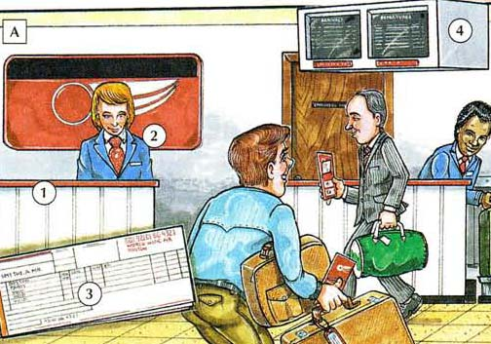

1._____________________

2. _____________________

3. _____________________

4. _____________________

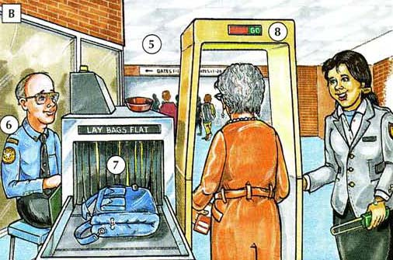

5. _____________________

6. _____________________

7. _____________________

8. _____________________

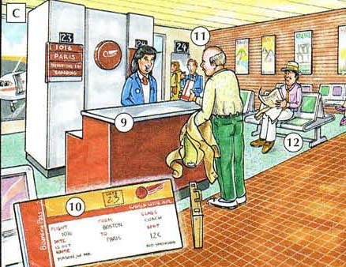

9. _____________________

10. _____________________

11. _____________________

12. _____________________

**3. a) In pairs try to describe each of the three pictures (place, people, what is happening, etc.).**

**b) Try to explain step by step what exactly you need to do if you want to travel by plane.**

**Start with….**

*When I choose the destination where I would like to fly, I have to…*

**4. Listen to the recording and fill in the missing words.**

The airport is your first stop before leaving on our dream vacation or trip. Generally speaking, you should ________________ at the airport with plenty of time to spare. Don't arrive 10 minutes before your plane ________________. You can park your car in long-term parking if you are planning to be away for a few days, or you can ask someone to _____________ in the loading zone right in front of the ___________________. In some cases, you can _________________ there at curb side, or you might have to go to the check-in counter inside the airport. Many airports now allow you to ___________ at a computer kiosk, but you will still need to check your bags if you have any. Once you are checked in, you will have to ______________ security where they will check your ID and your carry-on bags. You will also need to walk through a _________________, which will check for illegal items. After you pass through security, you can walk to the _______________ where you can wait to _______________ your flight. Just wait until they call your section to board. They usually seat first-class passengers and those who need assistance first. Enjoy your flight.

(<http://www.dailyesl.com/airport-arrival.htm>)

**5. Listen to two dialogues. Say if the sentences are True or False:**

(Opportunities Intermediate, track 24, 1:13)

***Dialog 2***

a) The man has got two pieces of baggage and a laptop.

b) His plane is not going to be delayed.

c) After getting the boarding card, the man can board the plane directly.

d) His plane departs from the gate No. 21.

***Dialog 3***

The woman is sitting on the seat No. 45.

The woman is very nice and helpful.

The man tries to be very polite.

**6. Role play**

Imagine that you are flying back from your Erasmus stay in Birmingham. At the moment you are at the airport and your plane should leave in 30 minutes. You have just reached the gate and you are ready to board the plane. However, you just realized that you are missing your laptop. Try to handle the situation with the airport staff, describing where you went and what you did, step by step, from the time you arrived at the airport to reaching the departure gate.

**7. Fill in the missing words:**

**check in aisle seat reservation flight number**

**ticket baggage domestic seat assignment**

**carry on passport international baggage claim**

**claim check gate window seat boarding pass**

Parte superior do formulário

1. A flight within one country is called a _________________ flight.
2. A flight between different countries is called an _________________flight.
3. The letters and numbers which identify an airplane making a specific flight are called a _________________ .
4. Ordering a seat to be held for you on the day you want to travel is called making a _________________.
5. A printed piece of paper which allows you to travel on an airplane is a __________________.
6. The first thing to do at the airport is _________________, which means to register as a passenger for a flight.
7. A document which identifies you as a citizen of a certain country and which allows you to travel to other countries is called a _________________.
8. The selection of a specific seat for a trip on an airplane is called _________________.
9. A seat next to the window in an airplane is called a _________________.
10. A seat next to the passage between the rows of seats in an airplane is called an _________________ .
11. The suitcases and bags which contain your belongings are called _________________.
12. A bag which you carry with you on the airplane is called a _________________bag.
13. A small ticket with printed numbers that identify your baggage is called a baggage _________________ .
14. A printed card which allows you to get on an airplane is called a_________________ .
15. A door which leads from the airport building into an airplane is called a _________________.
16. The area where you pick up your baggage after a flight is called _________________.

**8. Read the following story and answer the questions in pairs:**

**The Flight of My Life**

A twenty-three-year-old Dutch student has enjoyed a short but unexpected holiday in Dubai. Mr Frank Vreede, a business student, had taken a part-time job at Schiphol Airport to help pay for his studies. He worked as a baggage handler and was responsible for loading the suitcases into the hold of passenger planes.

Last Friday night, after an exhausting day in the university library preparing for his final exams, Frank was loading a plane at the airport. He was waiting for the next baggage truck to arrive and he felt tired. He decided to have a quick rest, so he sat down in the hold of the plane and shut his eyes – just for a second.

However, while he was sleeping, the plane took off. An hour later, Frank woke up and was horrified to discover that the plane was in the air. There was a terrible noise from the engines, and he tried not to panic. It was dark, uncomfortable and very very cold. Frank knew the flight would be long because it was an airline from the Middle East. He also knew he could not survive the freezing temperatures. It was an impossible situation.

He decided to make as much noise as possible. He banged on the ceiling of the baggage hold and shouted at the top of his voice. Luckily, a passenger heard the noise and called a flight attendant, who immediately informed the pilot. Once the captain understood what was happening, he ordered hot air to be pumped into the hold.

When the plane arrived at Dubai International Airport, an ambulance was waiting to take a very cold and frightened Mr Vreede to hospital. Doctors examined him, but he was unhurt and was allowed to leave after a few hours. News spread quickly about this stowaway. The Managing Director of one of Dubai’s top hotels offered him a free room for the weekend. “He must have wanted to come to Dubai very much if he was prepared to travel in the hold!” joked the MD.

“Everyone’s been so kind, “ said Mr Vreede. “I’m really enjoying my stay in Dubai and I’m getting a lot of rest, so I won’t fall asleep on the job again!”

When Frank returned to Schiphol Airport on Monday, his friends and relatives were overjoyed to see him. “When he didn’t come home after his evening shift on Friday, I called the airport – but nobody had seen him for hours,” his mother said to reporters. Frank explained that he was very lucky because it is possible to die of cold in the hold of an aircraft. He apologized to his boss for sleeping at work instead of working, and promised it would not happen again. “During the flight I was petrified. I thought I was going to die!” said Mr Vreede. “I wouldn’t want to do it again. Next time, I’ll catch a regular flight!”

(adapted from Academic Skills: Reading, Writing, and Sutdy Skills, Level 2)

**Questions**

1 Who is the article about?

2 What other people are mentioned in the article?

3 Where did the events take place?

4 When did the events happen?

5 What was the problem?

6 How was the problem solved?

7 Do you think Frank was a lucky or unlucky guy?

8 What would you do if you were in his shoes?

**9. Listen to the recording and complete the information:**

(Opportunities Intermediate, track 23)

|  |  |  |
| --- | --- | --- |
| **DEPARTURES** | | |
| **Flight** | **Destination** | **Gate** |
| **AF 2146** | **Ottawa** |  |
|  | **Budapest** |  |
| **LO 1462** |  |  |
|  |  | **13** |
|  | **Istanbul** |  |
|  |  | **9** |

**10. Listen carefully to one more airport announcement and choose the correct answer**

1. Who is probably making the announcement?   
A. a pilot   
B. a flight attendant   
C. a ticket agent   
D. a ground crew member

2. What is the ultimate destination of the flight?   
A. Atlanta   
B. Miami   
C. Caracas   
D. Lima

3. What change has been announced?   
A. the flight number   
B. the gate number   
C. the arrival time   
D. the boarding time

4. What are the current weather conditions outside?   
A. It's raining.   
B. It's cloudy.   
C. It's hailing.   
D. It's windy.

5. What time will the plane depart?   
A. 9:50 AM   
B. 12:15 PM   
C. 4:05 PM   
D. 8:45 PM

(http://www.esl-lab.com/airport/airportrd1.htm)

**AIRPORT VOCABULARY**

|  |
| --- |
| air hostess – letuška, stevardka |
| aircraft - letadlo |
| airline - aerolinie |
| aisle seat – sedadlo v uličce |
| arrivals - přílety |
| baggage / luggage - zavazadla |
| baggage allowance - nejvyšší povolená váha zavazadel při cestování |
| baggage carousel (US) – pás se zavazadly |
| baggage claim – výdej zavazadel |
| baggage compartment – zavazadlový prostor |
| boarding pass – palubní lístek |
| briefcase – kufřík |
| carry-on luggage – příruční zavazadlo |
| check-in desk – odbavovací přepážka |
| concourse – letištní hala |
| connecting flight – letecký spoj/ přípoj |
| crew - posádka |
| customs - celnice |
| customs officer – celní úředník |
| delayed - zpožděný |
| departure lounge – odletová hala |
| departures - odlety |
| direct flight/ non-stop flight – přímý let |
| domestic flight – vnitrostátní let |
| duty free – osvobozený od cla |
| emergency exit – únikový východ |
| emergency landing – nouzové přistání |
| excess baggage – zavazadla nad přípustý váhový limit |
| excess baggage charge – poplatek za překročení váhového limitu zavazadel |
| flight attendant – letuška, stevard |
| flight number – číslo letu |
| gate – brána (příchod k letadlům) |
| immigration – imigrační kontrola |
| immigration officer – imigrační úředník |
| international flight – mezinárodní let |
| jet lag – porucha biorytmu po cestě letadlem do jiného časového pásma |
| landing - přistání |
| life vest – záchranná vesta |
| restroom / lavatory/ toilet – toaleta, WC |
| scales - váhy |
| seat - sedadlo |
| seat belt – bezpečnostní pás |
| shuttle bus – kyvadlový spoj (autobus) |
| stopover - mezipřistání |
| suitcase - kufr |
| stewardess – letuška, stevardka |
| timetable – jízdní (odletový) řád |
| time of arrival – čas příletu |
| time of departure – čas odletu |
| to frisk – prohledat, prošacovat |
| to board – nastoupit, jít na palubu |
| to check in – odbavit se |
| to fasten the seatbelt – zapnout si bezpečnostní pás |
| to land - přistát |
| to take off - vzlétnout |
| terminal - terminál |
| trolley - vozík |
| turbulence - turbulence |
| window seat - sedadlo u okna |