# 10.2. Metallic nanoparticles

An interesting behavior exhibits colloidal aqueous solutions of gold nanoparticles. Although the macroscopic gold particles appear as yellow powder, dispersions of gold nanospheres have an intensive red color. More generally, we may say that the properties of nanoparticles differ from properties of bulk materials. Conventional materials have properties, which are dependent on their chemical composition. Nanoparticles in this way provide opportunities to obtain materials with otherwise inaccessible properties.

Interaction of electromagnetic radiation with metals leads to the oscillations of electrons. This oscillation is described by so called surface plasmons. If the nanoparticles interact with electromagnetic radiation, then we talk about localized surface plasmons. The radiation of certain frequency may resonate with the natural frequency of electrons in a metal nanoparticle; resonance of localized surface plasmons (LSPR). This resonance can be observed in the absorption spectra and the spectra of the scattered light as the maximum of absorbance or intensity. With gold and silver nanoparticles, the resonance occurs in the visible and near infrared region (VIS/NIR). The resonance frequency depends on the material, shape and size of nanoparticle, nanoparticle grouping and the refractive index of the environment. For example, new resonance peak corresponding to the longitudinal vibration of electrons appears in the spectra of gold nanorods. The position of this peak can be changed depending on the ratio between the length and nanorod diameter (Figure 1).2

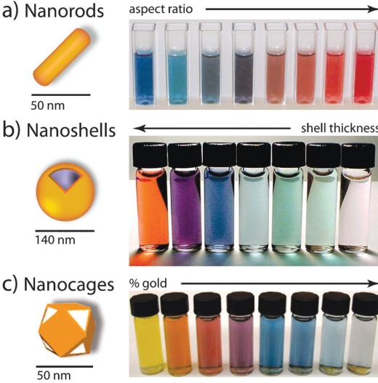

*Figure 1.*

*The dispersion of differently shaped gold nanoparticles*1

High extinction coefficient of gold nanoparticles is beneficial for bioassay development and is used, for example, in chromatographic detection strips.4 Gold nanomaterials may also enhance Raman scattering, which facilitates detection and spectral characterization of small molecules. If the monitored molecule is located near the metal nanoparticles, Raman scattering may be significantly amplified, which is the consequence of enhanced electric field near the surface of metal nanoparticle. This principle can be used for the detection of pesticide at the surface of the fruit peel as well as for the detection of many other substances.5