# 10.3. Quantum dots

Quantum dots (QDs) represent another example of unusual behavior of nanoparticles. QDs are very small semiconductor nanocrystals (~ 1–10 nm), which exhibit very intense photoluminescence converting short wavelength excitation light to a red shifted emission. As a result of quantum effects, the wavelength (color) of the emitted radiation depends not only on the material of QDs, but also on their size. These inorganic nanoparticles are in biology and (bio)analytical chemistry used similarly as an organic fluorophores, which are known for a long time. Some optical and chemical properties of QDs are exceptional, however, allowing the design of new analytical methods for the detection of ions, bacteria, viruses, nucleotide sequences, proteins and other analytes.6–7 QDs may become particularly useful in fluorescence microscopy and biological imaging (Figure 2).

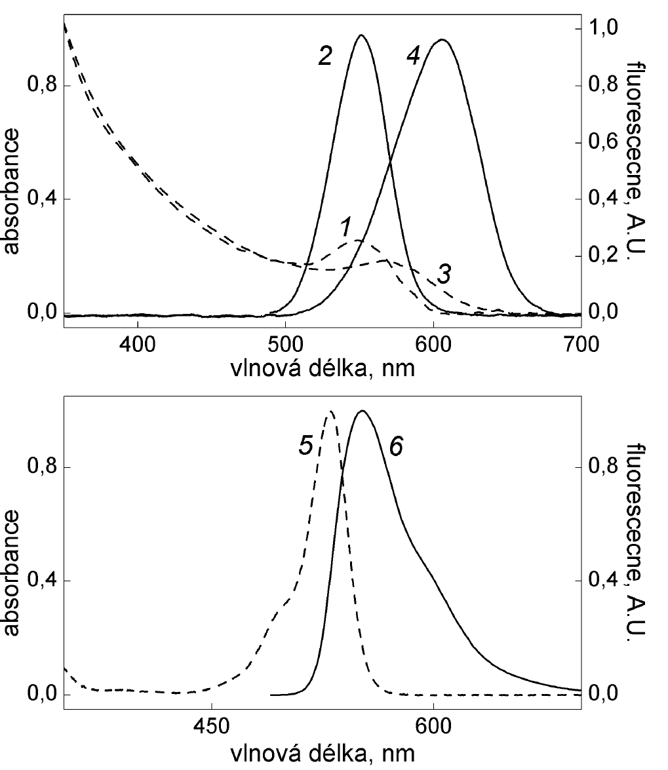

*Figure 2.*

*The comparison of absorption and emission spectra. The spectra of aqueous solutions of CdTe stabilized with sulfanylethane acid*

*(1,2 - QD with a diameter of 2.8 nm,*

*3,4 - QD having a diameter of 3.2 nm)*

*and the spectrum of rhodamine 6G in ethanol (5,6).*

*Curves 1, 3 and 5 show absorption spectra, 2, 4 and 6, emission spectra.6*

QDs can be used for the fluorescent labeling of biomolecules in a similar way as an organic fluorophores.8–12 Simultaneous determination of multiple analytes is facilitated by QDs emitting at different wavelengths. An order of magnitude more analytes may be simultaneously detected utilizing QDs encoded microparticles possessing unique fluorescence barcodes. Other application area of QDs is a fluorescent labeling of microscopic samples; various microscopic structures may be visualized by QDs emitting at different wavelengths. The possibility to excite QDs in a wide range of wavelengths is suitable for assays with Förster resonance energy transfer. QDs emitting in NIR were used for specific labeling of tissues of living organisms; NIR radiation has the ability to pass through animal tissues and allows for noninvasive insight into the bodies of animals. QD fluorescence intensity in aqueous solution may be modified by the presence of metal ions, which has been used for their determination.