# 10.4. Photon up-conversion nanoparticles

The last type of nanomaterial herein mentioned exhibits the so called photon up-conversion. Anti-Stokes luminescence, especially photon up-conversion attracts a growing interest. It is expected that the new generation of nanoparticles exhibiting photon up-conversion (UCNP) will lead to the development of methods for biological imaging, targeted drug delivery and detection methods in bioanalytical chemistry. UCNPs also represent a new generation of luminescence labels for microscopy. The recent results suggest an excellent applicability for single molecule detection.13–16

Photon up-conversion is a type of anti-Stokes luminescence, which is a conversion of long wavelength electromagnetic radiation into a radiation with a shorter wavelength. Photon up-conversion reveals crystalline materials doped with the ions of d and f elements (lanthanoids).14 These materials are able to absorb infrared radiation and emit visible light. Currently, the most studied and used UCNP consist of NaYF4 nanocrystals, which are doped with Yb3+ and Er3+ (NaYF4: Yb3 +/Er3+).14,17 The mechanism of photon up-conversion in NaYF4: Yb3 +/Er3+ may be described by the diagram in the Figure 3A.

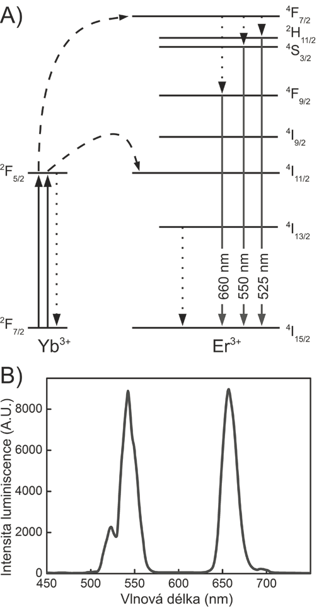

*Figure 3:*

*Photon up-conversion in nanocrystals of NaYF4: Yb3+/Er3+.17*

Yb3+ in the UCNP absorbs one photon of 980 nm laser and is excited into the state 2F5/2. Subsequently, the energy is transferred to the state 4I11/2 of Er3+ ion, which is in the vicinity of the excited Yb3+, and gradually excites Er3+ to the state 4F7/2. Accumulated energy may be emitted with a wavelength of approximately 525 nm, 550 nm (green) and 660 nm (red) after nonradiative relaxation in one of three states with slightly lower energy. Peaks that correspond to these transitions are found in emission spectrum (Figure 3B). Similarly, photon up-conversion in nanocrystals of NaYF4: Yb3+/Tm3+ leads to the emission at 450 nm, 475 nm (blue) and 800 nm (infrared).

In a comparison with other anti-Stokes processes, *e.g.* with two-photon luminescence, UCNP can be excited by infrared radiation with a million times lower intensity. This eliminates the need for expensive femtosecond lasers. Also other advantages are characteristic for UCNPs. (A) large anti-Stokes shift (B) the ability to set emission maxima of UCNP by varying chemical composition. Other benefits of UCNPs include negligible autofluorescence of biological samples, low scattering of long wavelength excitation light, low photochemical damage to biomolecules, which otherwise occurs by treatment with short wavelength radiation, the deeper penetration of the excitation light into biological material, high photostability, and the absence of blinking.14

The properties of these new nanomaterials in biology can be especially useful for biomolecule detection and biological imaging.14 Thanks to the specific luminescence properties of UCNP, it is possible to bypass the need for sophisticated imaging techniques, such X-rays or nuclear magnetic resonance imaging (Figure 4). Imaging is also possible to combine with the targeted transport of drugs into the affected tissues. In this case, it is possible to monitor the whole process of transfer of the drug from the bloodstream to the target site such as a tumor tissue. UCNPs provide excellent properties when combined with microscopy. In comparison with two-photon microscopy, microscopy utilizing photon up-conversion is less instrumentally demanding. It is not necessary to use a narrowly focused beam of femtosecond laser. Therefore, there is no limitation to a confocal scanning arrangement. As an excitation source suffices continuous wave semiconductor lasers, whose intensity is constant in time. UCNPs are therefore suitable also for epifluorescence and total internal reflection microscopy.13

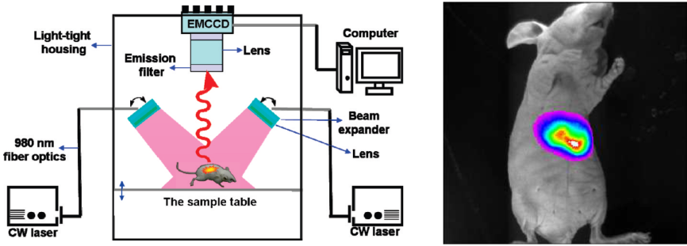

*Figure 4.*

*Biological imaging using photon up-conversion; accumulation of photon up-converting nanoparticles in liver tissue of mice.17*