**10. Nanoparticles**

# 10.1. Introduction

Nanoparticles are very small particles with a size in the range from 1 to 100 nanometers. The research of nanoparticles is currently the area of​ an increasing scientific interest. The main motivation for this research is a wide applicability of nanoparticles in biomedicine, bioanalytical chemistry, molecular biology, optics, electronics, chemical synthesis (catalysis) and others.1–3

# 10.2. Metallic nanoparticles

An interesting behavior exhibits colloidal aqueous solutions of gold nanoparticles. Although the macroscopic gold particles appear as yellow powder, dispersions of gold nanospheres have an intensive red color. More generally, we may say that the properties of nanoparticles differ from properties of bulk materials. Conventional materials have properties, which are dependent on their chemical composition. Nanoparticles in this way provide opportunities to obtain materials with otherwise inaccessible properties.

Interaction of electromagnetic radiation with metals leads to the oscillations of electrons. This oscillation is described by so called surface plasmons. If the nanoparticles interact with electromagnetic radiation, then we talk about localized surface plasmons. The radiation of certain frequency may resonate with the natural frequency of electrons in a metal nanoparticle; resonance of localized surface plasmons (LSPR). This resonance can be observed in the absorption spectra and the spectra of the scattered light as the maximum of absorbance or intensity. With gold and silver nanoparticles, the resonance occurs in the visible and near infrared region (VIS/NIR). The resonance frequency depends on the material, shape and size of nanoparticle, nanoparticle grouping and the refractive index of the environment. For example, new resonance peak corresponding to the longitudinal vibration of electrons appears in the spectra of gold nanorods. The position of this peak can be changed depending on the ratio between the length and nanorod diameter (Figure 1).2

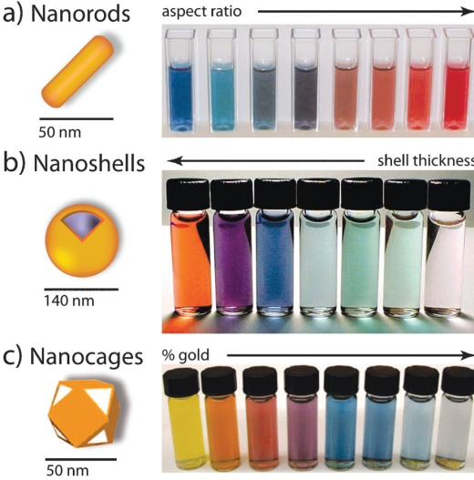

*Figure 1.*

*The dispersion of differently shaped gold nanoparticles*1

High extinction coefficient of gold nanoparticles is beneficial for bioassay development and is used, for example, in chromatographic detection strips.4 Gold nanomaterials may also enhance Raman scattering, which facilitates detection and spectral characterization of small molecules. If the monitored molecule is located near the metal nanoparticles, Raman scattering may be significantly amplified, which is the consequence of enhanced electric field near the surface of metal nanoparticle. This principle can be used for the detection of pesticide at the surface of the fruit peel as well as for the detection of many other substances.5

# 10.3. Quantum dots

Quantum dots (QDs) represent another example of unusual behavior of nanoparticles. QDs are very small semiconductor nanocrystals (~ 1–10 nm), which exhibit very intense photoluminescence converting short wavelength excitation light to a red shifted emission. As a result of quantum effects, the wavelength (color) of the emitted radiation depends not only on the material of QDs, but also on their size. These inorganic nanoparticles are in biology and (bio)analytical chemistry used similarly as an organic fluorophores, which are known for a long time. Some optical and chemical properties of QDs are exceptional, however, allowing the design of new analytical methods for the detection of ions, bacteria, viruses, nucleotide sequences, proteins and other analytes.6–7 QDs may become particularly useful in fluorescence microscopy and biological imaging (Figure 2).

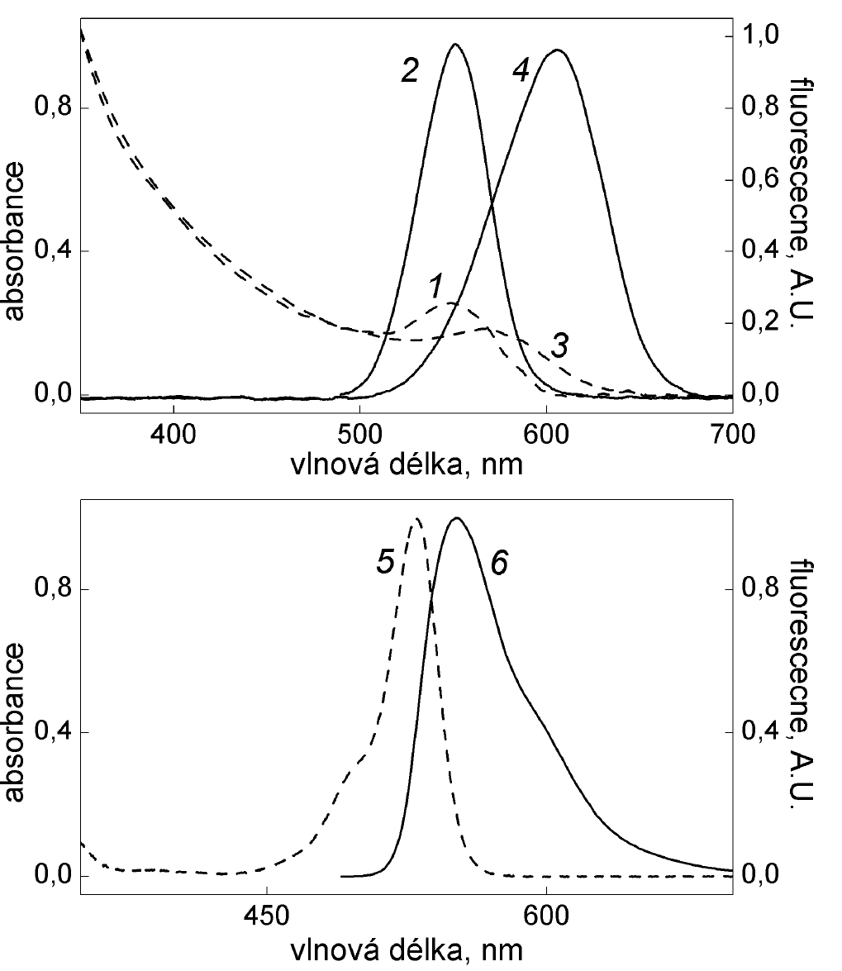

*Figure 2.*

*The comparison of absorption and emission spectra. The spectra of aqueous solutions of CdTe stabilized with sulfanylethane acid*

*(1,2 - QD with a diameter of 2.8 nm,*

*3,4 - QD having a diameter of 3.2 nm)*

*and the spectrum of rhodamine 6G in ethanol (5,6).*

*Curves 1, 3 and 5 show absorption spectra, 2, 4 and 6, emission spectra.6*

QDs can be used for the fluorescent labeling of biomolecules in a similar way as an organic fluorophores.8–12 Simultaneous determination of multiple analytes is facilitated by QDs emitting at different wavelengths. An order of magnitude more analytes may be simultaneously detected utilizing QDs encoded microparticles possessing unique fluorescence barcodes. Other application area of QDs is a fluorescent labeling of microscopic samples; various microscopic structures may be visualized by QDs emitting at different wavelengths. The possibility to excite QDs in a wide range of wavelengths is suitable for assays with Förster resonance energy transfer. QDs emitting in NIR were used for specific labeling of tissues of living organisms; NIR radiation has the ability to pass through animal tissues and allows for noninvasive insight into the bodies of animals. QD fluorescence intensity in aqueous solution may be modified by the presence of metal ions, which has been used for their determination.

# 10.4. Photon up-conversion nanoparticles

The last type of nanomaterial herein mentioned exhibits the so called photon up-conversion. Anti-Stokes luminescence, especially photon up-conversion attracts a growing interest. It is expected that the new generation of nanoparticles exhibiting photon up-conversion (UCNP) will lead to the development of methods for biological imaging, targeted drug delivery and detection methods in bioanalytical chemistry. UCNPs also represent a new generation of luminescence labels for microscopy. The recent results suggest an excellent applicability for single molecule detection.13–16

Photon up-conversion is a type of anti-Stokes luminescence, which is a conversion of long wavelength electromagnetic radiation into a radiation with a shorter wavelength. Photon up-conversion reveals crystalline materials doped with the ions of d and f elements (lanthanoids).14 These materials are able to absorb infrared radiation and emit visible light. Currently, the most studied and used UCNP consist of NaYF4 nanocrystals, which are doped with Yb3+ and Er3+ (NaYF4: Yb3 +/Er3+).14,17 The mechanism of photon up-conversion in NaYF4: Yb3 +/Er3+ may be described by the diagram in the Figure 3A.

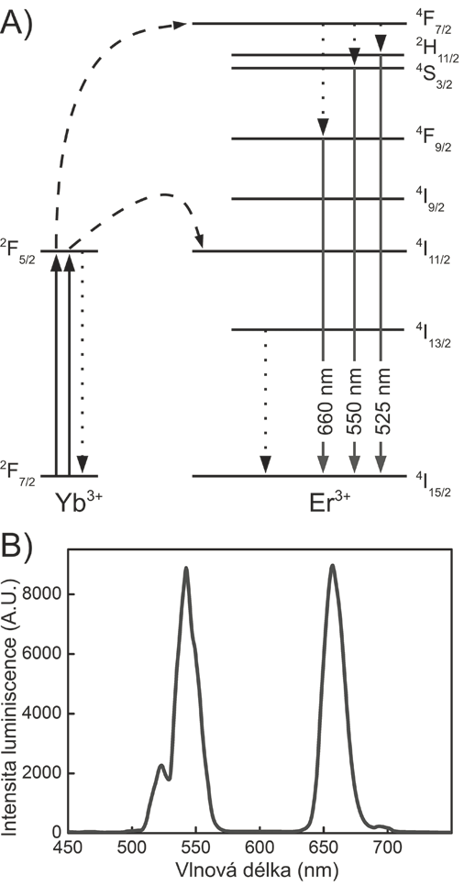

*Figure 3:*

*Photon up-conversion in nanocrystals of NaYF4: Yb3+/Er3+.17*

Yb3+ in the UCNP absorbs one photon of 980 nm laser and is excited into the state 2F5/2. Subsequently, the energy is transferred to the state 4I11/2 of Er3+ ion, which is in the vicinity of the excited Yb3+, and gradually excites Er3+ to the state 4F7/2. Accumulated energy may be emitted with a wavelength of approximately 525 nm, 550 nm (green) and 660 nm (red) after nonradiative relaxation in one of three states with slightly lower energy. Peaks that correspond to these transitions are found in emission spectrum (Figure 3B). Similarly, photon up-conversion in nanocrystals of NaYF4: Yb3+/Tm3+ leads to the emission at 450 nm, 475 nm (blue) and 800 nm (infrared).

In a comparison with other anti-Stokes processes, *e.g.* with two-photon luminescence, UCNP can be excited by infrared radiation with a million times lower intensity. This eliminates the need for expensive femtosecond lasers. Also other advantages are characteristic for UCNPs. (A) large anti-Stokes shift (B) the ability to set emission maxima of UCNP by varying chemical composition. Other benefits of UCNPs include negligible autofluorescence of biological samples, low scattering of long wavelength excitation light, low photochemical damage to biomolecules, which otherwise occurs by treatment with short wavelength radiation, the deeper penetration of the excitation light into biological material, high photostability, and the absence of blinking.14

The properties of these new nanomaterials in biology can be especially useful for biomolecule detection and biological imaging.14 Thanks to the specific luminescence properties of UCNP, it is possible to bypass the need for sophisticated imaging techniques, such X-rays or nuclear magnetic resonance imaging (Figure 4). Imaging is also possible to combine with the targeted transport of drugs into the affected tissues. In this case, it is possible to monitor the whole process of transfer of the drug from the bloodstream to the target site such as a tumor tissue. UCNPs provide excellent properties when combined with microscopy. In comparison with two-photon microscopy, microscopy utilizing photon up-conversion is less instrumentally demanding. It is not necessary to use a narrowly focused beam of femtosecond laser. Therefore, there is no limitation to a confocal scanning arrangement. As an excitation source suffices continuous wave semiconductor lasers, whose intensity is constant in time. UCNPs are therefore suitable also for epifluorescence and total internal reflection microscopy.13

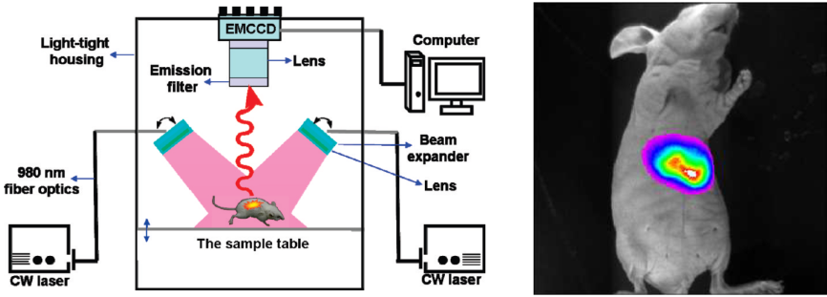

*Figure 4.*

*Biological imaging using photon up-conversion; accumulation of photon up-converting nanoparticles in liver tissue of mice.17*

# 10.5. Literatura

1. Dreaden, E.C., Alkilany, A.M., Huang, X., Murphy, C.J., El-Sayed, M.A. The golden age: Gold nanoparticles for biomedicine (2012) Chemical Society Reviews, 41 (7), pp. 2740–2779.
2. Huang, X., El-Sayed, I.H., Qian, W., El-Sayed, M.A. Cancer cell imaging and photothermal therapy in the near-infrared region by using gold nanorods (2006) Journal of the American Chemical Society, 128 (6), pp. 2115–2120.
3. Schmidt, G.: Nanoparticles From Theory to Application, 2. vyd. WILEY-VCH, Weinheim 2010.
4. Mao, X., Ma, Y., Zhang, A., Zhang, L., Zeng, L., Liu, G. Disposable nucleic acid biosensors based on gold nanoparticle probes and lateral flow strip (2009) Analytical Chemistry, 81 (4), pp. 1660–1668.
5. Li, J.F., Huang, Y.F., Ding, Y., Yang, Z.L., Li, S.B., Zhou, X.S., Fan, F.R., Zhang, W., Zhou, Z.Y., Wu, D.Y., Ren, B., Wang, Z.L., Tian, Z.Q. Shell-isolated nanoparticle-enhanced Raman spectroscopy (2010) Nature, 464 (7287), pp. 392–395.
6. Hlaváček, A., Skládal, P. The application of quantum dots in bioanalytical chemistry [Kvantové tečky: Příprava, konjugace a využití v bioanalytické chemii a biologii] (2011) Chemicke Listy, 105 (8), pp. 611–615.
7. Lowe J. P., Peterson K.: Quantum Chemistry, 3. vyd. Elsevier, Amsterdam 2006.
8. Giepmans, B.N.G., Adams, S.R., Ellisman, M.H., Tsien, R.Y. The fluorescent toolbox for assessing protein location and function (2006) Science, 312 (5771), pp. 217–224.
9. Reiss, P., Protičre, M., Li, L. Core/shell semiconductor nanocrystals (2009) Small, 5 (2), pp. 154–168.
10. Resch-Genger, U., Grabolle, M., Cavaliere-Jaricot, S., Nitschke, R., Nann, T. Quantum dots versus organic dyes as fluorescent labels (2008) Nature Methods, 5 (9), pp. 763–775.
11. Jaiswal, J.K., Mattoussi, H., Mauro, J.M., Simon, S.M. Long-term multiple color imaging of live cells using quantum dot bioconjugates (2003) Nature Biotechnology, 21 (1), pp. 47–51.
12. Jaiswal, J.K., Simon, S.M. Potentials and pitfalls of fluorescent quantum dots for biological imaging (2004) Trends in Cell Biology, 14 (9), pp. 497–504.
13. Park, Y.I., Lee, K.T., Suh, Y.D., Hyeon, T. Upconverting nanoparticles: A versatile platform for wide-field two-photon microscopy and multi-modal in vivo imaging (2015) Chemical Society Reviews, 44 (6), pp. 1302–1317.
14. Zhou, J., Liu, Q., Feng, W., Sun, Y., Li, F. Upconversion luminescent materials: Advances and applications (2015) Chemical Reviews, 115 (1), pp. 395–465.
15. Sedlmeier, A., Gorris, H.H. Surface modification and characterization of photon-upconverting nanoparticles for bioanalytical applications (2015) Chemical Society Reviews, 44 (6), pp. 1526–1560.
16. Cohen, B.E. Biological imaging: Beyond fluorescence (2010) Nature, 467 (7314), pp. 407–408.
17. Hlaváček, A. Nanočástice vykazující fotonovou up-konverzi: Nový typ luminiscenční značky pro zobrazování jednotlivých biomolekul? (2015) Bioprospect, 25 (2), pp. 38–41.
18. Zhan, Q., He, S., Qian, J., Cheng, H., Cai, F. Optimization of optical excitation of upconversion nanoparticles for rapid microscopy and deeper tissue imaging with higher quantum field (2013) Theranostics, 3 (5), pp. 306–316.