**PREPOSITIONS**

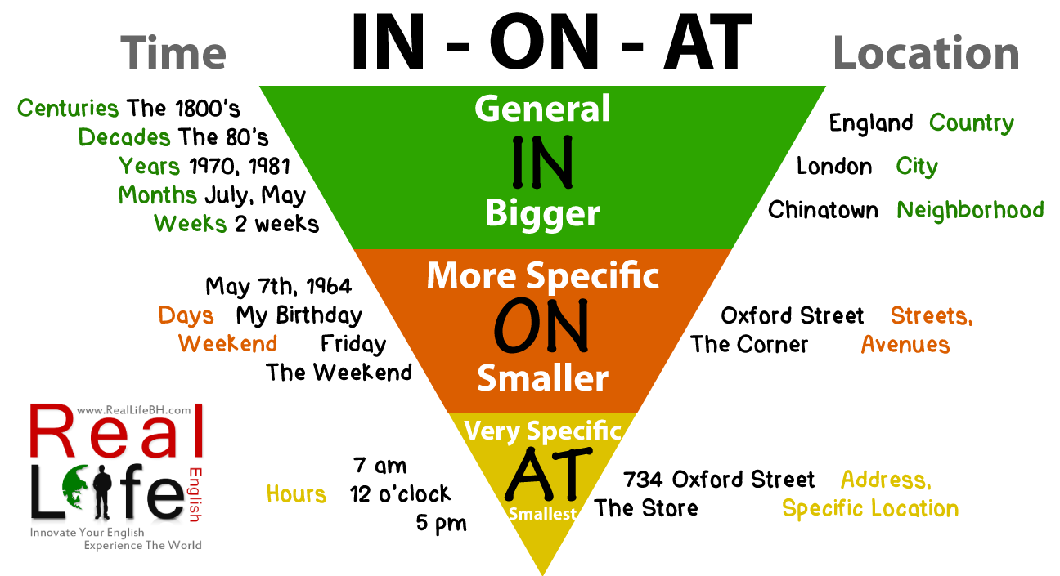

Picture taken from <http://reallifebh.com/wp-content/uploads/2014/02/in-on-at.png>

**Prepositions of Place and Movement**

**(place: in, on, above, under, next to, behind, in front of, between, near**

**movement : up, down, over, to, past, into, around, through, across)**

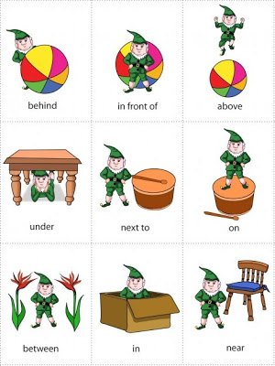 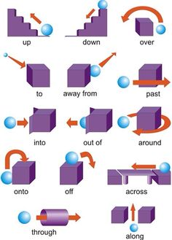

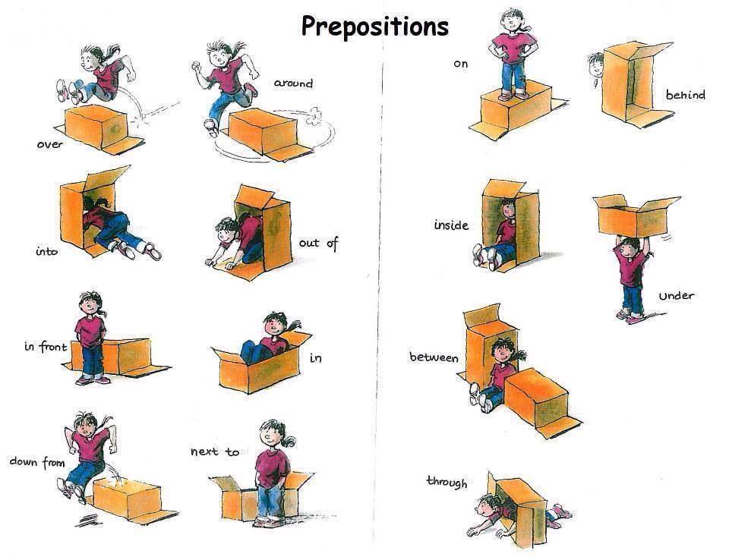

Pictures taken from:

<http://www.falibo.com/course/level_1/img/place_01.jpg>

<http://media-cache-ak0.pinimg.com/236x/b1/4f/46/b14f46da7b9faf9bf9a5e50d389e1c64.jpg>

<http://intermedio2cristina.files.wordpress.com/2014/03/prepositions-of-place-and-movement.jpg>

<http://cv01.twirpx.net/0915/0915941.jpg>