|  |  |  |
| --- | --- | --- |
|  |  |  |
|  | **Study Questions:** The following questions are designed to help you think about the key points raised in the article.  1) What is the meaning of the word ‘heuristic’?  2) What is the purpose of the Vee heuristic?  3) What is the difference between the left hand and right hand sides of the Vee?  4) What is a ‘concept’?  5) What is the difference between ‘records’ and ‘transformations’?  6) What is a claim?  7) What is the difference between a value claim and a knowledge claim? |  |
|  |  |  |

|  |  |  |  |  |
| --- | --- | --- | --- | --- |
| |  |  | | --- | --- | |  |  | |  | Novak, J. D., & Gowin, B. D. (1984). *Learning How To Learn.* New York: Cambridge University Press. (Chapter 3, pp. 55-70)  *Learning How To Learn* |   JOSEPH D. NOVAK AND D. BOB GOWIN  *Department of Education*  *New York State College of*  *Agriculture and Life Sciences*  *Cornell University*  CAMBRIDGE UNIVERSITY PRESS  *Cambridge*  *London New York New Rochelle*  *Melbourne Sydney*  1984  **NOTE FROM TONY CLARKE:** I have found Gowin’s Vee to be a very useful way for thinking about and designing research be it a quantitative, qualitative, mixed-methods. In this chapter, Novak and Gowin (1984) provide a useful ‘tool’ or heuristic for constructing a scholarly argument. The chapter has a distinctly euro-western bias, so please keep this in mind when reading the chapter. The text excerpted here, suitable for SoEL contexts, is a very slightly modified version of the original chapter. ***Please be sure to quote Novak and Gowan (1984) if you use or refer to this text.*** |

**CHAPTER 3**

**THE VEE HEURISTIC FOR UNDERSTANDING KNOWLEDGE AND KNOWLEDGE PRODUCTION**

**WHY USE A HEURISTIC?**

A heuristic is something employed as an aid to solving a problem or understanding a procedure. The Vee heuristic was first developed to help students and instructors clarify the nature and purpose of laboratory work in science. It grew out of a twenty-year search by Gowin for a method to help students understand the structure of knowledge and the ways in which humans produce knowledge, and evolved from his "five questions procedure,” a scheme for "unpacking" the knowledge in any particular field. Gowin's original five questions, to be applied to any document or exposition presenting

knowledge, were:

(1) What is the "telling question"?

(2) What arc the key concepts?

(3) What methods of inquiry (procedural commitments) are used?

(4) What are the major knowledge claims? and

(5) What are the value claims

In Chapter 1 (Figure 1.2) we presented a simple version of the Vee containing the key elements necessary to understand the nature of knowledge and knowledge production. Figure 3.1 shows a more complete Vee containing descriptions and other elements that can be considered.

|  |  |  |  |  |  |  |  |  |  |  |
| --- | --- | --- | --- | --- | --- | --- | --- | --- | --- | --- |
| **CONCEPTUAL** | **FOCUS QUESTIONS** | | | | | | | | | **METHODOLOGICAL** |
| **World Views**: (e.g., nature is orderly and knowable) | Initiate activity between the two domains and are embedded in or generated | | | | | | | | | **Value Claims**: The worth, either in field or out of field, of the claims produced in an inquiry |
| **Philosophies**: (e.g. Human Understanding by Toulmin)  **Theories**: Logically related sets of concepts permitting patterns of  reasoning leading to explanations | by theory: FQ’s focus attention on events or objects    Active Interplay | | | | | | | | **Knowledge Claims**: New generalizations, in answer to the telling questions, produced in the context of inquiry according to appropriate and explicit criteria of excellence | |
| **Principles:** Conceptual rules governing the linking of patters in events; propositional in form; derived from prior knowledge claims | |  | | | | | | I**nterpretations, Explanations, and Generalizations**: Product of methodology and prior knowledge used for warrant of claims | | |
| **Constructs**: Ideas which support  reliable theory, but without direct  referents in events or objects | |  | | | | | **Results**: Representations of the data in tables,  charts, graphs  **Transformations**: Ordered facts governed by | | | |
| **Conceptual Structures**:  Subsets of theory directly used in the inquiry | | |  | | | theory of measurement and classification | | | | |
| **Statements of Regularities or Concept Definitions** | | |  | | **Facts**: The judgment, based on trust in method, that records of events or objects are valid | | | | | |
| **Concepts**: Sign or symbols signifying regularities in events or shared socially | | |  | **Record of Events or Objects** | | | | | | |
|  | **Events/Objects** | | | | | | | | |  |
| Phenomenon of interest apprehended through concepts and record-marking: occurrences, objects | | | | | | | | | | |

**Figure 3.1** An expanded version of Gowin's knowledge Vee with descriptions and examples of elements. In knowledge production or the interpretation of knowledge, all elements function interactively with each other to make sense out of the events or objects observed).

Concepts operate in an explicit way to select the events or objects we choose to observe and the records we choose to make. If our concepts are inadequate or faulty, our inquiry is already in difficulty. If our records are faulty, then we do not have *facts* (valid

records) to work with and no form of transformation can lead to valid claims. The Vee helps us to see that although the meaning of all knowledge eventually derives from the events and/or objects we observe, there is nothing in the records of these events or objects that tells us what the records mean. This meaning must be constructed, and we must show how all elements interact when we construct new meanings.

In laboratories, for example, students may be engrossed in making records of observations of events or objects, transforming these records into graphs, tables, or diagrams, and drawing conclusions, or *knowledge claims* - often without knowing why. Rarely do students deliberately invoke relevant concepts, principles, or theories in order to understand why specific events or objects have been chosen for observation, why they are making certain records or certain kinds of graphs or tables, or why their conclusions from the data are often "wrong," when judged against the textbook or other authority. In short, students' methodological or procedural activities are usually not consciously guided by the kinds of conceptual and theoretical ideas scientists use in their inquiries - there is no active interplay between the *thinking side* on the left of the Vee and the *doing side* on

the right. As a result, science laboratory work is often frustrating and/or meaningless.

We see, then, that there is need for learning metaknowledge, or knowledge about how knowledge is produced. The Vee heuristic is a tool for acquiring knowledge about knowledge and how knowledge is constructed and used. As we noted in Chapter 1, there is a growing concern in education about the need for procedures to facilitate both metalearning and metaknowledge acquisition.

The construction of Vee diagrams, like the one shown in Figure 3.2, can help students grasp the meaning in laboratory work, and we have found that questions like the focus question asked there elicit good reflective thinking from our students. The Vee used as a heuristic with students [in laboratories] helps them to see the interplay between what they already know and the new knowledge they are producing and attempting to understand. It should be evident that such a heuristic has psychological value because it not only encourages meaningful learning, but also helps learners to understand the process by which humans produce knowledge. The Vee heuristic deals with the nature of knowledge and the nature of learning in a complementary fashion. And when concept maps are explicitly used as part of the Vee, the link between knowledge and learning is even clearer.

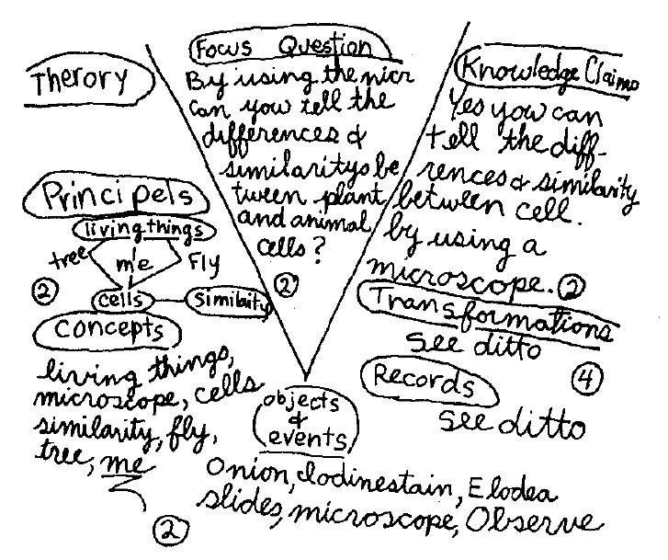

**Figure 3.2** A Vee diagram dealing with lab work on cell study prepared by a junior high biology student.

Why a Vee-shaped heuristic? There is nothing sacred or absolute about it, but we have found the Vee shape to be valuable for several reasons. First, the Vee "points" to the events or objects that are at the root of all knowledge production, and it is crucial that, for example, students become acutely aware of the events or objects they are experiencing, about which knowledge is to be constructed. Often this awareness is not present either in science laboratory work or work in other fields: For instance, what kind of events are we constructing when we con sider the equation 2X + 6 = 10? and what concepts and procedures lead us to claim that *x* = 2? Second, we have found that the Vee shape helps students recognize the tension and interplay between disciplinary knowledge constructed (and modified) over time and the knowledge an inquiry allows them to construct here and now. Although the conceptual elements on the left side of the Vee illuminate our inquiry, these are constructions (conceptions) that have been developed over time, whereas the elements on the right are constructions for the immediate inquiry. Although it is true that new knowledge claims may lead to new concepts or even new theories, this is a process that is spread over years or decades in most disciplines.

Another value of the Vee form is that because inquiries often go awry right at the bottom of the Vee, it is less easy to ignore relevant key events or objects or key concepts. With the point of the Vee signal, one is less likely to gather the wrong records or to fail to see the meaning of the records that are gathered. A perfect example of this trouble occurs repeatedly in educational research when investigators fail to recognize that the test response marked by a student is a very constrained kind of record of that student's thinking. Educational researchers may proceed to total the number of items marked "correctly," perform elegant statistical transformations on the test scores, and then produce claims about the "learning" effectiveness demonstrated by some group, procedure, or ability. When in fact, no records, of learning were made; no event of learning was observed. Whole sets of conceptual assumptions about the event of cognitive output that led to the student's marks on the test paper were simply ignored. Is it any wonder that educational research has produced so little functional knowledge in the past seventy-five years? (See Novak 1979b.) We will have more to say on the problems of learning evaluation in Chapters 7 and 8.

As time goes on and we continue to work with Gowin's Vee heuristic, we may find some other configural arrangement that is more powerful or more useful. This would be of no major consequence; heuristics -have no absolute or inherent validity; their value accrues only from whatever usefulness they exhibit. Nevertheless, it is likely that each of the elements on the right and left sides of the Vee will be necessary in any heuristic.

**INTRODUCING THE VEE**

Management of learning is never an easy task. When we attempt to achieve learning about knowledge (learning metaknowledge) we face problems that cut across all four of Schwab's commonplaces (the students, the teacher, the curriculum, and the milieu). The major problem involves governance: How do we focus attention on acquiring metaknowledge? The Vee helps solve this governance problem, and also helps with curriculum design, by structuring educational experience, in a way that requires that teacher and learner pay explicit attention to metaknowledge issues, whatever the specific context of the learning.

*Begin with concepts, objects, events.* Concept mapping should be introduced before the Vee so we are already familiar with two elements of the Vee: concepts, and the objects and/or events pertaining to them. The definition of concepts should be reviewed and a simple, familiar set of events chosen to illustrate them. For example, the regularities represented by the concepts water, melting, ice, steam, boiling, solid, liquid, and gas could be discussed with the students. No doubt many will have some fuzzy meanings for one or more of concepts related to their inquiry, but the variation in meanings will be useful to illustrate why different people sometimes see different things when they observe the same object(s) or event(s).

*Introduce the idea of records and focus questions.* When we are involved in constructing knowledge, we use concepts we know to observe events or objects and make some form of *records* of our observations. The kind of records we make is also guided by one or more *focus* *questions:* Different focus questions lead us to focus on different aspects of the events or objects we are observing. Again using the water example, we could ask, What happens to the temperature of ice water as we apply heat? or How does the appearance of water change as it changes from ice to steam? In the Vee in Figure 3.3, we have chosen the first question as our focus question. When asked if additional concepts are needed to understand what is happening in the event being observed, some might suggest steam, flame, and beaker or jar; others might cite more subtle concepts such as atoms, molecules, expansion (of mercury in the thermometer), temperature, or calories. The concepts of solid, liquid, and gas may also be applied.

|  |  |  |  |  |  |  |  |  |  |  |
| --- | --- | --- | --- | --- | --- | --- | --- | --- | --- | --- |
| **CONCEPTUAL**  **(thinking)** | **FOCUS QUESTION** | | | | | | | | | **METHODOLOGICAL**  **(doing)** |
| **Theories** | What happens to the temperature of ice water as we add heat? | | | | | | | | | **Claims**: |
| **Principles** | |  | | | | | | | **Transformations** | |
|  | | |  | | | | | |  | |
|  | | | |  | | | |  | | |
| **Concepts:** ice, water, head, thermometer | | | | |  | | **Records** | | | |
|  | | | | |  | |  | | | |
|  | | | | |  | |  | | | |
|  | **Events** | | | | |  | | | | |

**Figure 3.3 Sample Vee for constructing knowledge about the effect of heating on ice water.**

We begin to see that true understanding of an apparently simple event (heating ice water) requires the application of many concepts, some of which may have relatively little meaning at the outset. The obvious records to be kept in this example would be temperatures, time, and changes in the amount of ice and water and then we should ask how we think these records might be organized or transformed.

*Record transformation and knowledge claims.* The purpose of transforming records is to organize our observations in a form that allows us to construct answers to our focus question. We should discuss the different table formats suggested and decide which one( s) best organize observations to answer the focus question. All this serves to show that some of the creativity needed to construct new knowledge must be applied to finding the best way to organize observations. It should also become evident that the combinations of concepts and principles we know influences how we design record transformations.

From our transformed data, we can begin to construct *knowledge claims*. Knowledge claims are the products of an inquiry. Hereagain, constructingknowledge requires that we apply concepts and principles we alreadyknow. On the other hand, the process of constructing *new* knowledgeallows us to enhance and/or alter the meanings of those conceptsand principles, and to see, new relationships between them.There is an active interplay between what we know and our newobservations and knowledge claims. And this is how human culturesexpand their understanding of both natural and people-made eventsor objects. (There are other ways of predicting or interpreting events or objects - such as religion or clairvoyance - and may come into the discussion, but we are concerned here with rational inquiry only. )

Figure 3.4 shows records and a data table for the event of heating ice water. If this is the event chosen for observation, we can study the records and table and construct our own knowledge claims or answers to the focus question.

|  |  |  |  |  |  |  |
| --- | --- | --- | --- | --- | --- | --- |
| **CONCEPTUAL** | **FOCUS QUESTION** | | | | | **METHODOLOGICAL** |
|  | What happens to the temperature of ice water as we add heat? | | | | **Knowledge Claims**:  1. Ice melts when water is still cold  2. Water warms slowly  3. Water boils around 99C  4. Water’s temperature does not change when it is boiling | |
| **Concepts:** ice, water, head, thermometer, bubble, temperature | |  | | **Transformations**  Near 0C: Temperature rises a little if not stirred  Near 0C: Ice disappears  Temp Rising: Temperature rises slowly, bubbles of gas appear  Etc. | | |
|  | |  | **Records**  Water temperature rises from near 0C to 99C. Ice disappears. Bubble begin to form. Many bubbles form near bottom of beaker. | | | |
|  | **Event:** Heating ice water | | | | |  |

**Figure 3.4** The Vee showing concepts, records, transformed records, and knowledge claims for the event of heating ice water. More detailed records are shown in Table 3.1.

Knowledge claims are dependent on the kind of records we choose to make and the way we transform our data. For example, see the data in Table 3.1. Some may recognize that the temperature remained fairly constant when water was changing from ice to liquid or liquid to gas, but may not know the concepts, principles, or theory necessary to explain these observations. Some might suggest that we could further transform our observations by making a graph plotting water temperature against time. Graphs are a common form of record transformation in the natural and social sciences. Figure 3.5 shows a graph constructed from the information in Table 3.1.

As we acquire more experience with the Vee heuristic, we could try to construct a variety of record transformations for the same event, which could be a good test of our creativity as well as of our understanding of relevant concepts.

**Table 3.1.** One example of transformed data for the event of heating water

|  |  |  |
| --- | --- | --- |
| **Time** | **Temperature** | **Observation** |
| 10:00 | 1C | Ice is floating near top |
| 10:05 | 3C | Ice water is a little warmer |
| 10:06 | 1C | Temp drops after water is stirred |
| 10:10 | 2C | Most of ice is melted |
| 10:12 | 8C | Ice gone, temp rising; bubble appear |
| 10:14 | 30C | Water temp rising |
| 10:16 | 51C | Water temp rising |
| 10:18 | 71C | Water temp rising |
| 10:22 | 98C | Water temp rising; small bubbles on sides are gone, bubbles begin to appear at bottom of beaker |
| 10:23 | 99C | Large bubbles appear at bottom |
| 10:28 | 99C | Temp constant, water is boiling |

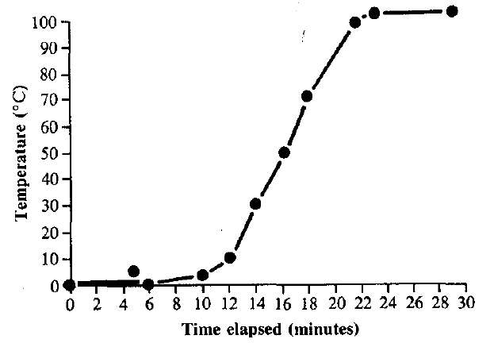

**Figure 3.5 A graph constructed from the experiment shown in Figure 3·4 and the data in Table 3.1.**

*Principles and theories.* On the left side of the Vee, above concepts, are *principles* and *theories.* Principles are significant relationships between two or more concepts that guide our understanding of the significant action in the events studied. For example, the principle "Pure water boils at 1000 C at sea level" describes a specific relationship between the boiling point of a pure substance (water) at a given atmospheric pressure (sea level or 760 mm of mercury).

Principles come from knowledge claims produced by inquiries over time, and they in turn guide the observation of events or objects and the transformation of records in subsequent inquiries. Principles are something scholars in a discipline construct, and students of a discipline may eventually understand. In ordinary science laboratory work, we are often not explicitly aware of the principles that might be guiding their inquiry, and it is useful to spend some time identifying one or more principles relevant to an inquiry, although this is difficult if one is not thoroughly familiar with the discipline. For example, in addition to the principle relating the boiling point of water and air pressure, other principles relevant to our example would be density (ice is less dense than water and floats; warm water is less dense than cold and rises), diffusion and convection (which account for the small rise in temperature and the drop after stirring), and energy conservation (heat energy is being transferred to the ice water). Even a simple event can be enormously complex, depending on how far we wish to go in the range and precision of the observations we make and the subsequent knowledge claims we choose to construct.

Theories are similar to principles in that they explain relationships between concepts, but they organize concepts and principles in order to describe events and claims about events. Theories are usually regarded as broader and more inclusive than principles and may encompass dozens of specific concepts and principles. Thus, the cell theory in biology and the kinetic molecular theory in physical science are broad explanatory ideas that subsume hundreds of more specific relationships. This makes theories powerful for guiding inquiries, but it also accounts for why theories are difficult to understand. Even specialists in a field may differ in their understanding of a theory, but they all use the theory as best they can to design studies and/or to explain their observations. Principles tell us *how* events or objects appear or behave, whereas theories tell us *why* they do *so.*

Because they are broad and comprehensive by nature, there are relatively few theories in each discipline. It usually takes a genius to a few geniuses per century. People like Newton, Darwin, and Einstein in the sciences and Mozart and Bach in music arc very rare. Even Bach and Mozart never actually propounded new theories of music, although they did significantly alter the scope and richness of musical events through their creative works. In general, though theories in different domains of human understanding - science, literature, mathematics, philosophy - take on somewhat different structures, they all represent broad, inclusive standards of meaning and excellence in those fields.

In spite of their somewhat elusive nature, theories should not be ignored, and whenever possible used to help understand our inquiries. For instance, kinetic molecular theory would be relevant to the water and ice experiment for those sufficiently conversant with the structures of science.

*Value claims.* Up to this point, our attention has been focused on the knowledge elements of the Vee. We have found that it is best to delay discussion of value claims until we are familiar and comfortable with knowledge claims. There is always an affective or feeling component in knowledge and value claims, and the feelings can sometimes be intensely positive or negative (as with claims about tobacco, drugs, or sex). Value claims give answers to value questions such as, Is this any good? Or bad? What is it good for? Is it right? Ought we choose it? Can we make it better? In our two examples, the claims one could make are not likely to have emotional valence. In the Vee on water and ice, we could suggest such value claims as, It is good to avoid unnecessary freezing and thawing to save energy. Or, wasting hot water is an misuse of energy.

Knowledge claims and value claims are not independent. Gowin (1981) suggests that knowledge claims and value claims "ride in the same boat, but they are not the same passenger." There is an interrelationship, but there is also a distinction, and it is important to stress this judgment.

