**PREPOSITIONS, PREPOSITIONAL PHRASES**

**Prepositions of TIME**

Taken from: <http://www.tinyteflteacher.co.uk/learning-english/prepositions/prepositions-time.html>

**IN**

We use **in** with years, seasons and months.

I got married **in 2007**.

I got married **in winter**.

I got married **in December**.

**ON**

We use **on** with days and dates.

I got married **on 31st December**.

I got married **on New Year's Eve**.

**AT**

We use **at** with times and well-known holiday periods.

I got married **at 3.30**.

I got married **at New Year**.

Here are some other *examples you should learn*:

* **In** + the morning, the afternoon, the evening, but **at** night.
* **At** + mealtimes (at breakfast, at dinner ...).
* **At** + the weekend.
* **At** the moment, **at** present, **at** that moment.
* **In** the past, **in** the future.

Remember: we don't use in/on/at when we say "this / last / next".

I'll see you **next week**.

**1. Complete the sentences with the correct preposition.**

1) We all meet ___________ Christmas.

2) We have a turkey for dinner ___________ Christmas Day.

3) She feels sleepy ___________ the morning.

4) I’m sorry, I can’t talk to you __________ the moment.

5) Last night he went to bed __________ midnight.

6) I’ll give you a ring ________ Sunday morning _________ 10 o’clock.

7) In England, the school term ends ___________ July.

8) People used to commute to work by tram ___________ the past.

9) There’s a big party at Freedom Square __________ New Year’s Eve.

10) We have a meeting _________ the first Tuesday of the month.

11) Charles is arriving _________ November, 17th, _________ three o’clock _________ the afternoon.

12) She started studying at university __________ 2013.

13) Ok. See you _________ next week __________ Tuesday.

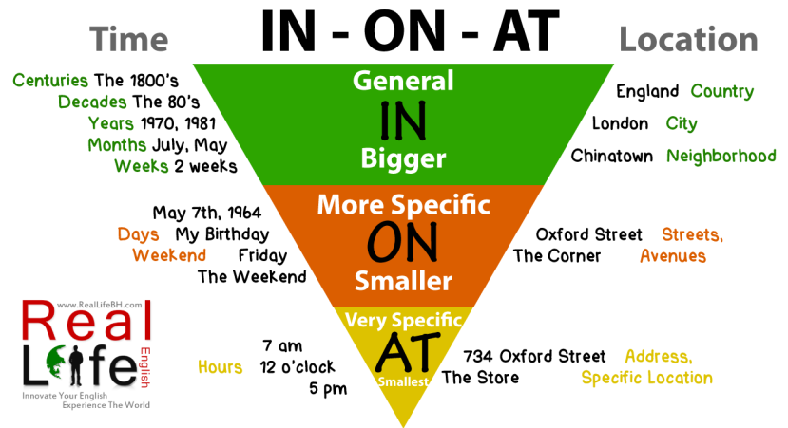

Picture taken from <http://reallifebh.com/wp-content/uploads/2014/02/in-on-at.png>

##### **Prepositions of PLACE**

Taken from:

<http://www.ecenglish.com/learnenglish/lessons/in-on-at-prepositions-place>, <http://www.learnenglish.de/grammar/prepositionplace.html>

**IN**

We use **in** to show that something is enclosed or surrounded.

The dog is **in the garden**.  
She is **in a taxi**.   
Put it **in the box**.

We also use **in** to show position within land-areas (towns, states, countries, and continents).

I used to live **in Nottingham**.

**ON**

We use **on** to show position on a horizontal or vertical surface.  
 The cat sat **on the mat**.  
 The satellite dish is **on** **the roof**.

**AT**

We use **at** to show a specific place or position.

Someone is **at the door**.  
They are waiting **at** **the bus stop**.  
 I used to live **at** **51 Portland Street**.

**2. Complete the sentences using IN, ON or AT.**

1) I always keep some extra money *___* my bag in case of emergencies.  
2) I'll read it tonight ___ home.  
3) Do you live ___ a house or an apartment?  
4) I read about it ___ the newspaper.  
5) He went for a swim ___ the river.  
6) The dog's sleeping ___ the carpet.  
7) The information is ___ the top of the page.

8) Were you ___ the party too?

**Other prepositions of PLACE / MOVEMENT**

**under, over, next to, between, near (to), in front of, behind, up, down, to, away from, past, into, onto, out of, around, through, across, along**

**3. Complete the sentences using the correct preposition from the brackets.**

<http://www.learnenglish.de/tests/prepositions/prepofmovement.html>

1) The mouse ran __________ the table to hide. *(through / in / under)*

2) The dog ran **__________** the garden to play. *(into / onto / over)*

3) The ship sailed **__________** the world. *(round / through / over)*

4) The train went **__________** the tunnel. *(over / through / onto)*

5) The paint fell **__________** the floor. *(into / onto / round)*

6) She broke her leg when she fell **___________** the stairs. *(off / in / down)*

7) The burglar made a mistake when he ran **__________** the policeman. *(towards / under / onto)*

8) I was tired after walking **___________** the hill. *(through / into / up)*

9) When the train arrived at my destination I got **__________**. *(into / onto / off)*

10) The horse jumped **__________** the fence. *(over / under / down)*

**Prepositional phrases – VERBS + PREPOSITIONS**

**AT - look at, shout at, smile/ laugh at**

**TO - listen to, write to, talk/speak to, look forward to**

**FOR - look for, ask for, pay for, wait for, feel/be sorry for, apply for**

**ON - spend money on, depend on, insist on, rely on, concentrate on, congratulate sb. on sth.**

**IN - believe in, succeed in, specialise in**

**OF - remind sb. of, afraid of, die of**

**WITH - agree with, share sth. with sb., deal with**

**No preposition**

**meet sb., marry sb., divorce sb., play the (musical instrument), phone/call sb., tell sb.**

**4. Fill in the missing prepositions**

1. You remind me ________ one of my classmates. She's got long dark hair and a little nose, too.
2. Mary admitted she shouted ________ her little sister yesterday and now she feels really sorry.
3. The little baby smiled ________ her parents for the first time. They were very happy.
4. I feel sorry ________ my students. I can't imagine sitting at the desk for almost six hours a day.
5. The boys laughed ________ him because he was clumsy.
6. His aunt died ________ cancer when she was young.
7. Sorry, I can’t decide it. It doesn’t depend ________ me.
8. Look ________ the sunset! It's so beautiful.
9. I’m afraid I don’t agree _________ you about the decision.

10) She is looking forward _________ seeing us at the meeting.

11) I really trust him and I think I can rely ________ him in every situation.

12) Kevin told ______ me about his sister’s accident.

**Note:**

**WORK + PREPOSITION** (work **in** a town/building, work **on** a project, work **for** a company, work **as** a journalist/an actor, work **with** people/material)

**Prepositional phrases – ADJECTIVES + PREPOSITIONS**

**ABOUT - excited about, worried about, nervous about, angry about sth., annoyed about sth., furious about**

**AT - good at, bad at, hopeless at**

**FOR - famous for, well known for, responsible for**

**OF - afraid of, frightened of, scared of, proud of, full of, aware of, tired of**

**- nice / kind / good / friendly / polite / rude / stupid of someone to do something**

**TO - engaged to, married to, similar to**

**- be nice/ kind/ good/ friendly/ polite/ rude to someone**

**WITH - pleased with, disappointed with, happy with, satisfied with, angry/ annoyed with sb.**

**5. Fill in the missing prepositions**

1) We were disappointed ______ the football match.

2) I’m excited ______ having my birthday party tomorrow.

3) You look very pleased ______ yourself.

4) I’m angry ______ all the mess you have made.

5) I’m not very good ______ mathematics.

6) Your camera is similar ______ mine.

7) Brazil is famous ______ its coffee.

8) Are you scared ______ spiders?

9) Who is responsible ______ breaking this window?

10) My homework was full ______mistakes.

11) I’m tired ______doing the same things every day.

12) It was very nice ______ Sam to lend you the money.

13) A shop assistant should be polite ______ customers.

14) I’m very proud ______you.