# Popis zkoumaného vzorku

**Frequencies**

|  |  |  |
| --- | --- | --- |
| **Statistics** | | |
| Gender | | |
| N | Valid | 9617 |
| Missing | 0 |

|  |  |  |  |  |  |
| --- | --- | --- | --- | --- | --- |
| **Gender** | | | | | |
|  | | Frequency | Percent | Valid Percent | Cumulative Percent |
| Valid | Female | 4905 | 51,0 | 51,0 | 51,0 |
| Male | 4712 | 49,0 | 49,0 | 100,0 |
| Total | 9617 | 100,0 | 100,0 |  |

**Frequencies**

|  |  |  |
| --- | --- | --- |
| **Statistics** | | |
| Age | | |
| N | Valid | 9617 |
| Missing | 0 |
| Mean | | 15,7827 |
| Std. Deviation | | ,28981 |
| Minimum | | 15,25 |
| Maximum | | 16,42 |

**Crosstabs**

|  |  |  |  |  |  |  |
| --- | --- | --- | --- | --- | --- | --- |
| **Case Processing Summary** | | | | | | |
|  | Cases | | | | | |
| Valid | | Missing | | Total | |
| N | Percent | N | Percent | N | Percent |
| Country code 3-character * OECD country | 9617 | 100,0% | 0 | 0,0% | 9617 | 100,0% |

|  |  |  |  |  |
| --- | --- | --- | --- | --- |
| **Country code 3-character * OECD country Crosstabulation** | | | | |
| Count | | | | |
|  | | OECD country | | Total |
| No | Yes |
| Country code 3-character | Australia | 0 | 526 | 526 |
| Austria | 0 | 251 | 251 |
| Belgium | 0 | 368 | 368 |
| Brazil | 431 | 0 | 431 |
| Canada | 0 | 624 | 624 |
| Colombia | 287 | 0 | 287 |
| Czech Republic | 0 | 279 | 279 |
| Germany | 0 | 217 | 217 |
| Denmark | 0 | 267 | 267 |
| Dominican Republic | 50 | 0 | 50 |
| Spain | 0 | 230 | 230 |
| Estonia | 0 | 254 | 254 |
| Finland | 0 | 250 | 250 |
| France | 0 | 207 | 207 |
| United Kingdom | 0 | 504 | 504 |
| Greece | 0 | 183 | 183 |
| Hungary | 0 | 220 | 220 |
| Switzerland | 0 | 238 | 238 |
| Chile | 0 | 145 | 145 |
| Ireland | 0 | 209 | 209 |
| Iceland | 0 | 134 | 134 |
| Israel | 0 | 246 | 246 |
| Italy | 0 | 479 | 479 |
| Japan | 0 | 277 | 277 |
| Korea | 0 | 165 | 165 |
| Luxembourg | 0 | 197 | 197 |
| Latvia | 0 | 214 | 214 |
| Mexico | 0 | 202 | 202 |
| Netherlands | 0 | 226 | 226 |
| Norway | 0 | 205 | 205 |
| New Zealand | 0 | 142 | 142 |
| Poland | 0 | 163 | 163 |
| Portugal | 0 | 216 | 216 |
| Slovak Republic | 0 | 261 | 261 |
| Slovenia | 0 | 290 | 290 |
| Sweden | 0 | 208 | 208 |
| Tunisia | 102 | 0 | 102 |
| United States | 0 | 150 | 150 |
| Total | | 870 | 8747 | 9617 |

# Popis učebních návyků (deskriptivní statistiky + vhodný graf)

**Frequencies**

|  |  |  |  |  |  |
| --- | --- | --- | --- | --- | --- |
| **Statistics** | | | | | |
|  | | Learning time (minutes per week) - <Mathematics> | Learning time (minutes per week) - <native language> | Learning time (minutes per week) - <science> | Learning time (minutes per week) - in total |
| N | Valid | 9478 | 9475 | 9437 | 9617 |
| Missing | 139 | 142 | 180 | 0 |
| Mean | | 212,19 | 209,17 | 206,17 | 1582,19 |
| Median | | 200,00 | 200,00 | 180,00 | 1575,00 |
| Std. Deviation | | 73,125 | 74,877 | 125,490 | 212,943 |
| Skewness | | ,619 | ,943 | 1,407 | ,241 |
| Std. Error of Skewness | | ,025 | ,025 | ,025 | ,025 |
| Kurtosis | | 3,396 | 4,562 | 6,138 | -,146 |
| Std. Error of Kurtosis | | ,050 | ,050 | ,050 | ,050 |
| Minimum | | 0 | 0 | 0 | 1050 |
| Maximum | | 720 | 900 | 1600 | 2125 |

**Histogram**

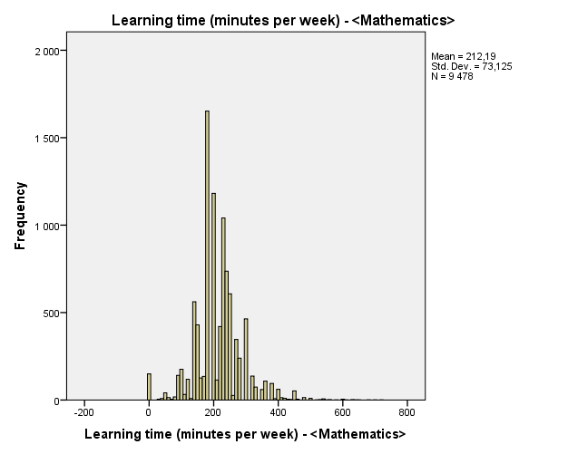

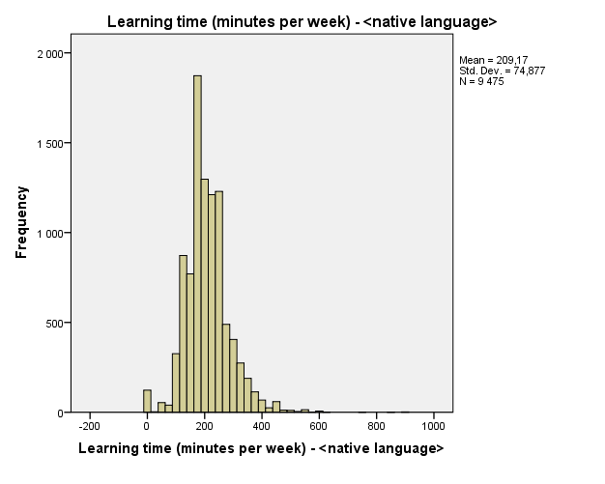

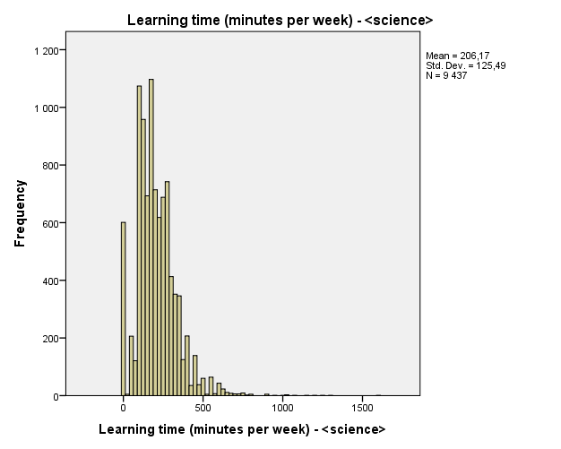

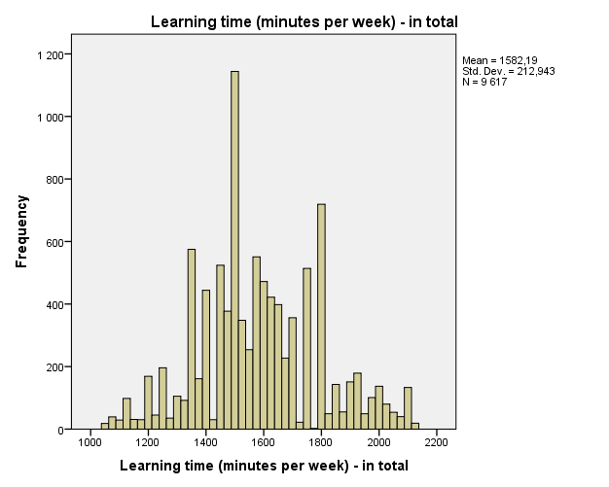

# Učební návyky v porovnání zemí OECD a neOECD

**Learning time (minutes per week) - in total**

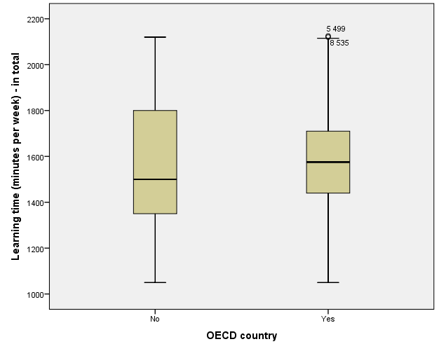

# Výzkumné otázky S01

**Crosstabs**

|  |  |  |  |  |  |  |
| --- | --- | --- | --- | --- | --- | --- |
| **Case Processing Summary** | | | | | | |
|  | Cases | | | | | |
| Valid | | Missing | | Total | |
| N | Percent | N | Percent | N | Percent |
| In your home: A room of your own * OECD country | 9326 | 97,0% | 291 | 3,0% | 9617 | 100,0% |

|  |  |  |  |  |  |
| --- | --- | --- | --- | --- | --- |
| **In your home: A room of your own * OECD country Crosstabulation** | | | | | |
|  | | | OECD country | | Total |
| No | Yes |
| In your home: A room of your own | Yes | Count | 617 | 7409 | 8026 |
| % within OECD country | 71,4% | 87,6% | 86,1% |
| No | Count | 247 | 1053 | 1300 |
| % within OECD country | 28,6% | 12,4% | 13,9% |
| Total | | Count | 864 | 8462 | 9326 |
| % within OECD country | 100,0% | 100,0% | 100,0% |

|  |  |  |  |  |  |
| --- | --- | --- | --- | --- | --- |
| **Chi-Square Tests** | | | | | |
|  | Value | df | Asymptotic Significance (2-sided) | Exact Sig. (2-sided) | Exact Sig. (1-sided) |
| Pearson Chi-Square | 170,321a | 1 | ,000 |  |  |
| Continuity Correctionb | 168,978 | 1 | ,000 |  |  |
| Likelihood Ratio | 140,855 | 1 | ,000 |  |  |
| Fisher's Exact Test |  |  |  | ,000 | ,000 |
| Linear-by-Linear Association | 170,302 | 1 | ,000 |  |  |
| N of Valid Cases | 9326 |  |  |  |  |

|  |
| --- |
| a. 0 cells (0,0%) have expected count less than 5. The minimum expected count is 120,44. |
| b. Computed only for a 2x2 table |

**Crosstabs**

|  |  |  |  |  |  |  |
| --- | --- | --- | --- | --- | --- | --- |
| **Case Processing Summary** | | | | | | |
|  | Cases | | | | | |
| Valid | | Missing | | Total | |
| N | Percent | N | Percent | N | Percent |
| In your home: A quiet place to study * OECD country | 9532 | 99,1% | 85 | 0,9% | 9617 | 100,0% |

|  |  |  |  |  |  |
| --- | --- | --- | --- | --- | --- |
| **In your home: A quiet place to study * OECD country Crosstabulation** | | | | | |
|  | | | OECD country | | Total |
| No | Yes |
| In your home: A quiet place to study | Yes | Count | 660 | 8006 | 8666 |
| % within OECD country | 77,1% | 92,3% | 90,9% |
| No | Count | 196 | 670 | 866 |
| % within OECD country | 22,9% | 7,7% | 9,1% |
| Total | | Count | 856 | 8676 | 9532 |
| % within OECD country | 100,0% | 100,0% | 100,0% |

|  |  |  |  |  |  |
| --- | --- | --- | --- | --- | --- |
| **Chi-Square Tests** | | | | | |
|  | Value | df | Asymptotic Significance (2-sided) | Exact Sig. (2-sided) | Exact Sig. (1-sided) |
| Pearson Chi-Square | 217,212a | 1 | ,000 |  |  |
| Continuity Correctionb | 215,379 | 1 | ,000 |  |  |
| Likelihood Ratio | 165,296 | 1 | ,000 |  |  |
| Fisher's Exact Test |  |  |  | ,000 | ,000 |
| Linear-by-Linear Association | 217,189 | 1 | ,000 |  |  |
| N of Valid Cases | 9532 |  |  |  |  |

|  |
| --- |
| a. 0 cells (0,0%) have expected count less than 5. The minimum expected count is 77,77. |
| b. Computed only for a 2x2 table |

**Crosstabs**

|  |  |  |  |  |  |  |
| --- | --- | --- | --- | --- | --- | --- |
| **Case Processing Summary** | | | | | | |
|  | Cases | | | | | |
| Valid | | Missing | | Total | |
| N | Percent | N | Percent | N | Percent |
| In your home: A computer you can use for school work * OECD country | 9540 | 99,2% | 77 | 0,8% | 9617 | 100,0% |

|  |  |  |  |  |  |
| --- | --- | --- | --- | --- | --- |
| **In your home: A computer you can use for school work * OECD country Crosstabulation** | | | | | |
|  | | | OECD country | | Total |
| No | Yes |
| In your home: A computer you can use for school work | Yes | Count | 612 | 8087 | 8699 |
| % within OECD country | 71,3% | 93,1% | 91,2% |
| No | Count | 246 | 595 | 841 |
| % within OECD country | 28,7% | 6,9% | 8,8% |
| Total | | Count | 858 | 8682 | 9540 |
| % within OECD country | 100,0% | 100,0% | 100,0% |

|  |  |  |  |  |  |
| --- | --- | --- | --- | --- | --- |
| **Chi-Square Tests** | | | | | |
|  | Value | df | Asymptotic Significance (2-sided) | Exact Sig. (2-sided) | Exact Sig. (1-sided) |
| Pearson Chi-Square | 462,405a | 1 | ,000 |  |  |
| Continuity Correctionb | 459,695 | 1 | ,000 |  |  |
| Likelihood Ratio | 324,397 | 1 | ,000 |  |  |
| Fisher's Exact Test |  |  |  | ,000 | ,000 |
| Linear-by-Linear Association | 462,357 | 1 | ,000 |  |  |
| N of Valid Cases | 9540 |  |  |  |  |

|  |
| --- |
| a. 0 cells (0,0%) have expected count less than 5. The minimum expected count is 75,64. |
| b. Computed only for a 2x2 table |

**Crosstabs**

|  |  |  |  |  |  |  |
| --- | --- | --- | --- | --- | --- | --- |
| **Case Processing Summary** | | | | | | |
|  | Cases | | | | | |
| Valid | | Missing | | Total | |
| N | Percent | N | Percent | N | Percent |
| In your home: A link to the Internet * OECD country | 9531 | 99,1% | 86 | 0,9% | 9617 | 100,0% |

|  |  |  |  |  |  |
| --- | --- | --- | --- | --- | --- |
| **In your home: A link to the Internet * OECD country Crosstabulation** | | | | | |
|  | | | OECD country | | Total |
| No | Yes |
| In your home: A link to the Internet | Yes | Count | 694 | 8418 | 9112 |
| % within OECD country | 80,6% | 97,1% | 95,6% |
| No | Count | 167 | 252 | 419 |
| % within OECD country | 19,4% | 2,9% | 4,4% |
| Total | | Count | 861 | 8670 | 9531 |
| % within OECD country | 100,0% | 100,0% | 100,0% |

|  |  |  |  |  |  |
| --- | --- | --- | --- | --- | --- |
| **Chi-Square Tests** | | | | | |
|  | Value | df | Asymptotic Significance (2-sided) | Exact Sig. (2-sided) | Exact Sig. (1-sided) |
| Pearson Chi-Square | 506,695a | 1 | ,000 |  |  |
| Continuity Correctionb | 502,779 | 1 | ,000 |  |  |
| Likelihood Ratio | 310,648 | 1 | ,000 |  |  |
| Fisher's Exact Test |  |  |  | ,000 | ,000 |
| Linear-by-Linear Association | 506,642 | 1 | ,000 |  |  |
| N of Valid Cases | 9531 |  |  |  |  |

|  |
| --- |
| a. 0 cells (0,0%) have expected count less than 5. The minimum expected count is 37,85. |
| b. Computed only for a 2x2 table |

# Výzkumné otázky S02

**Independent Samples T-Test**

|  |  |  |  |  |  |
| --- | --- | --- | --- | --- | --- |
| **Group Statistics** | | | | | |
|  | OECD country | N | Mean | Std. Deviation | Std. Error Mean |
| Learning time (minutes per week) - <Mathematics> | No | 844 | 210,12 | 74,150 | 2,552 |
| Yes | 8634 | 212,39 | 73,026 | ,786 |

|  |  |  |  |  |
| --- | --- | --- | --- | --- |
|  | t-test for Equality of Means | | | |
|  | t | df | Sig. (2-tailed) | Mean Difference |
| Learning time (minutes per week) - <Mathematics> | -,862 | 9476 | ,389 | -2,273 |

**Independent Samples T-Test**

|  |  |  |  |  |  |
| --- | --- | --- | --- | --- | --- |
| **Group Statistics** | | | | | |
|  | OECD country | N | Mean | Std. Deviation | Std. Error Mean |
| Learning time (minutes per week) - <native language> | No | 845 | 206,32 | 70,033 | 2,409 |
| Yes | 8630 | 209,45 | 75,333 | ,811 |

|  |  |  |  |  |
| --- | --- | --- | --- | --- |
|  | t-test for Equality of Means | | | |
|  | t | df | Sig. (2-tailed) | Mean Difference |
| Learning time (minutes per week) - <native language> | -1,159 | 9473 | ,246 | -3,129 |

**Independent Samples T-Test**

|  |  |  |  |  |  |
| --- | --- | --- | --- | --- | --- |
| **Group Statistics** | | | | | |
|  | OECD country | N | Mean | Std. Deviation | Std. Error Mean |
| Learning time (minutes per week) - <science> | No | 831 | 182,56 | 114,562 | 3,974 |
| Yes | 8606 | 208,45 | 126,267 | 1,361 |

|  |  |  |  |  |
| --- | --- | --- | --- | --- |
|  | t-test for Equality of Means | | | |
|  | t | df | Sig. (2-tailed) | Mean Difference |
| Learning time (minutes per week) - <native language> | -5,689 | 9435 | ,000 | -25,889 |

# Výzkumné otázky S03

**Correlations**

|  |  |  |  |  |
| --- | --- | --- | --- | --- |
| **Correlations** | | | | |
|  | | School performance - Science | School performance - Mathematics | School performance - Reading |
| Personality: Test Anxiety (WLE) | Pearson Correlation | -,215** | -,232** | -,137** |
| Sig. (2-tailed) | ,000 | ,000 | ,000 |
| N | 9617 | 9617 | 9617 |

|  |
| --- |
| **. Correlation is significant at the 0.01 level (2-tailed). |