* 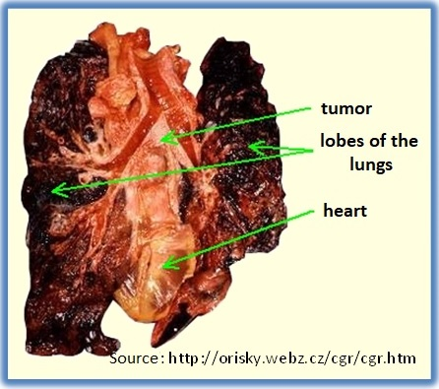

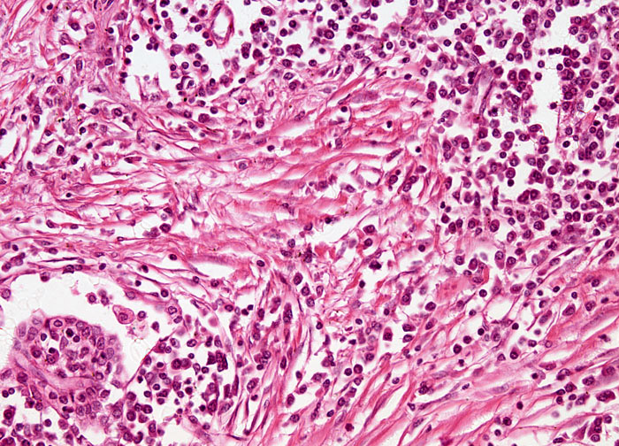

Bronchogenní karcinoma – microscopic picture

**http://www.microscopyu.com/galleries/pathology/index.html**

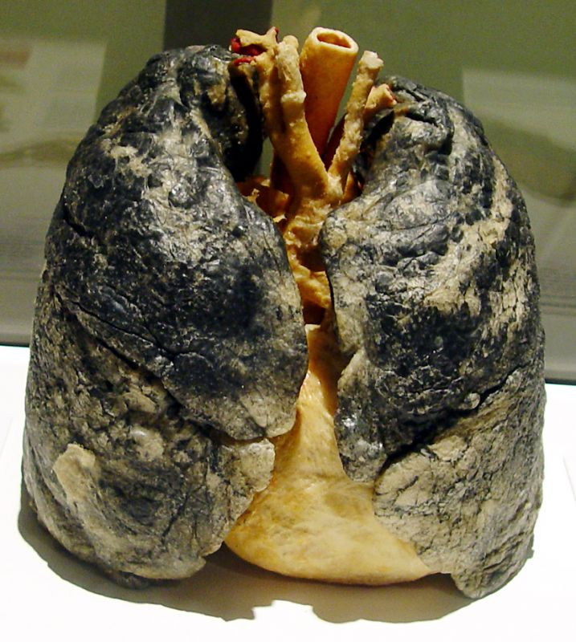

**Source:** BODIES…THE EXHIBITION.

Available from: http://www.people.cz/mag/cs/articles-detail/aid-11624

# Smoker’s lungs