# Healthy lungs

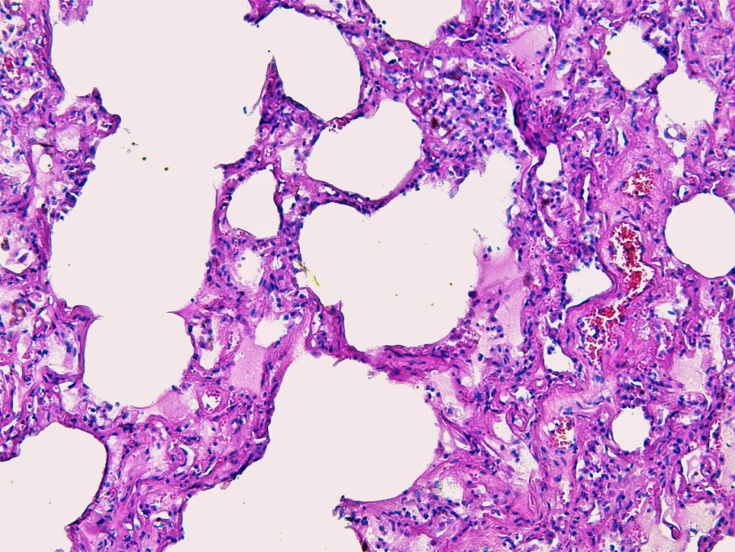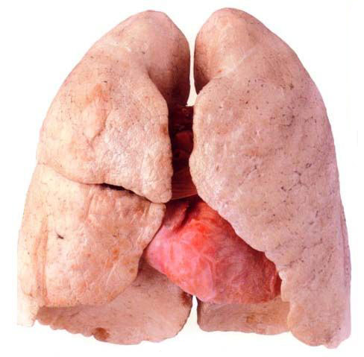

Photo: M. Jančová

Lung microscopic picture (100 x magnification)

**Source**: http://strankaprotikoureni.webnode.cz/news/plice-/