Learning about vocabulary

Collocation

A collocation is a pair of words that are often used together. There are many different types of collocation. Here are some examples:

ADJECTIVE + NOUN | private school
VERB + NOUN | do your homework
ADVERB + ADJECTIVE | highly educated
VERB + ADVERB | study hard

Collocations are sometimes very different in English and your first language, for example:

In English we say... | We don't say...
take an exam | write an exam
make a mistake | did a mistake
a primary school | a basic school
a tall student | a high student

Native speakers will usually understand mistakes like write an exam, but learning collocations will help you sound more natural and fluent.

Finding collocations with SKELL

Sketch Engine for Language Learning (SKELL) is an online tool that helps language learners understand more about how words are used in English. The Word sketch tool (1) will help you find useful collocations to learn, and the Examples tool (2) will show you simple examples of how words and phrases are used in real life.

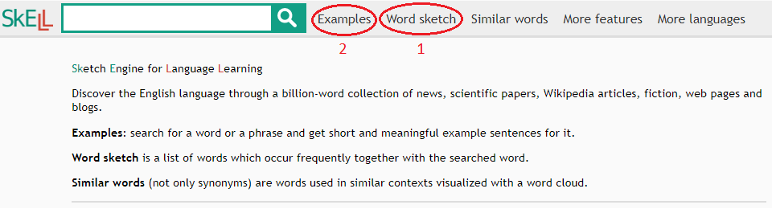

(1) Word sketch

To find useful collocations, enter a word in the search box and click on 'Word sketch' with the mouse. For example, the word school:

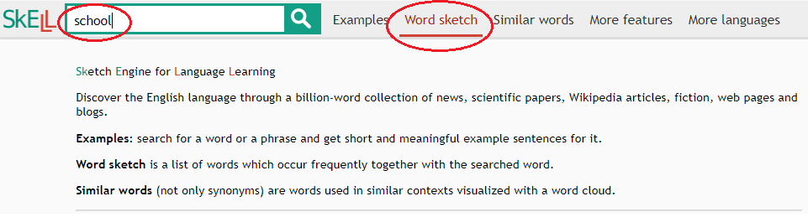

Here you can see the most useful collocations with the word school. To see more information, click on 'Context'.

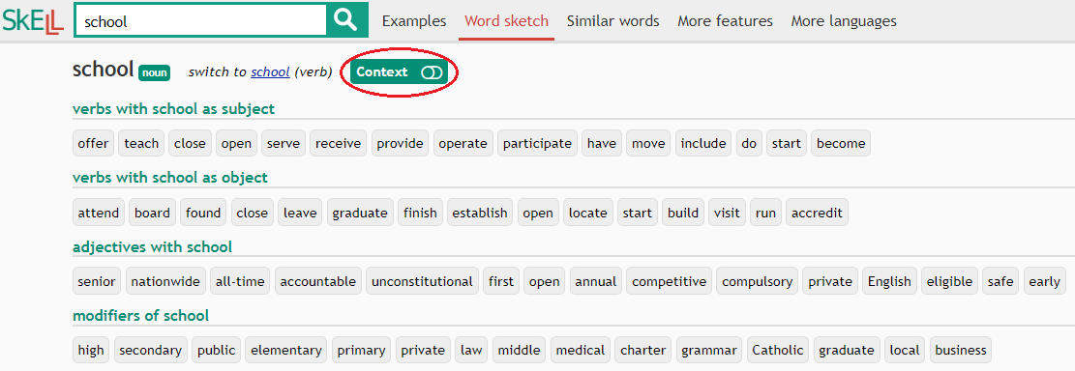

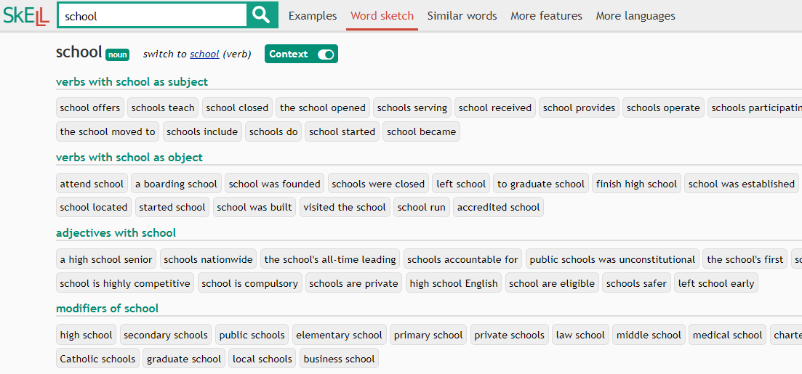

Now click on a collocation to see example sentences. For example, the collocation attend school:

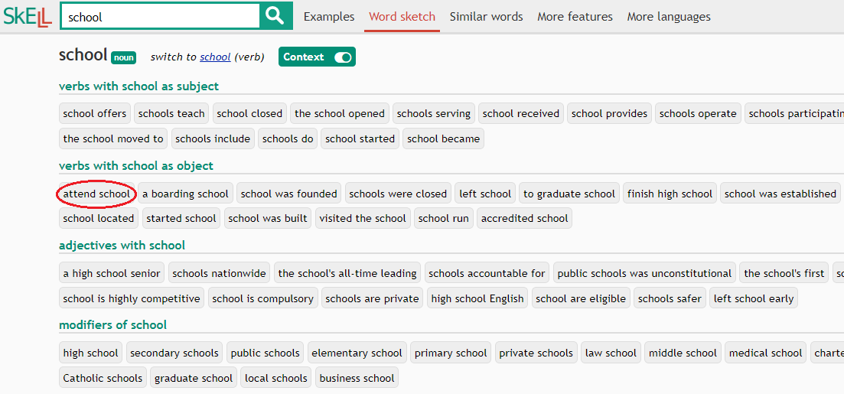

For common collocations like attend school, you can see up to 40 example sentences.

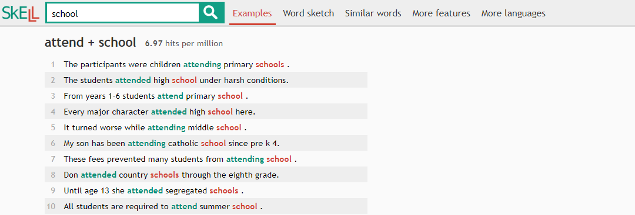

Practice

1. Brainstorm words on the topic of the education. Choose a word that interests you and use the Word sketch tool to search for collocations. Draw a mind map with your word and four or five collocations.

2. Click on the collocations to see example sentences. Write down two or three sentences that show how each collocation is often used in real life.

(2) Examples

To find examples of words or phrases, enter a single word or phrase in the search box and click on 'Examples' with the mouse. For example, the phrase graduate from university:

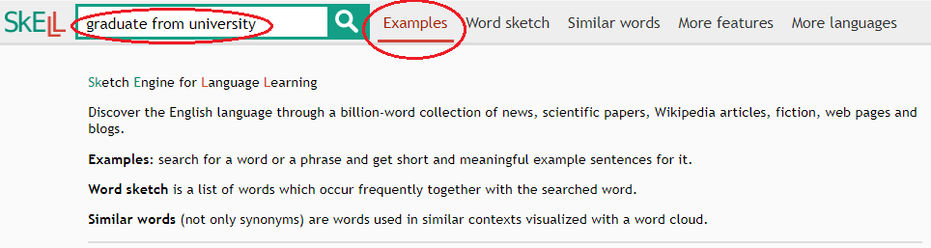

For common words or phrases, you can see up to 40 example sentences.

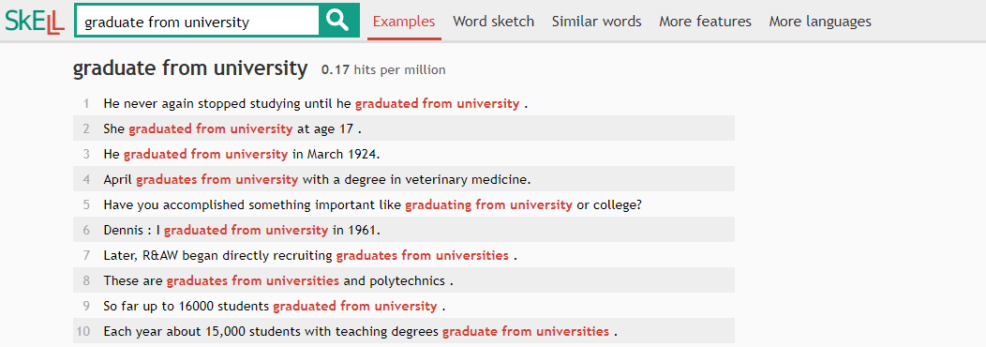

Practice

1. Brainstorm phrases (two or more words) on the topic of the education. Choose a phrase that interests you and use the Examples tool to search for example sentences. Write down two or three sentences that show how the phrase is often used in real life.

SKELL is available for free here: https://skell.sketchengine.co.uk/run.cgi/skell

