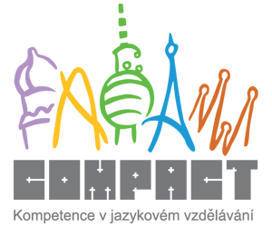

Modal Verbs
Form and use:
- Modals do not take a final –s, even when the subject is she, he, it (She can do it.). The only exception is have to: She has to do it.
- Modals have the same form in all persons.
- Modals are followed immediately by the simple form of a verb (= infinitive). (She can do it.)
- There is NO do or does in questions or negative phrases. When we want to make a question we just change the word order. (She can do it. – Can she do it? – She cannot do it.) The only exception is have to: Does she have to do it? – She doesn’t have to do it.
Modal verbs | Czech eqv. | Use
can / can’t |  | ability (=>schopnost):  Sue can dance quite well but she can’t sing.  permission (=>povolení):  You can’t come in here.  Can we go home now?
must  need not |  | necessity/obligation (=> nutnost/povinnost):  You must clean your room.  lack of necessity (=> není to nutné)  He needn’t come in person, he can send an email.
have to  don’t have to |  | necessity/obligation (=> nutnost, povinnost):  You can’t turn right. You have to turn left.  it’s not necessary (=> není to nutné):  We don’t have to arrive on time.
mustn‘t |  | you can’t do st. because it’s prohibited (=> zákaz):  You must keep it a secret. You mustn’t tell anyone.
should /shouldn’t |  | something is/isn’t a good idea to do (to give advice, to make a suggestion) (=> rada, návrh):  You look tired. You should go to bed.
would / wouldn’t |  | a hypothetical action or event in the present (=>hypotetická možnost v přítomnosti):  I would go there if I had time. (But I don’t have it.)
may / may not  might / might not  (carries less probability than “may”) |  | it’s (not) possible (=>možnost):  It may/might be true.  I’m not sure whether I can lend you any money. I may not have enough.

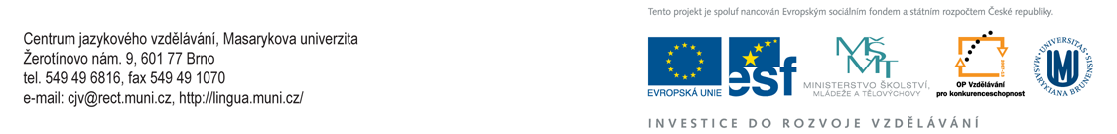
PRACTICE
1 Complete the sentences. Use must, mustn’t, don’t/doesn’t have to.
1 We haven’t got much time. We __________ hurry.
2 We have enough food at home so we __________ go shopping today.
3 Jim gave me a letter to post yesterday. I __________ remember to post it today.
4 Jim gave me a letter to post yesterday. I __________ forget to post it today.
5 There is plenty of time for you to make up your mind. You __________ decide now.
6 Jane __________ wash those tomatoes. They’ve already been washed.
7 This is a valuable book. You __________ look after it carefully and you __________ lose it.
8 “What sort of house do you want to buy?“ “Well, it __________ be big, that’s not important. But it __________ have a nice garden, because I love flowers.“

2 Complete the sentences. Use mustn’t or don’t have to.
1 The windows aren’t very dirty. You __________ clean them.
2 Keep these documents in a safe place. You __________ lose them.
3 We __________ forget to turn off the lights before we leave.
4 I __________ write the letter now. I can do it tomorrow.

3 Choose the correct completion according to the meaning.
1 She got the job because she __________ speak five languages.
- must b. can
2 A: “I have a toothache.” B: “You __________ go to a doctor.”
- would b. should
3 They __________ finish the bridge in time for the holiday traffic though I’m a bit sceptical about it.
- might b. would
4 I __________ go any farther. I am exhausted.
- cannot b. may not
5 If you asked me nicely, I __________ buy you that sweater.
- may b. would
6 You __________ make so much noise. He is trying to concentrate.
- wouldn’t b. shouldn’t

4 Translate the sentences using suitable modal verbs.
 | Czech | English
1 | Můj bratr neumí lyžovat.
2 | Možná bude odpoedne pršet.
3 | Měl bys mu zavolat.
4 | Nemusíš odpovídat na ten email, já to udělám.
5 | Navštívil bys mne?
6 | Musíš se rozhodnout dnes.
7 | Můžeme jet na hory?
8 | Nesmíte zde kouřit.
9 | Neměl bys tam chodit.
10 | Jana si bude si muset najít novou práci.

