**CZECH PATRIOTIC QUIZ** 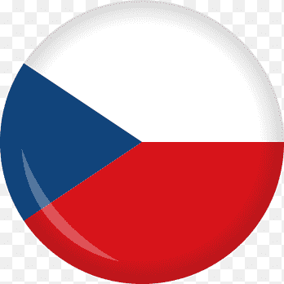

**LISTEN TO THIS MUSICAL PIECE AT AN AMERICAN ARMY FUNERAL:**

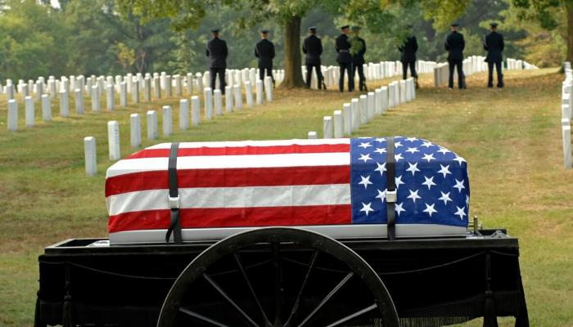

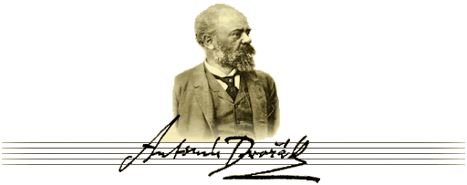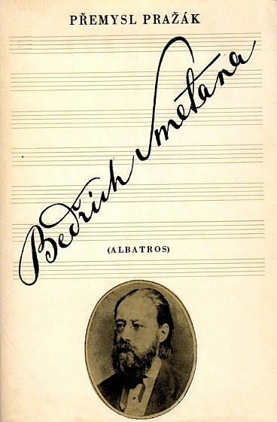

**WHAT IS THE RIVER Vltava CALLED IN GERMAN AND ENGLISH?**

**WHAT ARE THESE LYRICS?**

Where is my home, where is my home?

Water roars across the meadows,

Pinewoods rustle among crags,

The orchard is glorious with spring blossom,

Paradise on earth it is to see.

And this is that beautiful land,

The Czech land, my home,

The Czech land, my home!

**YOUR TIPS FOR THE BEST CZECH WRITERS?**

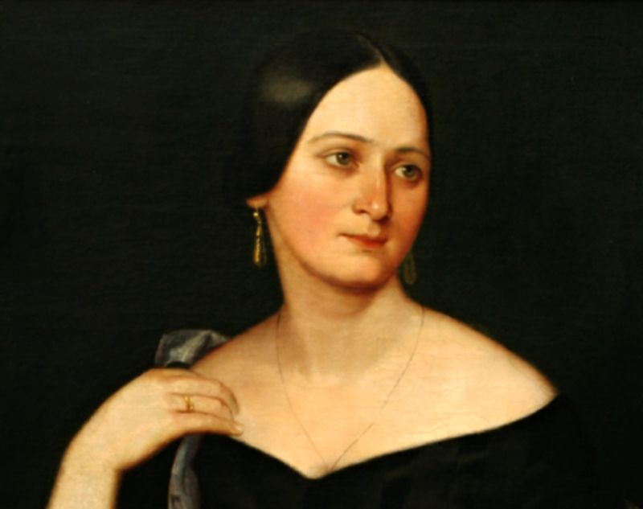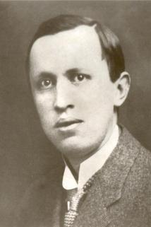

**CZECH WORDS IN ENGLISH:**

* **Robot**
* **Dollar**
* **Pistol**
* **Polka, polka-dotted**
* **Howitzer**

**WHO INVENTED**

* **Lightning conductor**
* **Fingerprints, heart fibres and brain cells**
* **Sugar cube**
* **Arc lamp**
* **Ship’s screw propeller**
* **Soft contact lenses**

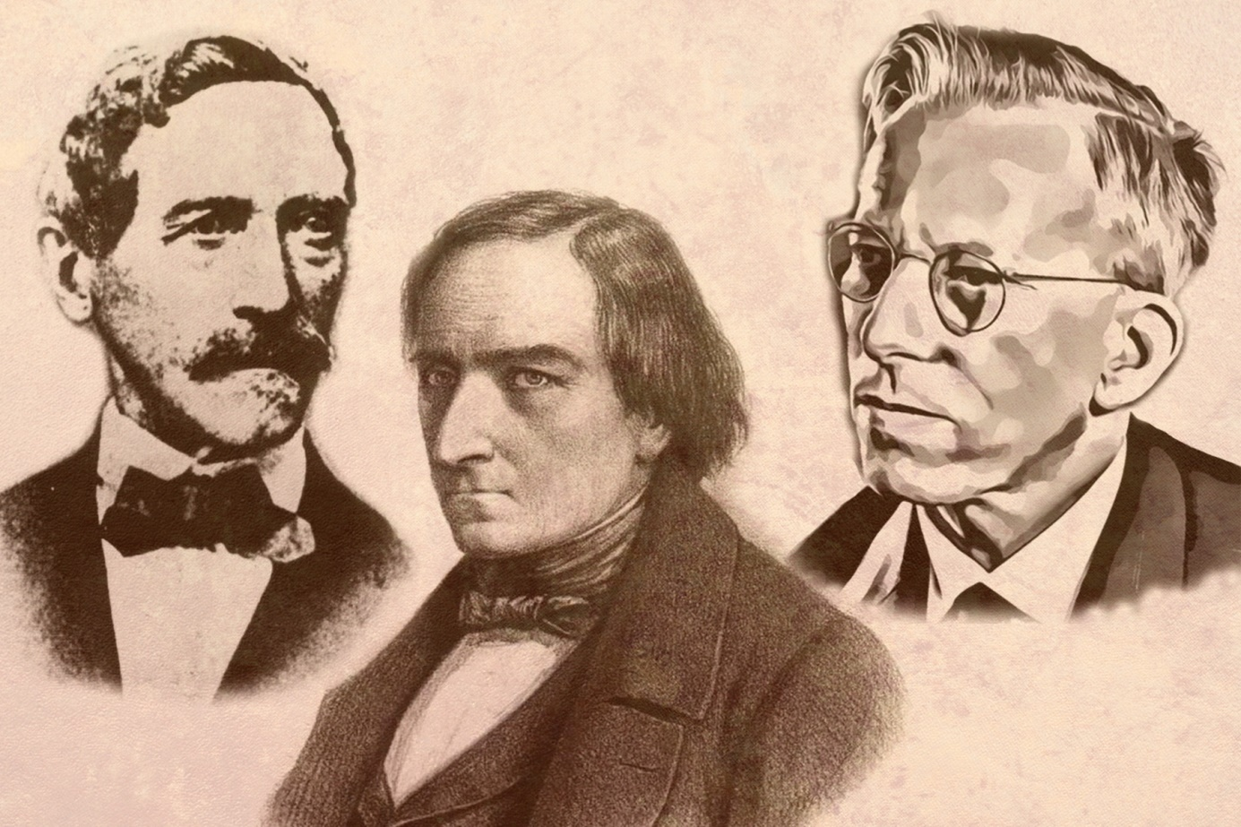

**Jakub Kryštof Rad, Josef Ressel, Otto Wichterle**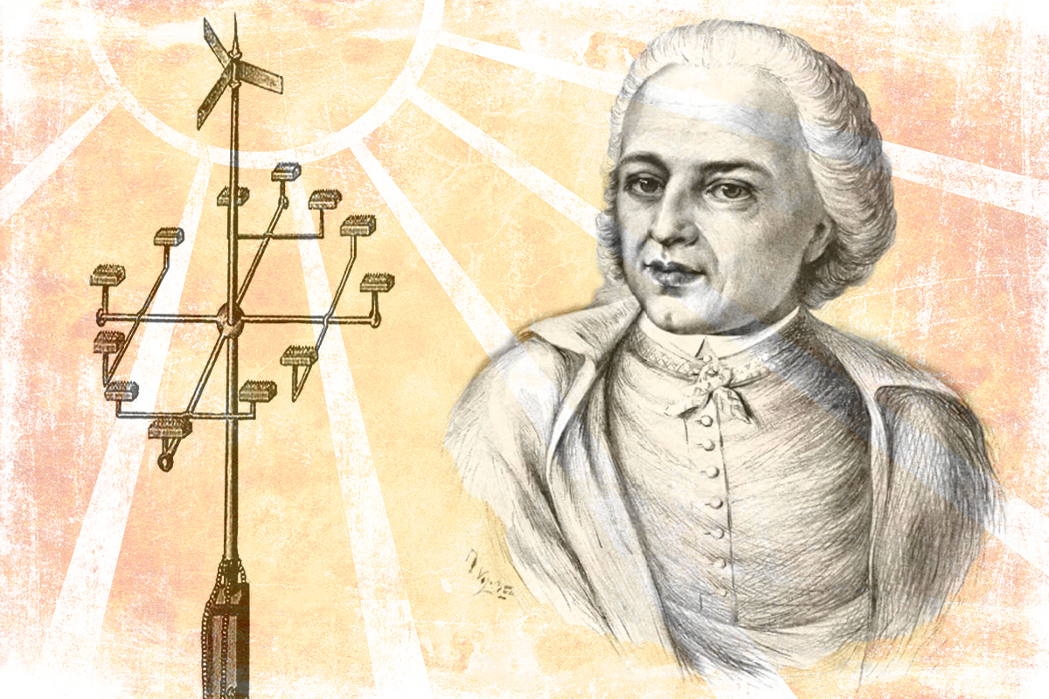

**Václav Prokop Diviš**

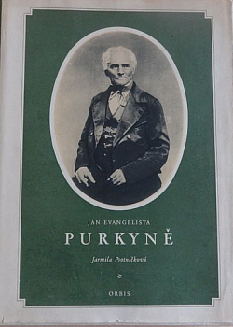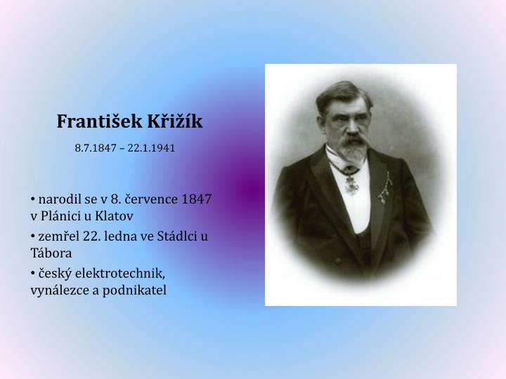

**BRNO SCIENTISTS**

