Written assignment

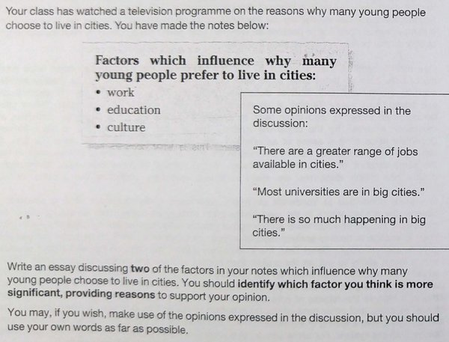

Write an essay of 200-250 words.

- Do not use any other sources.

- Check your work carefully for errors and typos before submitting it.

- Upload your essay as a Microsoft Word document to the homework vaults folder (do not send it via email).

DEADLINE: Sunday 19 December (23:59) - late work may be penalised

