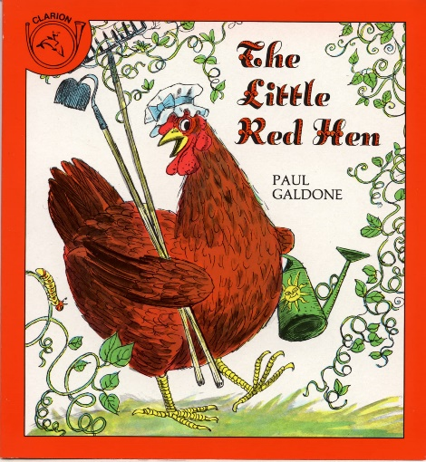**VERSION 1**

Topic:

Vocabulary:

Grammar:

Pronunciation:

Illustrations:

**VERSION 2**

Topic:

Vocabulary:

Grammar:

Pronunciation:

Illustrations: