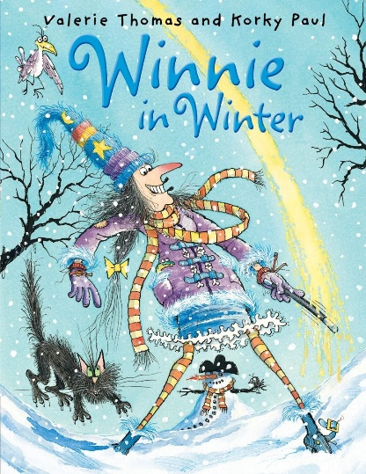**Winnie in Winter**

**Topic:**

**Vocabulary:**

**Language:**

**Pronunciation:**

**Illustrations:**