# **Specific learning disabilities**

# General Information

# **The aim of the course:**

### Familiarized students with the basic therminology of Specific learning disabilities from the international perspective.

### Student will be introduced to main types of SLD

### Students with be introduced to contemporary provision provided for students with SLD and concepts of remediation care*.*

# Course requirements

# Attendance

* Essay – Effect of the SLD on the child´s development

# **Specific Learning Disabilities - Definition**

# The world health organization – International Classification of Diseases

# Chapter 6 – ICD 11 Mental, behavioural or neurodevelopmental disorders

# 6A03 Developmental learning disorder **Definition**

## Developmental learning disorder is characterised by significant and persistent difficulties in learning academic skills, which may include reading, writing, or arithmetic.

## The individual’s performance in the affected academic skill(s) is markedly below what would be expected for chronological age and general level of intellectual functioning, and results in significant impairment in the individual’s academic or occupational functioning.

## Developmental learning disorder first manifests when academic skills are taught during the early school years.

## Developmental learning disorder is not due to a disorder of intellectual development, sensory impairment (vision or hearing), neurological or motor disorder, lack of availability of education, lack of proficiency in the language of academic instruction, or psychosocial adversity.

# 6A03 Developmental learning disorder - Types Definition:

## 6A03.0 **Impairment in reading**

### Learning difficulties are manifested in impairments in **reading skills** such as word reading accuracy, reading fluency, reading comprehension.

## 6A03.1 **Impairment in written expression**

### Learning difficulties are manifested in impairments **in writing skills** such as spelling accuracy, grammar and punctuation accuracy, organization and cohesion of ideas in writing.

## 6A03.2 **Impairment in mathematics**

### Learning difficulties are manifested in impairments in **mathematical skills** such as number sense, memorization of number facts, accurate calculation, fluent calculation, accurate mathematic reasoning.

## 6A03.3 **Other specified impairment of learning**

### Learning difficulties are manifested in impairments in learning and performance of specific academic skills that are not adequately characterized by one of the other available specifiers.

## 6A03.Z **Developmental Learning Disorder, Unspecified**

# **Definitions of SLD – USA**

## Individuals with Disability Act – IDEA (2004)

## Specific Learning Disability

## ''(A) IN GENERAL

### The term 'specific learning disability' means a **disorder** in 1 or more of the basic **psychological processes** involved in understanding or in **using language**, spoken or written, which disorder may manifest itself in the imperfect ability to listen, think, speak, read, write, spell, or do mathematical calculations."

## ''(B) DISORDERS INCLUDED

### Such term includes such conditions as perceptual disabilities, brain injury, minimal brain dysfunction, dyslexia, and developmental aphasia."

## ''(C) DISORDERS NOT INCLUDED

### Such term does not include a learning problem that is primarily the result of visual, hearing, or motor disabilities, of mental retardation, of emotional disturbance, or of environmental, cultural, or economic disadvantage."

# Types of Learning disabilities in usa (LDA USA, 2021)

## Dyslexia

## Dysgraphia

## Dyscalculia

## Non-verbal Learning Disabilities

## Oral/Written Language Disorder and Specific Reading Comprehension Deficity

## Related Disorders:

## ADHD

## Dypraxia

## Executive Functioning

## *„Although learning disabilities may occur concomitantly with other disabilities (for example, sensory impairment, intellectual disabilities, emotional disturbance), or with extrinsic influences (such as cultural or linguistic differences, insufficient or inappropriate instruction), they are not the result of those conditions or influences.“*

## National Joint Committee on Learning Disabilities Definition of Learning Disabilities, 2016

## Learning Disabilities (Kirk 1963)

# **UK Definition of SLD**

## **Specific learning disability =** the result of cognitive and other impairment. Learning disability can be caused by autism and global developmental delay. He causes can be developed in pre-peri-postnatal period.

## **WHILE**

## **Specific learning difficulty -** neurological (rather than psychological) disorder, usually run in families and occur independently of intelligence. They can have significant impact on education and learning and on the acquisition of literacy skills.

## **SpLD** is an umbrella term used to cover a range of frequently co-occurring difficulties:

### Dyslexie

### Dyspraxia of Developemntal Coordination Disordet (DCD)

### Dyscalculia

### Dysgraphia

### Attention Deficit Disorder or Attention Deficit Hyperactivity Disorder (ADD or AD(H)D)

## It's estimated up to 1 in every 10 people in the UK has some degree of dyslexia.

# Severity of SLD – Mild – Moderate – Severe - Profound

# **Defition of SLD in the Czech**

# Definition of SLD – Czech definition

## *„Specific learning disabilities means inability to learn how to read, write or calculate while using standard teaching methods, in an adequate socio-cultural opportunity and an average intellect.“*

## *Jucovičová & Žáčková, 2014*

# Czech SLD classification

## Dyslexia

## Dysgraphia

## Dyscalculia

## „Dysortographia“

## Dyspraxia

## Dyspinxia

## Dysmusia

# **Prevalence of SLD**

## Internationally

### 10 % in overall population

## Czech Republic

### Unclear prevalence

### In betwen 2 – 20 % in school population

### 2 – 4 children in 100 (2 – 4 %) – Matějček,1995

# **Etiology of SLD**

## **Etiological factors:**

### Central nervous system dysfunction

#### Minimal brain injury

### Heredity (Dyslexia)

### Combination of heredity and central nervous system dysfunction

### Phonetic difficulties + phonological memory

### Social causes

### Neurotic etiology

### Unidentified cause

# **Associated difficulties**

* Lack of sense for humor
* Problems in self-regulatory behaviors
* Problems in social perception (self-esteem)
* Difficulties in social interaction
* Difficulties in motor skills development
* Difficulties in spatial orientation

# **Dyslexia - Defintion**

## *“Dyslexia is a specific learning disability that is neurobiological in origin. It is characterized by* ***difficulties with accurate and/or fluent word recognition*** *and by* ***poor spelling and decoding abilities****.*

## *These difficulties typically result from a deficit in the* ***phonological component*** *of language that is often unexpected in relation to other cognitive abilities and the provision of effective classroom instruction.*

## *Secondary consequences may include problems in* ***reading comprehension and reduced reading experience*** *that can impede growth of vocabulary and background knowledge.”*

# **Dyslexia - symptoms**

## **Vision, Reading, and Spelling**

### Confused by letters, numbers, words, sequences, or verbal explanations.

### Reading or writing shows repetitions, additions, substitutions, and reversals in letters, numbers and/or words.

### Complains of feeling or seeing non-existent movement while reading, writing, or copying.

## **Hearing and Speech**

### Difficulty putting thoughts into words; mispronounces long words, or transposes phrases, words, and syllables when speaking.

### **Writing and Motor Skills**

### Clumsy, uncoordinated, poor at ball or team sports; difficulties with fine and/or gross motor skills and tasks

### Can be ambidextrous, and often confuses left/right, over/under.

## **Math and Time Management**

### Has difficulty telling time, managing time, learning sequenced information or tasks, or being on time.

## **Memory and Cognition**

### Excellent long-term memory for experiences, locations, and faces.

### Poor memory for sequences, facts and information that has not been experienced.

## **Behavior, Health, Development and Personality**

### Can be class clown, trouble-maker, or too quiet.

### Had unusually early or late developmental stages (talking, crawling, walking, tying shoes).

# **Dyslexia in the Child development**

## **Before school**

## Late talking

## Learning new words slowly

## Problems forming words correctly, such as reversing sounds in words or confusing words that sound alike

## Problems remembering or naming letters, numbers and colors

## Difficulty learning nursery rhymes or playing rhyming games

## **School age**

## Reading well below the expected level for age

## Problems processing and understanding what he or she hears

## Difficulty finding the right word or forming answers to questions

## Difficulty seeing (and occasionally hearing) similarities and differences in letters and words

## Inability to sound out the pronunciation of an unfamiliar word + Difficulty in spelling

## Spending an unusually long time completing tasks that involve reading or writing

## Avoiding activities that involve reading

# **USA Reading methods** **Orton-Gillingham method**

## Orton-Gillingham (OG) is An approach to teaching reading and spelling that uses instruction that is multisensory, sequential, incremental, cumulative, individualized, phonics-based, and explicit

## The Orton-Gillingham approach helps by focusing on why words are spelled the way they are.

## English language contains:

### just 26 letters

### these letters combine to create approximately 44 speech sounds,

### and there are over 250 ways to spell those sounds.

## OG approach translates the spelling of these sounds into phonograms and demystifies reading and spelling by teaching students to apply rules and generalizations that help make what was once difficult *much* easier!

# Phonograms ??

## **A phonogram** is a letter or combination of letters that represent a sound. For example:

## CK is a phonogram that says /k/ as in *clock*.

## S is a phonogram that says /s/ as in *sat*or /z/ as in *has*.

## OY is a phonogram that says /oi/ as in *boy*.

# **Uk Reading methods -** Jolly phonics

## **Jolly Phonics** is a comprehensive programme, based on the proven, fun and muliti-sensory synthetic phonics method that gets children reading and writing from an early age.

## ***Learning the letter sound***

### Children are taught 42 letter sounds, which is a mix of alphabet sounds (1 sound – 1 letter) and digraphs (1 sound – 2 letters) such as sh, th, ai and ue.

## ***Learning letter formation***

### Children will learn how to form and write the letters down alongside with the first phase

## ***Blending***

### Once the first few letter sounds are learnt, children begin blending the sounds together to help them read and write new words

## ***Segmenting***

### When children start reading words, they also need to start identifying the phonic components

## ***Tricky words***

## **Dyslexia in Teens and adults**

## Slow and labor-intensive reading and writing

## Mispronouncing names or words, or problems retrieving words

## Trouble understanding jokes or expressions that have a meaning not easily understood from the specific words (idioms), such as "piece of cake" meaning "easy"

## Spending an unusually long time completing tasks that involve reading or writing

## Difficulty summarizing a story

## Trouble learning a foreign language

## Difficulty memorizing

## Difficulty doing math problems

# **Dyslexia in numbers**

## **Dyslexia occurs worldwide regardless of culture or language and affects about 9 - 12 % of the population**;

## 2 – 4 % of the population can be seriously affected  **(**European Dyslexia Association)

## Co-occurrence of the DYS-differences:

### 20-55 % of persons with developmental language disorder are dyslexic.

### 20-40 % of persons with dyslexia are also having dyscalculia

### 10-20 % of persons with dyslexia are having an anxiety disorder

### 2-14 % of persons with dyslexia are having a depression

### 8-18 % of persons with dyslexia are having an attention deficit (ADD) and/or hyperactivity disorder (ADHD)

# **Child with dyslexia in the class - Support**

## Multi-sensory instructional approach

## Intensity of intervention – efficient intervention is managed either in school and at home

## Teacher´s patient with student´s difficulties

## Ongoing everyday feedback

## Adjustments in evaluation, tests, others

## Support in other subjects affected by dyslexia

## Twice exceptionality – SLD + Giftedness

## Appreciation of the child´s effort

## Teaching comprehension strategies to work with the text and information in general

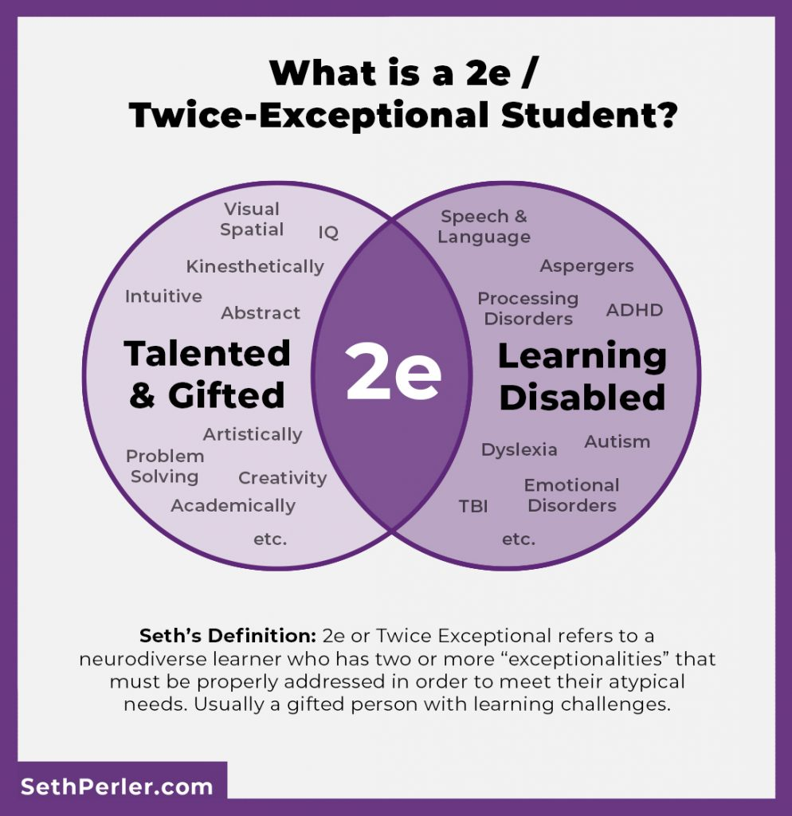

# **Dysgraphia**

## *Dysgraphia is a condition that causes trouble with written expression. The term comes from the Greek words dys (“impaired”) and graphia (“making letter forms by hand”).*

## *It's very messy writing, that is often illegible and incomprehensible.*

# **Types of dysgraphia**

## **Dyslexic dysgraphia**

## Spontaneously written work is illegible, copied work is fairly good, and spelling is bad. Copied writing or drawings, may be clear. A Dyslexic Dysgraphic does not necessarily have dyslexia.

## **Motor dysgraphia**

## Dysgraphia is due to deficient fine motor skills, poor dexterity, poor muscle tone, and/or unspecified motor clumsiness. Generally, written work is poor to illegible, even if copied by sight from another document. Letter formation may be acceptable in very short samples of writing, but this requires extreme effort and an unreasonable amount of time to accomplish, and cannot be sustained for a significant length of time. Spelling skills are not impaired.

## **Spatial dysgraphia**

## Dysgraphia due to a defect in the understanding of space has illegible spontaneously written work, illegible copied work, but normal spelling,

## Some children may have a combination of any two or all three of these. Symptoms in actuality may vary in presentation from what is listed here.

## **Dysgraphia vs. dyslexia difficulites in writing**

## **Dysgraphia**

## Child with dysgraphia knows hot to write, but is unable to develop proper motor plan to create it, even if the letter, shape, the word is in front of them

## **Dyslexia**

## Child with dyslexia is physically able to copy, but might have trouble writing due to difficulty in phonological awarenness, spelling, memory deficits and less severe fine motor deficits

## Dyslexia and Dysgraphia seems unrelated according to the researches!

# **Dysgraphia in the development**

## **Preschool children** may be hesitant to write and draw and say that they hate coloring.

## **School-age children** may have illegible handwriting that can be mix of cursive and print. They may have trouble writing on a line and may print letters that are uneven in size and height. Some children also may need to say words out loud when writing or have trouble putting their thoughts on paper.

## **Teenagers** may write in simple sentences. Their writing may have many more grammatical mistakes than the writing of other kids their age.

# **Prevalence**

## Reynolds, USA 2007

### Prevalence of dysgraphia is estimated at 5 – 20 % of all students having some type of writing deficit

## Döhla & Heim, USA - 2016

### There are 7 – 15 % of school-age children exhibit some form of development writing deficit

## Chung, Patel & Nizami, USA- 2020

### Between 10 % and 30 % of children experience difficulty in writing

**Stimulation**

## Gross and Fine motor Skills

## Excercise for graphomotor excercise

## Letter shape – Letter size – Letter linking

## Stimulation depends on the:

### Severity of motor deficits

### Severity of the deficits in cognitive and perspetual functions (spatial orientation, memory, phonological awarenness)

### Cursive vs. print letters use

# **Child with dysgraphia in the class**

## Inappropriate practices

### Completing written tasks during the break and at home

### Task rewritting – inefficient, often of poorer quality

## Extra time subsidy

## Compensation

### Writing in block letters – eliminating the stress of connecting letters

### Typing on a computer combined with writing short tasks by hand

## Provide student with copied materials for the lessons

## The pupil should use the time in which others write, for example, to draw sketches in a workbook, dealing with additional questions to text, etc.

# **Dyscalculia - definition**

## *Developmental Dyscalculia (DD) is a specific learning disorder that is characterised by impairments in learning basic arithmetic facts, processing numerical magnitude and performing accurate and fluent calculations.*

## 3–7% of all children, adolescents, and adults suffer from dyscalculia

## High comorbidity with

### Dyslexia - 30–40%

### ADHD - 10–20%

### Anxiety, School phobia – 20 %

# Number sense

## Child’s fluidity and flexibility with numbers

## It helps children understand what numbers mean, improving their performance of mental mathematics, and giving them the tools to look at maths in the outside world and make comparisons

# **Dyscalculia - symptoms**

## 1. **Delay in counting**. 5 to 7 year-old dyscalculic children show less understanding of basic counting principles than their peers (e.g. that it doesn't matter which order objects are counted in).

## 2. **Delay in using counting strategies** for addition. Dyscalculic children tend to keep using inefficient strategies for calculating addition facts much longer than their peers.

## 3. **Difficulties in memorizing arithmetic facts**. Dyscalculic children have great difficulty in memorizing simple addition, subtraction and multiplication facts (eg. 5 + 4 = 9), and this difficulty persists up to at least the age of thirteen.

# Dyscalculia types - Dyscalculia. Org. USA

## **Practognostic** dyscalculia

### These children are able to understand mathematical concepts but have trouble listing, comparing, and manipulating mathematical equations.

## **Verbal** dyscalculia

### Difficulty naming and understanding the mathematical concepts presented verbally. Children are able to read or write numbers, but have a hard time recognizing them when presented verbally.

## **Lexical** dyscalculia

### Trouble reading and understanding mathematical symbols and numbers, as well as mathematical expressions or equations.

## **Graphical** dyscalculia - Difficulty writing mathematical symbols; Difficulties in geometry

## **Ideognostical** dyscalculia

### Difficulty carrying out mental operations without using numbers to answer math problems and understand mathematical concepts.

## **Operational** dyscalculia

### This type of dyscalculia presents itself with a difficulty to complete written or spoken mathematical operations or calculations.

# **Math difficulties in the Czech Republic** (Blažková, 2009)

## Pre-numerical skills

## Propaedeutic exercises to create the term number

## Numbers as category

## General mathematical operations

## Verbal tasks

## Geometry

## Unit conversions

## Estimation of results

## Mathematics in everyday life – financial literacy, spatial orientation

# **Important notes – what does it need to be take into account?** Haberstroh,s.; Schulte-Körne g. 2019,

## Persons with dyscalculia **perform poorly in all areas of mathematics,** particularly in the processing of numbers and quantities, in basic arithmetic operations, and in the solving of word problems.

## The diagnosis of dyscalculia requires mathematical performance as assessed by a standardized test to be at least one standard deviation below the age- or grade-appropriate mean.

## **The treatment** should be disorder-specific, should be **initiated as early as possible**, and should be provided by an appropriately trained expert in an individual setting.

## **Comorbid symptoms** and disorders must be kept in mind during the diagnosis and treatment of dyscalculia, particularly comorbid dyslexia, attention deficit/hyperactivity disorder, and disorders of either the internalizing type (anxiety, depression) or the externalizing type (characterized by aggression or rule-breaking).

# Dyscalculia – Intervention Frey, D. 2020.How to Treat the Symptoms of Dyscalculia.

## **Allow extra time on tests.** Children with dyscalculia often feel rushed during standard-length math tests.

## **List the steps for multi-step problems and algorithms.** Post clearly numbered step-by-step instructions on the board.

## **Keep sample problems on the board**

## **Use plenty of brightly colored, uncluttered reference charts and diagrams.**

## **Whenever possible, allow calculator use**

## **Reduce the number of assigned problems.** Assigning 10 problems, rather than a full page, is enough to assess a student’s understanding.

# **Developmental coordination Disorder - Dyspraxia**

# Developmental Coordintion Disorder (DCD)

## Developmental Coordination Disorder (DCD), also known as dyspraxia, is a common disorder affecting fine and/or gross motor coordination in children and adults.

## Dyspraxia Foundation, UK, 2019

## Developmental Coordination Disorder (DCD) is a motor skills disorder that affects five to six percent (5 - 6 %) of all school-aged children – 2 % diagnosed.

### The ratio of boys to girls varies from 2:1 to 5:1

### CanChild, Canada, 2019

# **Developmental Coordintion Disorder (DCD) – etiology unclear**

## By definition, children with DCD may have an identifiable medical or neurological condition that explains their coordination problems.

# **Developmental Coordintion Disorder (DCD) – types** Becky L. Spivey, M.Ed (2019)

## **Ideomotor Dyspraxia** – Completing single-step motor tasks such as combing hair and waving goodbye.

## **Ideational Dyspraxia** – Completing multi-step tasks: brushing teeth, making a bed, putting clothes on in order, buttoning, buckling, or lacing.

## **Oromotor Dyspraxia** – Coordinating muscle movements needed to pronounce words.

## **Constructional Dyspraxia** – Establishing spatial relationships, e.g., accurately positioning or moving objects from one place to another.

# Coocuring difficulties

## Attention deficit hyperactivity disorder (ADHD),

## Learning disabilities (LD),

## Specific language impairment (SLI) – Speech disorders

## Behavioural disorder

## Social and emotional difficulties

## Non-motor difficulties

### Memory, perception and processing as well as additional problems with planning, organising and carrying out movements in the right order in everyday situations

# Sensory integration as a therapy for DCD

# Therapy in Child with dyspraxia in the Czech

### Physiotherapy

#### Individual/Group

### Occupational therapy

### Health exercises for children

### Selected sports activities - Swimming

# Amanda Kirby – Dyspraxia Olga Zelinková - Dyspraxie