Speech and language impairment

**Lesson focus**

|  |  |  |
| --- | --- | --- |
| **Skills** | **Terminology** | **Functional language** |
| Mediating information | Speech and language impairment | Defining |

**Preparation (optional or can be done in class)**

* Pick a topic within speech impairment and therapy you are interested in or you would like to learn more about. Please note that each topic should be researched by only one student, so the sooner you pick one, the wider choice you will have. Remember to post your topic along with your source(s) in the Google document linked in the syllabus, so that everyone can see what you have chosen and avoid selecting the same topic. Research the topic and prepare a short oral summary (ca. 3 mins). Remember to structure it as a presentation (see How to present) as this is a presentation training activity.
* In addition, write down and be able to explain at least 5 specialised expressions related to speech impairment and/or therapy.
* Bring a laptop/tablet if possible.

**Lead-in.**

a) Work in groups. Think of some phrases you can use to initiate discussion, show interest in other people’s opinions, and agree/disagree with their ideas. Share your ideas on Google Jamboard.

b) Work in groups of three and brainstorm.

* What is communication?
* How do people communicate?

|  |  |
| --- | --- |
| What is communication? | How do people communicate? |

* Present your ideas graphically as a word cloud. Use [this](https://wordart.com/) app to do so. Link your word cloud in this Google doc to share with the other groups.

**1 Terminology.** Let’s look at verbal communication.

a) Which organs help us produce sounds? Look at the image below and complete the missing organs. Do not worry if you don’t know. Compare with another student. If you still don’t have everything between the both of you, you may search online the missing parts.   
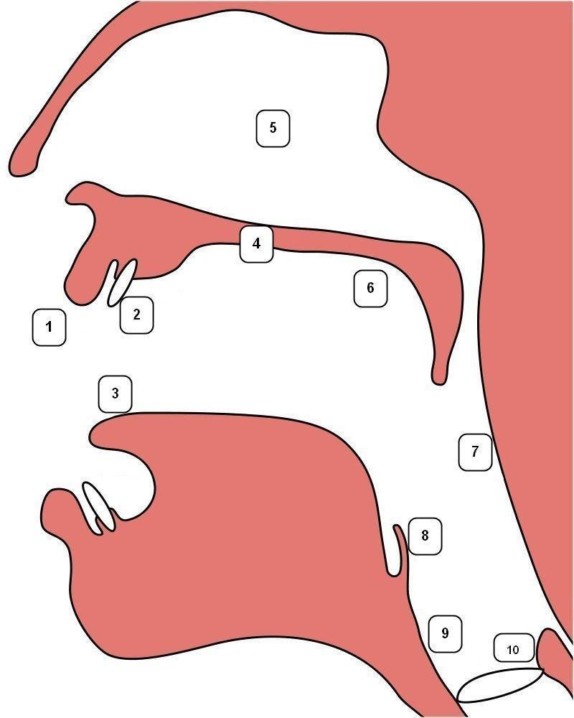

|  |  |
| --- | --- |
| **Organ** | **Pronunciation** |
| 1 LIPS |  |
| 2 TEETH |  |
| 3 TONGUE |  |
| 4 HARD PALATE |  |
| 5 NASAL CAVITY |  |
| 6 SOFT PALATE (VELUM) |  |
| 7 PHARYNX |  |
| 8 EPIGLOTTIS |  |
| 9 LARYNX |  |
| 10 VOCAL FOLDS |  |

Adapted from <https://en.wikipedia.org/wiki/Place_of_articulation>  
  
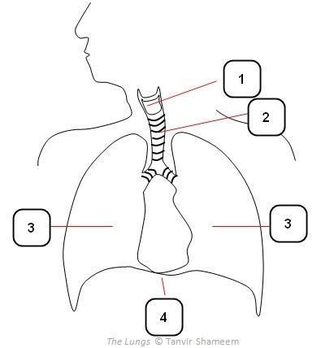

|  |  |
| --- | --- |
| **Organ** | **Pronunciation** |
| 1 LARYNX |  |
| 2 TRACHEA |  |
| 3 LUNGS |  |
| 4 DIAPHRAGM |  |

Adapted from   
<http://dinarlailia.blogspot.com/2013/04/organ-speech.html>

b) Work in pairs. Share the number of terms equally, look up the pronunciation in an online dictionary, practise saying the words and then teach your partner.

**2 Defining.**

a) On your own define speech and language. Then compare with your partner.

* How would you define **speech**?

|  |
| --- |
|  |

* How would you define **language**?

|  |
| --- |
|  |

b) Watch [this](https://www.youtube.com/watch?v=a43SmCKhfHE) video (1:08 - 2:16) and make notes on how speech and language can be defined.

|  |  |
| --- | --- |
| **Speech** | **Language** |

* Were your definitions similar or did they differ considerably? If so, how?

|  |
| --- |
|  |

c) What kind of information is typically included in a definition? Study this brief definition of speech organ from Merriam-Webster dictionary online and identify the following:

1 term 2 class 3 differentiating characteristics

|  |
| --- |
| A speech organ is any of the organs (such as the larynx, tongue, or lips) playing a part in the production of articulate speech. |

* Think of two specialised expressions and write down their definitions. Take turns sharing the definitions and guessing the terms.
* Work in pairs. Each of you will read a text. One person is going to read about speech sound disorders and the other one about language disorders. Make notes about the key information in your text, prepare a short summary and write down **at least three comprehension check questions** for your partner. What do you want him/her to take away from your text? Then, share your summary with them and ask your questions. Your partner is allowed to take notes to be able to answer your questions.

|  |
| --- |
| Notes about your text: |

|  |  |
| --- | --- |
| Questions for your partner: | Notes for answering: |

**3 Information exchange. (optional; requires previous home preparation; or can be done in class)**

|  |
| --- |
| Bernard Shaw, Irish playwright, once said: “The single biggest problem in communication is the illusion that it has taken place.” |

* Can you get your message across? Imagine you’re at an **information exchange,** where you can learn new or refresh familiar topics about speech impairment and speech therapy. You will assume the role of both an expert and an information seeker.

As an **expert** you will report about the topic you have prepared at home. Before you do so, remember to pre-teach at least five specialised expressions so that your audience can understand your topic.

As an **information seeker**, you will approach experts who will tell you about their topic. Make notes as well as add new expressions to your list.

Then, swap roles.

* Go to this Google document and in your own words write down what you have learnt from an expert about his/her topic. Include specialised expressions as well.

The expert will then comment on whether he/she managed to get their message across and add their original report.

* For inspiration, see the example in the Google document.

**4 Listening & describing.**

a) Before you start, discuss these questions in pairs.

* What does the job of a speech therapist involve?
* What kind of people do STs work with?
* What kind of institutions can STs work at?
* Why do you want to become a ST (if you’re a student of speech therapy) or why do you think people would like to become a ST (if speech therapy is not your specialisation)?

|  |
| --- |
|  |

b) One of you will watch a [video](https://www.youtube.com/watch?v=9IBjuTSRL-g) about a young woman training to become a speech therapist, and the other one a [video](https://www.youtube.com/watch?v=nzCVEo173OE) (0:00 - 01:06) about the speech and language therapy programme at Newcastle University. Make notes to the above questions while watching your videos.  Share your notes with your partner. Then, together synthesise the information from both videos into one text. Post your synthesis [here](https://docs.google.com/document/d/13kBHLsVzFt-Cm-VM95ahc-ZzxaPRVSaeVCzJUhuqdxA/edit?usp=sharing).

|  |  |
| --- | --- |
| **A speech therapist trainee** | **Newcastle university speech therapy programme** |
|  |  |
| **Synthesis** | |