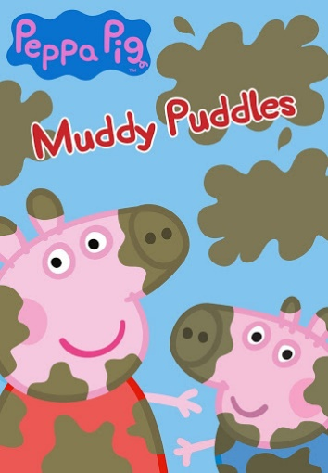**Peppa Pig: Muddy Puddles**

Topic:

Vocabulary:

Grammar:

Pronunciation:

Visuals:

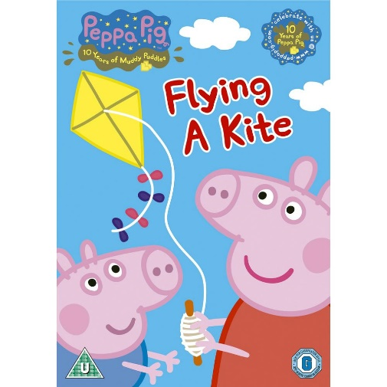**Peppa Pig: Flying a Kite**

Topic:

Vocabulary:

Grammar:

Pronunciation:

Visuals: