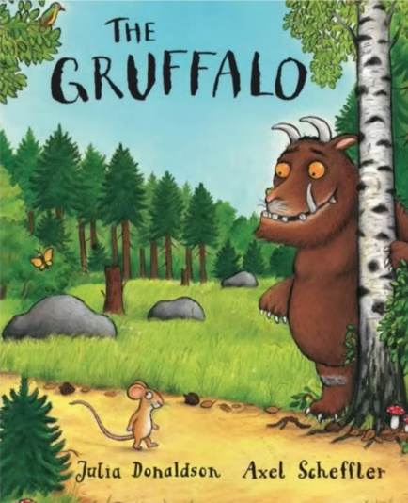
Gruffalo
Topic:
Vocabulary:
Language:
Pronunciation:
Illustrations:

