**Peppa Pig: Muddy Puddles**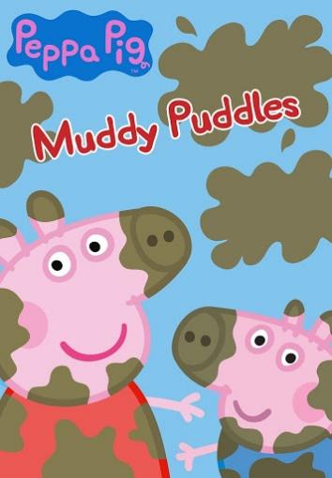

Topic:

Vocabulary:

Grammar:

Pronunciation:

Visuals:

**Muddy Puddles - Song**

Topic:

Vocabulary:

Grammar:

Pronunciation:

Activities/movement:

Dance, dance, dance in muddy puddles

__________, __________, __________, __________, __________

Dance, dance, dance in muddy puddles

__________, __________, __________, __________, __________

With a big __________here, and a big __________there

Here a __________, there a __________

Everywhere a __________, __________

Dance, dance, dance in muddy puddles

__________, __________, __________, __________, __________