Autism Spectrum Disorder

**Lead-In.**

* **First, write down five keywords you associate with autism.**
* **Then, imagine you have been asked to join a podcast as an expert on ASD. What kind of questions might you be asked? Write down at least three questions.**

| 1  2  3 |
| --- |

**3 Listening. You are going to watch a video about ASD in teams.**

**3a First, get familiar with the relevant vocabulary. Follow these steps:**

1. **Go to the lesson notes.**
2. **Find the box of your team.**
3. **Divide the words in your box equally between pairs/small groups.**

* **For example, if there are four people in the team, one pair will work on half of the expressions, and the other pair on the remaining half.**

**4. Use an online monolingual dictionary to check the pronunciation and meaning of each word/collocation.**

* **Paraphrase the definitions in your own words to explain what each word/collocation means.**

| Team 1 (2:30-4:40) | Team 2 (4:40-6:26) | Team 3 (6:27-7:12) |
| --- | --- | --- |
| pervasive | deficit | to be a mystery |
| severity | different spectrum of symptoms | environmental triggers |
| reciprocate / reciprocity | substantial support | to explore something |
| repetitive behaviour | Intelligible speech | risk factors |
| nonverbal cues | rarely initiate interaction | treatment is tailored to each child |
| hard time making friends | resistant to change | to maximise quality of life |
| to line up toys | caretaker | functional independence |
| to flap hands | back-and-forth conversation |  |

**3b Watch your section of the video on your devices using earplugs. To learn more about ASD, you are going to work in pairs/groups and watch parts of a** [**video about ASD**](https://www.youtube.com/watch?v=FCejya1WWC8)**. Listen twice to your section and write down key ideas and some relevant supporting details. Talk to the other people in your team and compare your notes. Prepare a short summary. Then, get together with the people from the other two teams and share what you have learned.**

| **Section 1 (2:30-4:40)** |
| --- |
| **Section 2 (4:40-6:26)** |
| **Section 3 (6:27-7:12)** |

**4 Reading. You are going to read a text about ASD and how it manifests in young children.**

**4a Change groups. Together with your new group, study this list and mark those expressions that you would like to practise.**

| Room for your notes |
| --- |

**4b Study the infographic. With your group, speculate on what early signs of autism these images represent. Remember to use the language for speculation. Put a tick next to an expression when you use it.**

|  |
| --- |

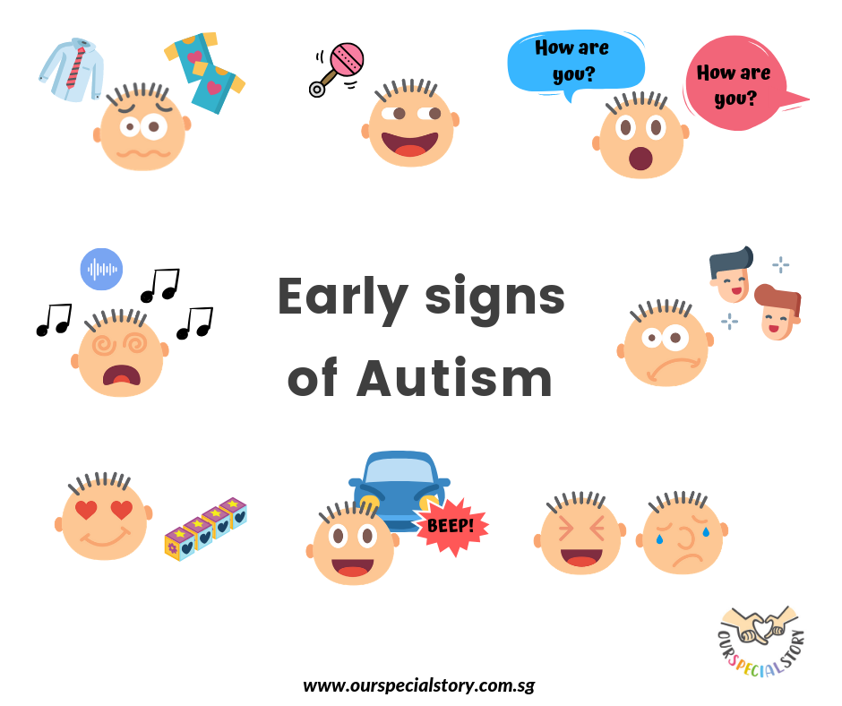

**4c Read the text below. What signs of autism does the text discuss? Write them in the box below and compare them with your speculations. Did you have the same or different?**

|  |
| --- |

| Autism is a bio-neurological developmental disability that generally appears before the age of 3. It impacts the normal development of the brain in the areas of social interaction, communication skills, and cognitive function. Individuals with autism typically have difficulties in verbal and nonverbal communication, social interactions, and leisure or play activities.  Because autism is a spectrum disorder, it can range from very mild to very severe and occur in all ethnic, socioeconomic, and age groups. Males are four times more likely to have autism than females. Some children with autism appear normal before age 1 or 2 and then suddenly “regress” and lose language or social skills they had previously gained.  Currently, there is no cure for autism, though with [early intervention and treatment](https://nationalautismassociation.org/autism-treatment-2/early-intervention/), the diverse symptoms related to autism can be greatly improved and in some cases completely overcome.  There are some typical behaviours that may indicate ASD. For example, children with autism will probably avoid making or maintaining eye contact. In addition, they will find it extremely difficult to make friends since ASD affects social interaction. They might also get upset over minor changes, such as offering them a drink in a cup of a different colour other than the one they typically use. Very often, children with autism obsessively play with only specific toys, such as trains, cards, or blocks, which can be built in a line. Furthermore, they may demonstrate little safety or danger awareness, for example when crossing the road or handling sharp objects. Some children with ASD may also have sensory sensitivities, which means they overreact to certain sensory stimuli. For example, they may cover their ears when they hear loud noises or eat only foods with a certain texture. Finally, their behaviour may be characterised by episodes of inappropriate laughing (unshared laughter) or crying regardless of the situation they find themselves in. For more information on other signs of ASD, follow [this link](https://nationalautismassociation.org/resources/signs-of-autism/). |
| --- |

Adapted from:

<https://nationalautismassociation.org/resources/autism-fact-sheet/>

<https://raisingchildren.net.au/autism/behaviour/understanding-behaviour/sensory-sensitivities-asd>

<https://www.spectrumnews.org/opinion/laugh-factory/>

**5 In the next activity, you are going to prepare a short talk about an ASD therapy.**

**5a First, what does the text above (4c) say about treatment for ASD? Use your own words to convey the idea.**

|  |
| --- |

**5b Now, listen to a psychotherapist speaking about treatment for ASD. In your opinion, what point(s) is she trying to make? Discuss your answer with your partner.** [**5:00 - 5:45**](https://www.youtube.com/watch?v=JxpEQY-yiOk)**.**

|  |
| --- |

**5c Work in small groups. What ASD therapies do you know of? Write down as many as you can recall in the box below.**

|  |
| --- |

**5d** **Work in pairs. Go to the syllabus and pick an ASD therapy you would like to learn more about. Each document contains two texts. Skim and scan your article, note down the main ideas and relevant details to prepare a short summary for your speaking partner. Use your own words to describe the therapy and to say how it helps people with ASD. Add any professional experience you might have with the therapy. Then compare your summary with that of your partner. Look for similarities and differences. Combine your key ideas to prepare a short talk for the whole class.**

**Key ideas and supporting details for the summary of your text**

|  |
| --- |

**Key ideas and supporting details for the talk based on both summaries**

|  |
| --- |

**6 Exit ticket. What from this lesson would you like to…**

| take away (totally relevant) | keep fresh (moderately relevant) | bin (hardly relevant / irrelevant) |
| --- | --- | --- |
|  |  |  |
|
|
|
|

**7 Here is a list of resources that you might find useful to watch.**

* [This is a radio programme of Mayo Clinic radio with Dr. Huebner as a host on ASD](https://www.youtube.com/watch?v=4MKVCn34Isk) (presentations, causes, diagnosing).
* [This video shows women who have been diagnosed with ASD talking about what life is like with ASD.](https://www.youtube.com/watch?v=NwEH9Ui4HV8)
* [This is a video by psychotherapist Katie Norton on the way autism manifests in females.](https://www.youtube.com/watch?v=gpJ6bJHEc-k)