**Pronunciation module**

**English for Teachers B, Autumn 2024**

**Warm-up**

**Discuss the following questions in groups of 3-4.**

What is pronunciation? What does it include?

How have you learned English pronunciation so far?

What have you found difficult about English pronunciation? What have you found easy?

What are the main differences between English pronunciation and the pronunciation of your language?

How important do you think correct pronunciation is? Why?

Do you think you need to improve your pronunciation? If so, do you know how you can do it?

**How much do you know? (OuIS)**

**Try to do the quiz as quickly as possible:**

1. How many letters are there in the English alphabet:
2. 26
3. 30
4. 34
5. 44
6. How many sounds are there in English:
   1. 26
   2. 30
   3. 34
   4. 44
7. A, E, I, O, U are:
8. consonants
9. monophtongs
10. vowels
11. dipthongs
12. P, M, V, D, X are:
13. consonants
14. syllables
15. vowels
16. dipthongs
17. How many syllables are there in the word *obviously*:
18. 5
19. 2
20. 3
21. 4
22. In which of the following pairs both words contain a **silent letter**:
23. listen, psychology
24. wash, knife
25. autumn, secret
26. often, cat
27. Which of the following words ends in a voiced consonant:
28. snack
29. bread
30. leaf
31. sink
32. Word stress in English can be placed:
    1. only on the first syllable
    2. only on the second syllable
    3. only on the third syllable
    4. any of the above

**Divide into groups based on the cards that your teacher gives you. In your group, carry out the following tasks.**

What can you see in the picture below? What is it used for?

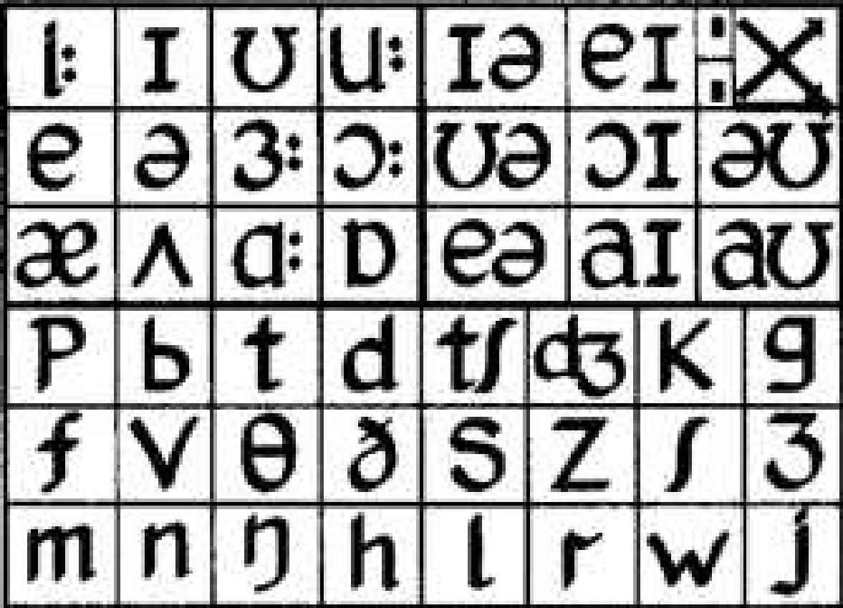

Can you pronounce all the sounds correctly? Take it in turns to read all the symbols. Then check [here](https://elt.oup.com/student/englishfile/advanced3/pronunciation?srsltid=AfmBOoo3vhbD-AQk5MORgdsLhO0GdRhf4lEbewW3blktI-Wix0U_W3Pn&cc=cz&selLanguage=cs).

**Tip:**

If you want to find out more about English phonetics and the International Phonemic Chart (IPA), watch this [YouTube playlist](https://www.youtube.com/watch?v=7mahmMmnSx4&list=PLOZUTLsJbEAjW-Z9Bou0fPvPs8zdF79pJ).

**Discuss in your group:**

Is it useful for English learners to be able to read the IPA? Why (not)?

In your opinion, is it a useful skill to be able to record the pronunciation of English words using the IPA? Why (not)?

**Can you do it? Let’s try! Write the following words:**

/skuːl/ _________________________

/ˌedʒuˈkeɪʃn/ _________________________

/ˈhɒlədeɪ/ _________________________

/ˈɡrædʒuət/ _________________________

/kəˈrɪkjələm/ _________________________

**Transcribe the following words:**

university _________________________

teacher _________________________

homework _________________________

exam _________________________

language _________________________

**Resource Bank**

[Anglická výslovnost s Irenou](https://www.youtube.com/@anglickavyslovnostsirenou9070/videos)

[BBC Learning English – Tim’s pronunciation workshop](https://www.youtube.com/playlist?list=PLcetZ6gSk96-ayXj5thbTpbh2vHWpP08o)

[Pronunciation skills with Adrian Underhill](https://youtu.be/Vm3T5rCp5E0?si=FXT8AhmZBl9JvGn_)

[ELSA – personal pronunciation coach app](https://elsaspeak.com/en/)

[Help for English – pronunciation](https://www.helpforenglish.cz/vyslovnost)