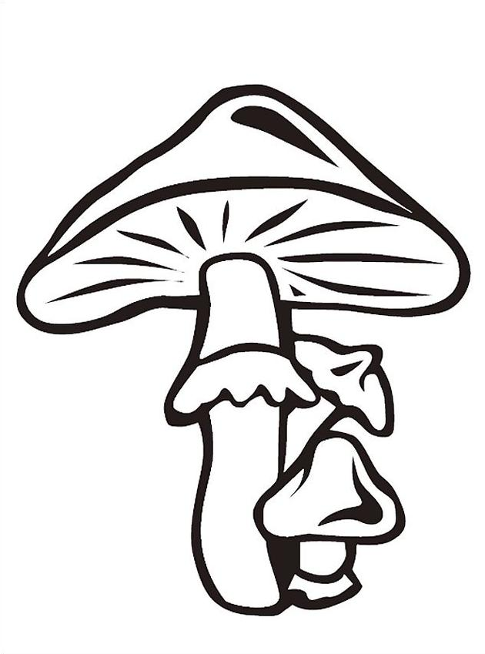
Buchstabengitter

Suche im Buchstabengitter alle deutschen und tschechischen Pilznamen. Ordne die deutschen Namen der Pilze den tschechischen Namen zu. Das Wörterbuch kann dir helfen.
Hledej v písmenkové mříži všechny německé a české názvy hub. Přiřaď k sobě německé a české názvy. Slovník ti pomůže.

B | N | A | U | Z | O | M | X | V | E | H | A | I | G | M | D | F | T
E | U | J | M | Ä | R | U | T | W | A | β | Ű | H | R | P | Ő | E | F
T | N | E | B | A | W | C | M | J | M | K | E | B | Ű | D | A | T | U
F | A | H | Ű | K | L | H | R | S | G | V | E | O | N | O | M | A | K
I | B | M | U | C | H | O | M | Ů | R | K | A | Z | E | L | E | N | Á
C | S | Ő | N | M | I | M | K | Ä | F | I | J | L | R | T | G | B | N
H | Z | O | P | N | U | Ů | D | S | L | V | N | R | K | B | β | R | E
T | J | I | B | N | E | R | V | C | I | D | Ű | H | N | K | L | U | M
E | S | X | Y | Z | U | K | O | P | E | F | B | E | O | S | Ä | N | O
N | T | Y | Z | O | K | A | D | B | G | E | N | B | L | U | J | L | M
S | W | E | G | U | B | R | C | I | E | X | Ő | D | L | F | S | R | E
T | B | M | J | I | T | Ů | D | Ű | N | O | V | J | E | Ű | R | U | K
E | β | L | U | H | A | Ž | G | U | P | A | L | I | N | G | T | Ä | D
I | N | D | W | B | H | O | B | L | I | R | L | Ä | B | O | T | U | L
N | Ä | D | R | A | C | V | I | M | L | β | W | E | L | A | S | Y | L
P | R | A | C | M | E | K | L | I | Z | O | D | X | Ä | V | Ő | S | A
I | P | I | W | A | H | A | L | R | U | C | Ű | H | T | O | M | B | O
L | H | Ř | I | B | S | M | R | K | O | V | Ý | K | T | U | S | F | V
Z | I | M | D | U | H | C | Ő | F | V | F | O | G | E | M | Z | U | L
B | M | U | C | H | O | M | Ů | R | K | A | Č | E | R | V | E | N | Á
H | S | M | Ä | T | O | N | J | I | S | O | Z | A | P | J | O | N | A
S | E | β | E | M | O | D | Z | M | W | B | A | T | I | N | O | V | O
D | O | M | M | Ő | T | O | P | E | R | L | P | I | L | Z | W | A | K
Z | Ű | S | A | M | I | V | E | F | O | R | B | I | Z | E | L | β | E

Lösung:

Buchstabengitter

 |  |  |  |  |  | M |  |  |  |  |  |  | G
 |  |  |  |  |  | U |  |  |  |  |  |  | R
 |  |  |  |  |  | C |  |  |  |  |  |  | Ű
F |  |  |  |  |  | H |  |  |  |  |  |  | N
I |  | M | U | C | H | O | M | Ů | R | K | A | Z | E | L | E | N | Á
C |  |  |  |  |  | M |  |  | F |  |  |  | R
H |  |  |  |  |  | Ů |  |  | L |  |  |  | K
T |  |  |  |  |  | R |  |  | I |  |  |  | N
E |  |  |  |  |  | K |  |  | E |  |  |  | O
N |  |  |  |  |  | A |  |  | G |  |  |  | L
S |  |  |  |  |  | R |  |  | E |  |  |  | L
T |  |  |  |  |  | Ů |  |  | N |  |  |  | E
E |  |  |  |  |  | Ž |  |  | P |  |  |  | N
I |  |  |  |  |  | O |  |  | I |  |  |  | B
N |  |  |  |  |  | V |  |  | L |  |  |  | L
P |  |  |  |  |  | K |  |  | Z |  |  |  | Ä
I |  |  |  |  |  | A |  |  |  |  |  |  | T
L | H | Ř | I | B | S | M | R | K | O | V | Ý |  | T
Z |  |  |  |  |  |  |  |  |  |  |  |  | E
 | M | U | C | H | O | M | Ů | R | K | A | Č | E | R | V | E | N | Á
 |  |  |  |  |  |  |  |  |  |  |  |  | P
 |  |  |  |  |  |  |  |  |  |  |  |  | I
 |  |  |  |  |  |  | P | E | R | L | P | I | L | Z
 |  |  |  |  |  |  |  |  |  |  |  |  | Z

Grűner Knollenblätterpilz
Muchomůrka zelená

Perlpilz
Muchomůrka růžovka
Fichtensteinpilz
Hřib smrkový
Fliegenpilz
Muchomůrka červená

